module :: Item/Cannon.java

test/design :: test_cannon_10_02_00_constructor_equivalence

description :: cannon class design and constructor verification

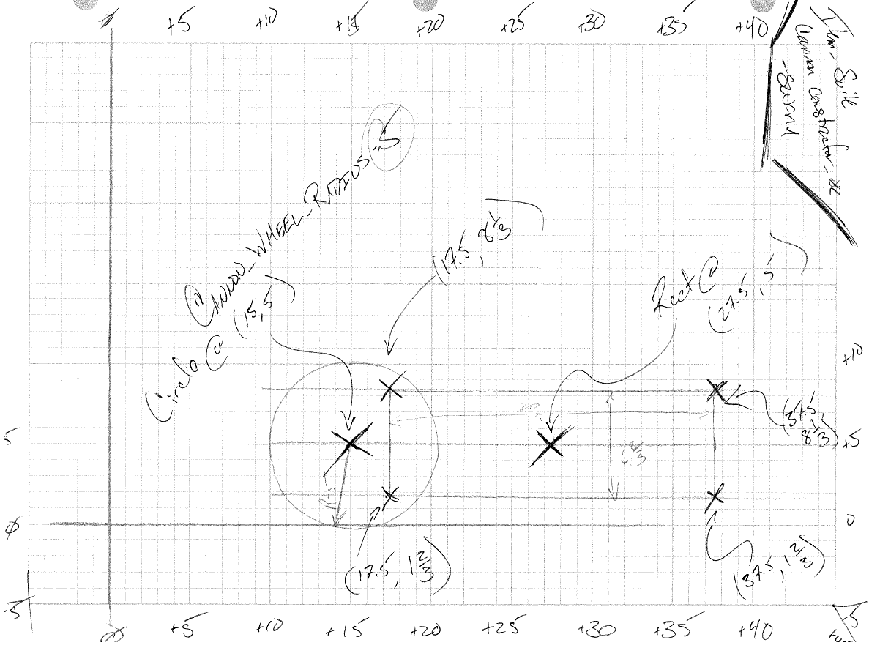

test notes :: cannon size values changed from initial sketch; sketch not re-drawn to reflect amendments to test

// Cannon constructor equivalence { part 2 }

@Test

**public** **void** test_cannon_10_02_00_constructor_equivalence() {

// Cannon object

Cannon the_new_cannon = **new** Cannon(15, *FIVE*, *ZERO*);

// Composite Shape

Shape the_shape = (Shape) the_new_cannon.get_shape();

// Composite List

ArrayList<Shape> the_list = the_shape.get_composite_list();

// Admin arrays

**float**[] tracking_one, tracking_two;

// Internal shape iterator

Shape inner_shape = the_list.get(*ZERO*);

// Non-assert testing --> same effect different angle of attack

**if** ( ! (inner_shape **instanceof** Circle) ) {

*fail*(" test_cannon_10_02_00_constructor_equivalence --> First shape should be a circle");

}

tracking_one = inner_shape.get_location();

**if** ( ! ( tracking_one[*ZERO*] == 15 ) ) {

*fail*(" test_cannon_10_01_00_constructor_equivalence --> Circle X-coord");

}

**if** ( ! ( tracking_one[*ONE*] == 5 ) ) {

*fail*(" test_cannon_10_01_00_constructor_equivalence --> Circle Y-coord");

}

**if** ( ! ( tracking_one[*TWO*] == *ZERO* ) ) {

*fail*(" test_cannon_10_01_00_constructor_equivalence --> Circle Z-coord");

}

inner_shape = the_list.get(*ONE*);

**if** ( ! (inner_shape **instanceof** Rectangle) ) {

*fail*(" test_cannon_10_02_00_constructor_equivalence --> Second shape should be a rectangle");

}

Node head = inner_shape.get_head_point();

tracking_two = head.get_location();

*assertEquals*(tracking_two[*ZERO*], 127.5, *A_THOUSANDTH*);

*assertEquals*(tracking_two[*ONE*], 21.667, *A_THOUSANDTH*);

*assertEquals*(tracking_two[*TWO*], *ZERO*, *A_THOUSANDTH*);

head = head.get_next();

tracking_two = head.get_location();

*assertEquals*(tracking_two[*ZERO*], 127.5, *A_THOUSANDTH*);

*assertEquals*(tracking_two[*ONE*], -11.667, *A_THOUSANDTH*);

*assertEquals*(tracking_two[*TWO*], *ZERO*, *A_THOUSANDTH*);

head = head.get_next();

tracking_two = head.get_location();

*assertEquals*(tracking_two[*ZERO*], 27.5, *A_THOUSANDTH*);

*assertEquals*(tracking_two[*ONE*], -11.667, *A_THOUSANDTH*);

*assertEquals*(tracking_two[*TWO*], *ZERO*, *A_THOUSANDTH*);

head = head.get_next();

tracking_two = head.get_location();

*assertEquals*(tracking_two[*ZERO*], 27.5, *A_THOUSANDTH*);

*assertEquals*(tracking_two[*ONE*], 21.667, *A_THOUSANDTH*);

*assertEquals*(tracking_two[*TWO*], *ZERO*, *A_THOUSANDTH*);

}

module :: Item/Cannon.java

test/design :: test_cannon_10_01_00_constructor_equivalence

description :: cannon class design and relational math equations; text flexibility installation

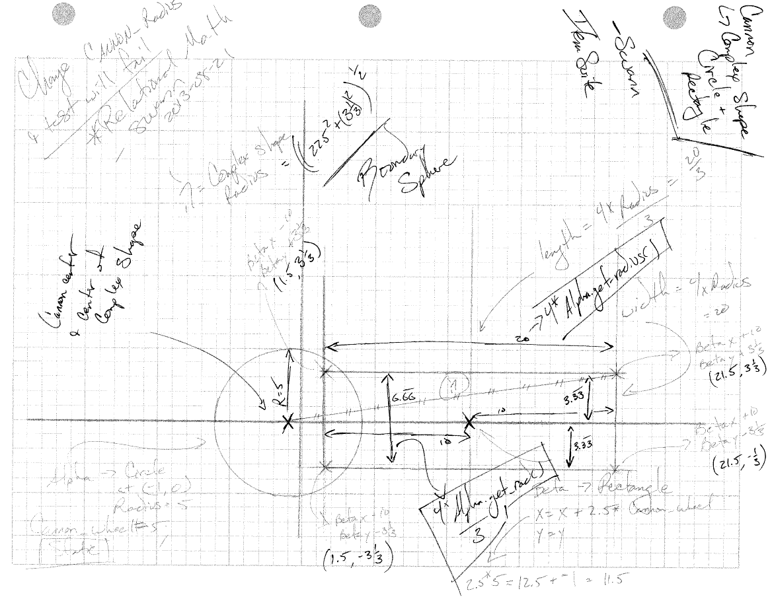

test notes :: verification of relative mathematics on cannon aspect proportions

// Cannon constructor equivalence { part 1 }

@Test

**public** **void** test_cannon_10_01_00_constructor_equivalence() {

// Cannon object

Cannon the_new_cannon = **new** Cannon(*NEGATIVE_ONE*, *ZERO*, *ZERO*);

// Composite Shape

Shape the_shape = (Shape) the_new_cannon.get_shape();

// Composite List

ArrayList<Shape> the_list = the_shape.get_composite_list();

// Admin arrays

**float**[] tracking_one, tracking_two;

// Internal shape iterator

Shape inner_shape = the_list.get(*ZERO*);

// Non-assert testing --> same effect different angle of attack

**if** ( ! (inner_shape **instanceof** Circle) ) {

*fail*(" test_cannon_10_01_00_constructor_equivalence --> First shape should be a circle");

}

tracking_one = inner_shape.get_location();

**if** ( ! ( tracking_one[*ZERO*] == *NEGATIVE_ONE* ) ) {

*fail*(" test_cannon_10_01_00_constructor_equivalence --> Circle X-coord");

}

**if** ( ! ( tracking_one[*ONE*] == *ZERO* ) ) {

*fail*(" test_cannon_10_01_00_constructor_equivalence --> Circle Y-coord");

}

**if** ( ! ( tracking_one[*TWO*] == *ZERO* ) ) {

*fail*(" test_cannon_10_01_00_constructor_equivalence --> Circle Z-coord");

}

**float** radius = inner_shape.get_radius();

inner_shape = the_list.get(*ONE*);

**if** ( ! (inner_shape **instanceof** Rectangle) ) {

*fail*(" test_cannon_10_01_00_constructor_equivalence --> Second shape should be a rectangle");

}

Node head = inner_shape.get_head_point();

tracking_two = head.get_location();

**if** ( ! ( tracking_two[*ZERO*] == tracking_one[*ZERO*]+4.5*radius ) ) {

*fail*(" test_cannon_10_01_00_constructor_equivalence --> point one X-coord");

}

**if** ( Math.*abs*(tracking_two[*ONE*] - tracking_one[*ONE*]+2/3*radius) < *A_HUNDREDTH* ) {

*fail*(" test_cannon_10_01_00_constructor_equivalence --> point one Y-coord");

}

**if** ( ! ( tracking_two[*TWO*] == *ZERO* ) ) {

*fail*(" test_cannon_10_01_00_constructor_equivalence --> point one Z-coord");

}

head = head.get_next();

tracking_two = head.get_location();

**if** ( ! ( tracking_two[*ZERO*] == tracking_one[*ZERO*]+4.5*radius ) ) {

*fail*(" test_cannon_10_01_00_constructor_equivalence --> point two X-coord");

}

**if** ( Math.*abs*(tracking_two[*ONE*] - tracking_one[*ONE*]-2/3*radius) < *A_HUNDREDTH* ) {

*fail*(" test_cannon_10_01_00_constructor_equivalence --> point two Y-coord");

}

**if** ( ! ( tracking_two[*TWO*] == *ZERO* ) ) {

*fail*(" test_cannon_10_01_00_constructor_equivalence --> point two Z-coord");

}

head = head.get_next();

tracking_two = head.get_location();

**if** ( ! ( tracking_two[*ZERO*] == tracking_one[*ZERO*]+.5*radius ) ) {

*fail*(" test_cannon_10_01_00_constructor_equivalence --> point three X-coord");

}

**if** ( Math.*abs*(tracking_two[*ONE*] - tracking_one[*ONE*]-2/3*radius) < *A_HUNDREDTH* ) {

*fail*(" test_cannon_10_01_00_constructor_equivalence --> point three Y-coord");

}

**if** ( ! ( tracking_two[*TWO*] == *ZERO* ) ) {

*fail*(" test_cannon_10_01_00_constructor_equivalence --> point three Z-coord");

}

head = head.get_next();

tracking_two = head.get_location();

**if** ( ! ( tracking_two[*ZERO*] == tracking_one[*ZERO*]+.5*radius ) ) {

*fail*(" test_cannon_10_01_00_constructor_equivalence --> point four X-coord");

}

**if** ( Math.*abs*(tracking_two[*ONE*] - tracking_one[*ONE*]+2/3*radius) < *A_HUNDREDTH* ) {

*fail*(" test_cannon_10_01_00_constructor_equivalence --> point four Y-coord");

}

**if** ( ! ( tracking_two[*TWO*] == *ZERO* ) ) {

*fail*(" test_cannon_10_01_00_constructor_equivalence --> point four Z-coord");

}

}

module :: Item/Drop_Tower.java

test/design :: test_drop_tower_10_01_00_swing_arm_generation

description :: drop tower class design and constructor verification with generation of attached swing arm

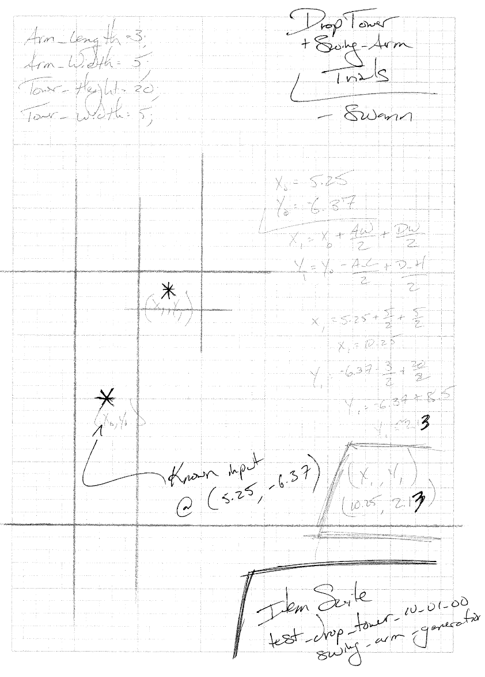

test notes :: verification of non-relative mathematics on drop tower and related swing arm constructors

// DropTower.swing_arm_generation()

@Test

**public** **void** test_drop_tower_10_01_00_swing_arm_generation() {

// Battery One

DropTower tower = **new** DropTower(*TEN*, 15, *ZERO*);

SwingArm swing_arm = tower.swing_arm_generation();

**float**[] location = swing_arm.get_location();

*assertEquals*(location[*ZERO*], (**float**) 15, *A_THOUSANDTH*);

*assertEquals*(location[*ONE*], (**float**) 23.5, *A_THOUSANDTH*);

*assertEquals*(location[*TWO*], (**float**) *ZERO*, *A_THOUSANDTH*);

// Battery Two

tower = **new** DropTower((**float**) 5.25, (**float**) -6.37, *ZERO*);

swing_arm = tower.swing_arm_generation();

location = swing_arm.get_location();

*assertEquals*(location[*ZERO*], (**float**) 10.25, *A_THOUSANDTH*);

*assertEquals*(location[*ONE*], (**float**) 2.13, *A_THOUSANDTH*);

*assertEquals*(location[*TWO*], (**float**) *ZERO*, *A_THOUSANDTH*);

}

module :: Item/Drop_Tower.java

test/design :: test_drop_tower_10_01_00_swing_arm_generation

function :: Drop_Tower(x_coord, y, coord, z_coord) && Drop_Tower.swing_arm_generation()

description :: relational math diagram of generated swing arm

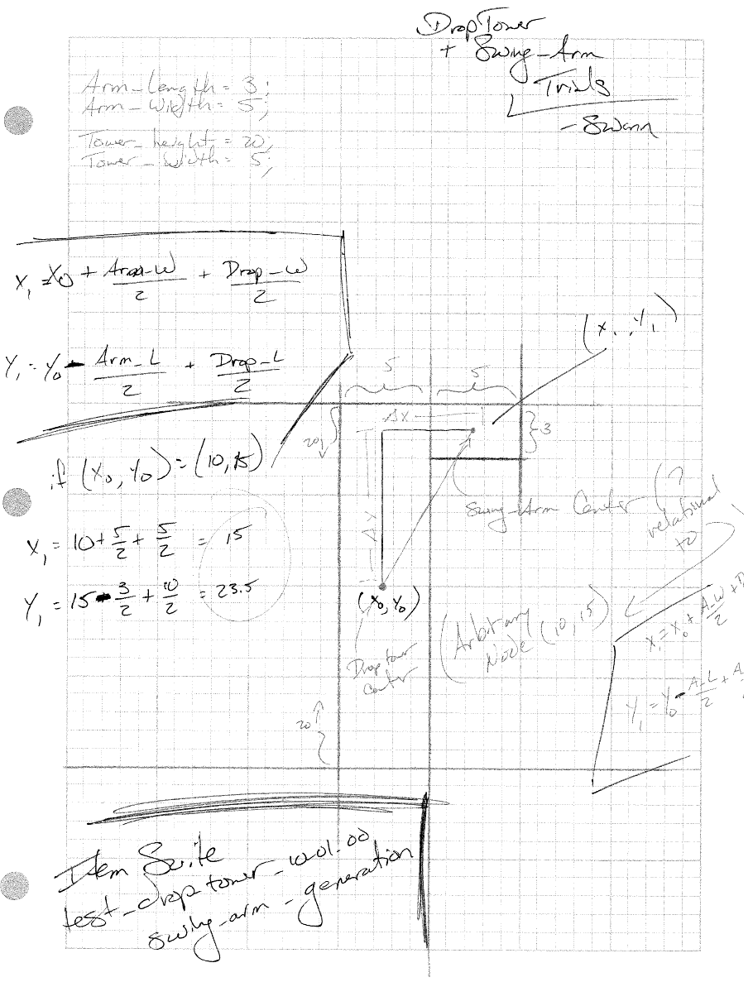

function notes :: implementation of relative mathematics on drop tower and related swing arm

/**

* Basic constructor for the DropTower Class taking parameters for the x, y, and z

* coordinates.

*

* Current 'z' parameter currently unused.

* ~swann 2013-11-06

*

* **@param** x_coordinate : Position on 'x' axis

* **@param** y_coordinate : Position on 'y' axis

* **@param** z_coordinate : Position on 'z' axis

*/

**public** DropTower( **float** x_coordinate, **float** y_coordinate, **float** z_coordinate ) {

**this**.set_interactive( **false** );

**this**.shape = **new** Rectangle( x_coordinate, y_coordinate, z_coordinate,

*TOWER_HEIGHT*, *TOWER_WIDTH*);

} // end DropTower()

/**

* Generates and returns a SwingArm object at a relative location to the current

* DropTower.

*

* **@return** { SwingArm } : Object generated in relation to the space occupied by the

* DropTower itself.

*/

**public** SwingArm swing_arm_generation( ) {

**float**[] location = **this**.get_location();

**float** x_prime = (**float**) ( location[*ZERO*] +

( SwingArm.*ARM_WIDTH*/(**float**)*TWO*) +

( DropTower.*TOWER_WIDTH*/(**float**)*TWO*));

**float** y_prime = (**float**) ( location[*ONE*] -

( SwingArm.*ARM_LENGTH*/(**float**)*TWO*) +

( DropTower.*TOWER_HEIGHT*/(**float**)*TWO*));

**float** z_prime = *ZERO*;

**return** **new** SwingArm( x_prime, y_prime, z_prime );

} // end DropTower.swing_arm_generation()

module :: Item/Photogate.java

test/design :: test_photogate_15_01_00_object_interaction

description :: battery of checks on photogate vs circular-objects; each should trip the gate

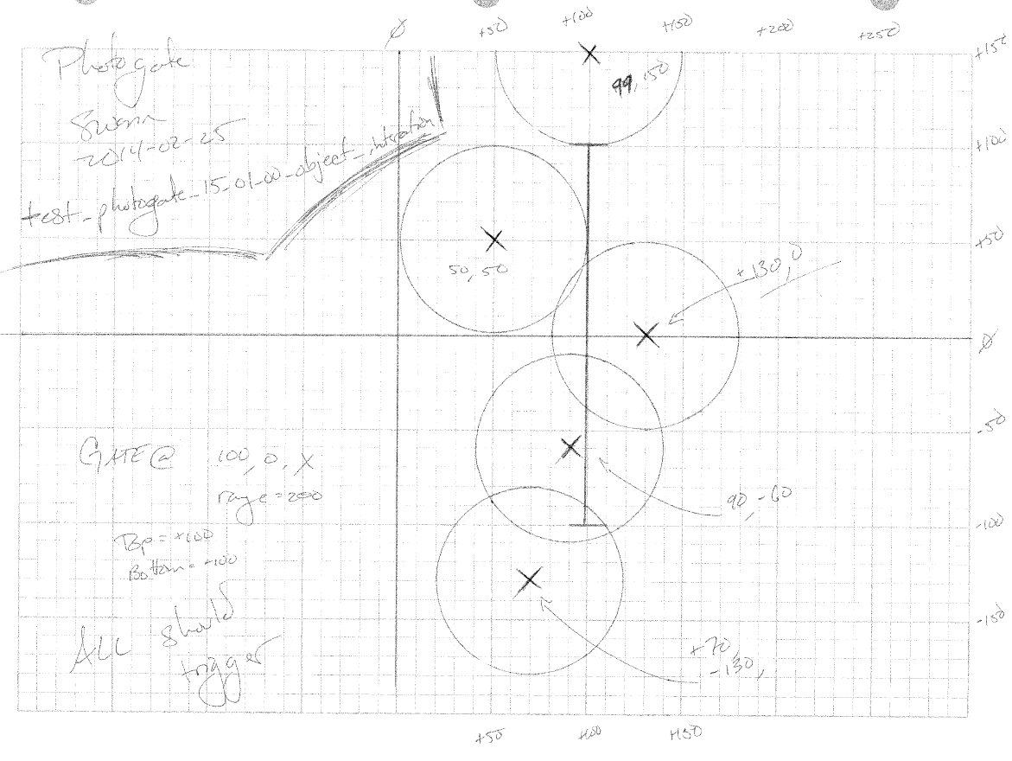

test notes :: design of interaction of circular objects with the photogate class

// Photogate object interaction tests

@Test

**public** **void** test_photogate_15_01_00_object_interaction() {

// The Setup

Ball alpha = Ball.*generate_Baseball*(99, 150, *ZERO*);

Ball beta = Ball.*generate_Baseball*(50, 50, *ZERO*);

Ball delta = Ball.*generate_Baseball*(130, 0, *ZERO*);

Ball gamma = Ball.*generate_Baseball*(90, -60, *ZERO*);

Ball iota = Ball.*generate_Baseball*(70, -130, *ZERO*);

Photogate gate_one = **new** Photogate( 100, 0, *ZERO*,

100, Photogate.axis_enumeration.*X*, 200);

// Each circle should trip the gate

*assertEquals*(gate_one.is_tripped_by( alpha ), **true**);

*assertEquals*(gate_one.is_tripped_by( beta ), **true**);

*assertEquals*(gate_one.is_tripped_by( delta ), **true**);

*assertEquals*(gate_one.is_tripped_by( gamma ), **true**);

*assertEquals*(gate_one.is_tripped_by( iota ), **true**);

}

function notes :: implementation of related is_tripped_by( )

/**

* Returns true or false depending on whether or not the object tripped the gate by

* entering the area of influence.

*

* **@param** { Actor_Object } : Any Actor_Object with a Shape

*

* **@return** { boolean } : True if the current placement of the Actor_Object trips the gate.

*/

**public** **boolean** is_tripped_by( Actor_Object the_object ) {

**boolean** output = **false**;

**switch** ( **this**.axis ) {

**case** *X*:

**if** ( the_object.get_y_position() <= **this**.ranged_axis_top &&

the_object.get_y_position() >= **this**.ranged_axis_bottom &&

( the_object.shape.get_high_bound_x_projection() >= **this**.fixed_axis_value &&

the_object.shape.get_low_bound_x_projection() <= **this**.fixed_axis_value )) {

output = **true**;

}

**else** {

Node top_node = **new** Node(**this**.fixed_axis_value, **this**.ranged_axis_top, *ZERO*);

Node bot_node = **new** Node(**this**.fixed_axis_value, **this**.ranged_axis_bottom, *ZERO*);

**if** ( Collision.*point_inside_shape*(top_node, the_object.get_shape()) ) {

output = **true**;

}

**if** ( Collision.*point_inside_shape*(bot_node, the_object.get_shape()) ) {

output = **true**;

}

}

**break**;

**case** *Y*:

**if** ( the_object.get_x_position() <= **this**.ranged_axis_top &&

the_object.get_x_position() >= **this**.ranged_axis_bottom &&

( the_object.shape.get_high_bound_y_projection() >= **this**.fixed_axis_value &&

the_object.shape.get_low_bound_y_projection() <= **this**.fixed_axis_value )) {

output = **true**;

}

**else** {

Node top_node = **new** Node(**this**.ranged_axis_top, **this**.fixed_axis_value, *ZERO*);

Node bot_node = **new** Node(**this**.ranged_axis_bottom, **this**.fixed_axis_value, *ZERO*);

**if** ( Collision.*point_inside_shape*(top_node, the_object.shape) ) {

output = **true**;

}

**if** ( Collision.*point_inside_shape*(bot_node, the_object.shape) ) {

output = **true**;

}

}

**break**;

} // end switch

**return** output;

} // end Photogate.is_tripped_by()

module :: Item/Photogate.java

test/design :: test_photogate_15_02_00_object_interaction

description :: battery of checks on photogate vs polygon-objects; each should trip the gate

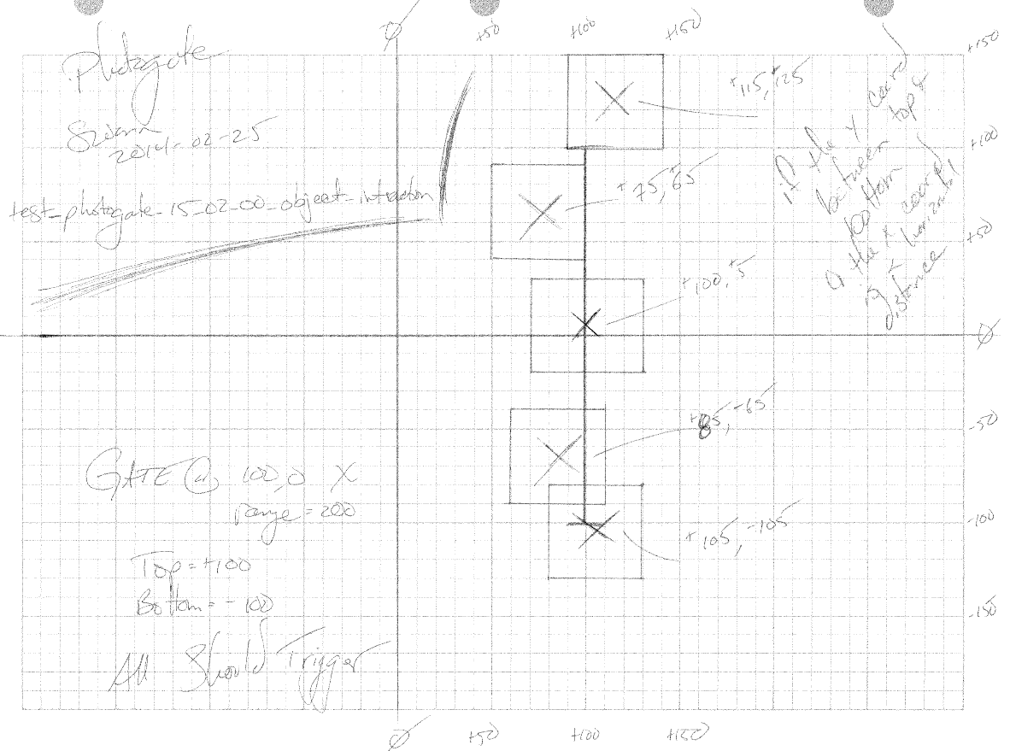

test notes :: design of interaction of polygon objects with the photogate class

// Photogate object interaction tests

@Test

**public** **void** test_photogate_15_02_00_object_interaction() {

// The Setup

Standard_Mass alpha = Standard_Mass.*generate_fifty_g_mass*(115, 125, *ZERO*);

Standard_Mass beta = Standard_Mass.*generate_fifty_g_mass*(75, 65, *ZERO*);

Standard_Mass delta = Standard_Mass.*generate_fifty_g_mass*(100, 5, *ZERO*);

Standard_Mass gamma = Standard_Mass.*generate_fifty_g_mass*(85, -65, *ZERO*);

Standard_Mass iota = Standard_Mass.*generate_fifty_g_mass*(105,-105, *ZERO*);

Photogate gate_one = **new** Photogate( 100, 0, *ZERO*,

100, Photogate.axis_enumeration.*X*, 200);

// Each circle should trip the gate

*assertEquals*(gate_one.is_tripped_by( alpha ), **true**);

*assertEquals*(gate_one.is_tripped_by( beta ), **true**);

*assertEquals*(gate_one.is_tripped_by( delta ), **true**);

*assertEquals*(gate_one.is_tripped_by( gamma ), **true**);

*assertEquals*(gate_one.is_tripped_by( iota ), **true**);

}

module :: Item/Photogate.java

test/design :: test_photogate_15_03_00_object_interaction

description :: battery of checks on photogate objects; none should trip the gate

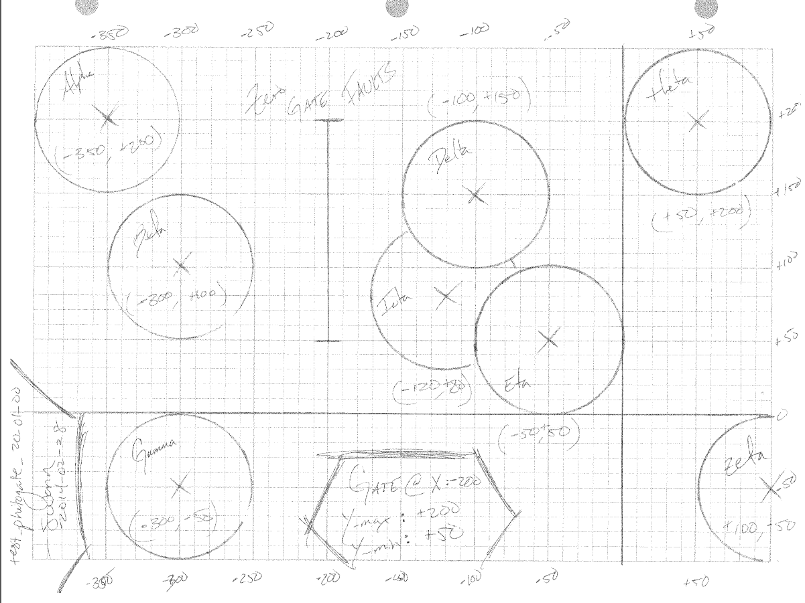

test notes :: designed for above_list && below_list tracking; doubled as a set of non-tripping objects

// Photogate object interaction tests

@Test

**public** **void** test_photogate_15_03_00_object_interaction() {

// The Setup

Ball alpha = Ball.*generate_Baseball*( -350, 200, *ZERO* );

Ball beta = Ball.*generate_Baseball*( -300, 100, *ZERO* );

Ball gamma = Ball.*generate_Baseball*( -300, -50, *ZERO* );

Ball delta = Ball.*generate_Baseball*( -100, 150, *ZERO* );

Ball iota = Ball.*generate_Baseball*( -120, 80, *ZERO* );

Ball eta = Ball.*generate_Baseball*( -50, 50, *ZERO* );

Ball theta = Ball.*generate_Baseball*( 50, 200, *ZERO* );

Ball zeta = Ball.*generate_Baseball*( 100, -50, *ZERO* );

Photogate the_gate = **new** Photogate( -200, 125, *ZERO*,

-200, Photogate.axis_enumeration.*X*, 150);

// Each circle should NOT trip the gate

*assertEquals*(the_gate.is_tripped_by( alpha ), **false**);

*assertEquals*(the_gate.is_tripped_by( beta ), **false**);

*assertEquals*(the_gate.is_tripped_by( gamma ), **false**);

*assertEquals*(the_gate.is_tripped_by( delta ), **false**);

*assertEquals*(the_gate.is_tripped_by( iota ), **false**);

*assertEquals*(the_gate.is_tripped_by( eta ), **false**);

*assertEquals*(the_gate.is_tripped_by( theta ), **false**);

*assertEquals*(the_gate.is_tripped_by( zeta ), **false**);

}

module :: Item/Photogate.java

test/design :: test_photogate_15_04_00_object_interaction

description :: battery of checks on photogate objects; none should trip the gate

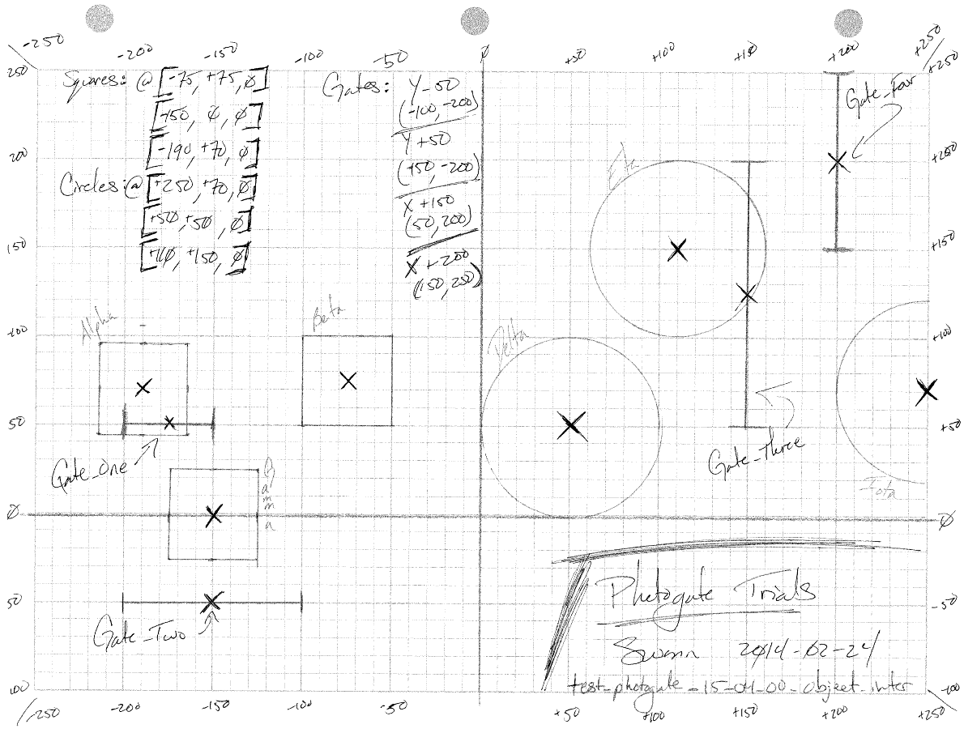

test notes :: design of heterogeneous interaction with photogates; some gates tripped in static state, some not;

tracking of tripped/locked status along with the object responsible for the locked state

// Photogate object interaction tests

@Test

**public** **void** test_photogate_15_04_00_object_interaction() {

// The Setup

// Objects with simple objects

Standard_Mass alpha = Standard_Mass.*generate_fifty_g_mass*(-190, 70, *ZERO*),

beta = Standard_Mass.*generate_fifty_g_mass*(-75, 75, *ZERO*),

gamma = Standard_Mass.*generate_fifty_g_mass*(-150, *ZERO*, *ZERO*);

Ball delta = Ball.*generate_Baseball*(50, 50, *ZERO*),

eta = Ball.*generate_Baseball*(110, 150, *ZERO*),

iota = Ball.*generate_Baseball*(250, 70, *ZERO*);

alpha.set_label("alpha");

beta.set_label("beta");

gamma.set_label("gamma");

delta.set_label("delta");

eta.set_label("eta");

iota.set_label("iota");

ArrayList<Actor_Object> interaction_list = **new** ArrayList<Actor_Object>();

interaction_list.add(alpha);

interaction_list.add(beta);

interaction_list.add(gamma);

interaction_list.add(delta);

interaction_list.add(eta);

interaction_list.add(iota);

// Gates

Photogate gate_one = **new** Photogate( -175, 50, *ZERO*,

50, Photogate.axis_enumeration.*Y*, 50),

gate_two = **new** Photogate( -150, -50, *ZERO*,

-50, Photogate.axis_enumeration.*Y*, 100),

gate_tre = **new** Photogate( 125, 125, *ZERO*,

150, Photogate.axis_enumeration.*X*, 150),

gate_for = **new** Photogate( 200, 200, *ZERO*,

200, Photogate.axis_enumeration.*X*, 100);

gate_one.update_information(interaction_list, *ZERO*);

*assertEquals*(gate_one.is_locked(), **true**);

*assertEquals*(gate_one.get_object_which_tripped(), alpha);

gate_two.update_information(interaction_list, *ZERO*);

*assertEquals*(gate_two.is_locked(), **false**);

*assertEquals*(gate_two.get_object_which_tripped(), **null**);

gate_tre.update_information(interaction_list, *ZERO*);

*assertEquals*(gate_tre.is_locked(), **true**);

*assertEquals*(gate_tre.get_object_which_tripped(), eta);

gate_for.update_information(interaction_list, *ZERO*);

*assertEquals*(gate_for.is_locked(), **false**);

*assertEquals*(gate_for.get_object_which_tripped(), **null**);

}

module :: Item/Photogate.java

test/design :: test_photogate_15_05_00_object_interaction

description :: battery of checks on photogates with static state; beginning work on the ‘clipping algorithm’

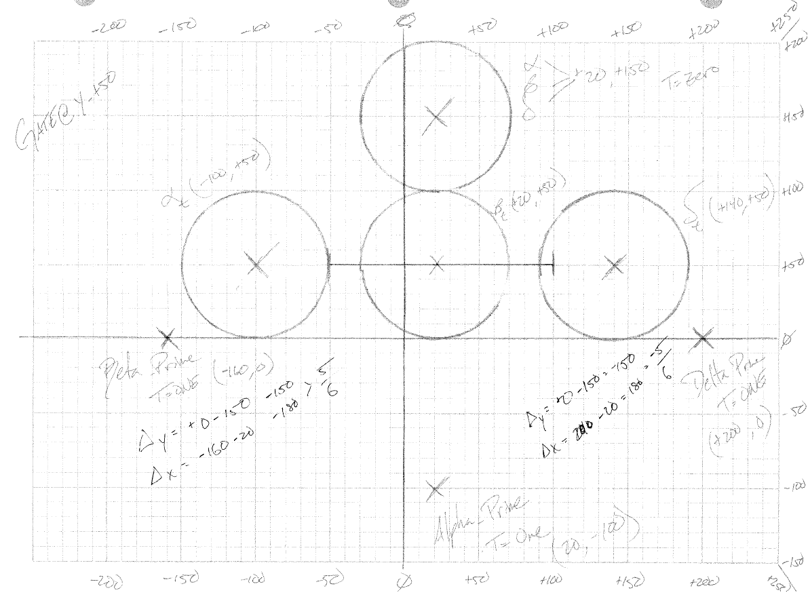

test notes :: design of heterogeneous interaction with photogates; some gates tripped in static state, some not;

tracking of tripped/locked status along with the object responsible for the locked state

// Photogate object interaction tests

@Test

**public** **void** test_photogate_15_05_00_object_interaction() {

// The Setup

Ball alpha_knot = Ball.*generate_Baseball*( 20, 150, *ZERO* );

Ball beta_knot = Ball.*generate_Baseball*( 20, 150, *ZERO* );

Ball delta_knot = Ball.*generate_Baseball*( 20, 150, *ZERO* );

Ball alpha_intra = Ball.*generate_Baseball*((**float**)99.99999, 50, *ZERO* );

Ball beta_intra = Ball.*generate_Baseball*( 20, 50, *ZERO* );

Ball delta_intra = Ball.*generate_Baseball*( 140, 50, *ZERO* );

Ball alpha_prime = Ball.*generate_Baseball*( -160, 0, *ZERO* );

Ball beta_prime = Ball.*generate_Baseball*( 20, -100, *ZERO* );

Ball delta_prime = Ball.*generate_Baseball*( 200, 0, *ZERO* );

Photogate gate_one = **new** Photogate( 25, 50, *ZERO*,

50, Photogate.axis_enumeration.*Y*, 150);

Photogate gate_two = **new** Photogate( 25, 50, *ZERO*,

50, Photogate.axis_enumeration.*Y*, 150);

Photogate gate_tre = **new** Photogate( 25, 50, *ZERO*,

50, Photogate.axis_enumeration.*Y*, 150);

Photogate gate_for = **new** Photogate( 25, 50, *ZERO*,

50, Photogate.axis_enumeration.*Y*, 150);

Photogate gate_fiv = **new** Photogate( 25, 50, *ZERO*,

50, Photogate.axis_enumeration.*Y*, 150);

Photogate gate_six = **new** Photogate( 25, 50, *ZERO*,

50, Photogate.axis_enumeration.*Y*, 150);

Photogate gate_svn = **new** Photogate( 25, 50, *ZERO*,

50, Photogate.axis_enumeration.*Y*, 150);

Photogate gate_ate = **new** Photogate( 25, 50, *ZERO*,

50, Photogate.axis_enumeration.*Y*, 150);

Photogate gate_nin = **new** Photogate( 25, 50, *ZERO*,

50, Photogate.axis_enumeration.*Y*, 150);

// Each gate has a specific object that COULD trip it

// see designs for test_photogate_......................

// ~swann 2014-03-01

*assertEquals*(gate_one.is_tripped_by( alpha_knot ), **false**);

*assertEquals*(gate_two.is_tripped_by( beta_knot ), **false**);

*assertEquals*(gate_tre.is_tripped_by( delta_knot ), **false**);

*assertEquals*(gate_for.is_tripped_by( alpha_intra ), **true**);

*assertEquals*(gate_fiv.is_tripped_by( beta_intra ), **true**);

*assertEquals*(gate_six.is_tripped_by( delta_intra ), **true**);

*assertEquals*(gate_svn.is_tripped_by( alpha_prime ), **false**);

*assertEquals*(gate_ate.is_tripped_by( beta_prime ), **false**);

*assertEquals*(gate_nin.is_tripped_by( delta_prime ), **false**);

}

module :: Item/Photogate.java

test/design :: test_photogate_20_01_00_populate_new_lists

functions :: Photogate.populate_new_above_list() && Photogate.populate_new_below_list() &&

Photogate.populate_new_swapped_list()

description :: used to determine which objects are above or below the gate; to be used within the ‘clipping algorithm’



test notes :: algorithms used to determine which objects have switched sides in relation to the photogate; to be used as

support functionality in connection to the ‘clipping algorithm’ which determines whether an object passed

over a gate tripping it between time-steps and if multiple objects did so, which was first to trip the gate

// Photogate.populate_new_lists()

// --> Photogate.populate_new_above_list()

// --> Photogate.populate_new_below_list()

// --> Photogate.produce_swapped_list()

@Test

**public** **void** test_photogate_20_01_00_populate_new_lists() {

// The Setup

Ball alpha = Ball.*generate_Baseball*( -350, 200, *ZERO* );

Ball beta = Ball.*generate_Baseball*( -300, 100, *ZERO* );

Ball gamma = Ball.*generate_Baseball*( -300, -50, *ZERO* );

Ball delta = Ball.*generate_Baseball*( -100, 150, *ZERO* );

Ball iota = Ball.*generate_Baseball*( -120, 80, *ZERO* );

Ball eta = Ball.*generate_Baseball*( -50, 50, *ZERO* );

Ball theta = Ball.*generate_Baseball*( 50, 200, *ZERO* );

Ball zeta = Ball.*generate_Baseball*( 100, -50, *ZERO* );

ArrayList<Actor_Object> swapped_list = **new** ArrayList<Actor_Object>();

ArrayList<Actor_Object> above_list_one = **new** ArrayList<Actor_Object>();

ArrayList<Actor_Object> below_list_one = **new** ArrayList<Actor_Object>();

ArrayList<Actor_Object> above_list_two = **new** ArrayList<Actor_Object>();

ArrayList<Actor_Object> below_list_two = **new** ArrayList<Actor_Object>();

ArrayList<Actor_Object> interaction_list = **new** ArrayList<Actor_Object>();

Photogate the_gate = **new** Photogate( -200, 125, *ZERO*,

-200, Photogate.axis_enumeration.*X*, 150);

alpha.set_label("alpha");

beta.set_label("beta");

gamma.set_label("gamma");

delta.set_label("delta");

eta.set_label("eta");

iota.set_label("iota");

theta.set_label("theta");

zeta.set_label("zeta");

interaction_list.add( alpha );

interaction_list.add( beta );

interaction_list.add( gamma );

interaction_list.add( delta );

interaction_list.add( iota );

interaction_list.add( eta );

interaction_list.add( theta );

interaction_list.add( zeta );

*assertEquals*(interaction_list.size(), *EIGHT*, *ZERO*);

*assertEquals*(below_list_one.size(), *ZERO*, *ZERO*);

*assertEquals*(above_list_one.size(), *ZERO*, *ZERO*);

// Initial State Assertions

below_list_one = the_gate.populate_new_below_list(interaction_list);

*assertEquals*(below_list_one.size(), *THREE*, *ZERO*);

above_list_one = the_gate.populate_new_above_list(interaction_list);

*assertEquals*(above_list_one.size(), *FIVE*, *ZERO*);

// Secondary State Assertions

alpha.update_location(350, 200, *ZERO*);

below_list_two = the_gate.populate_new_below_list(interaction_list);

*assertEquals*(below_list_two.size(), *TWO*, *ZERO*);

above_list_two = the_gate.populate_new_above_list(interaction_list);

*assertEquals*(above_list_two.size(), *SIX*, *ZERO*);

swapped_list = the_gate.produce_swapped_list( above_list_one, below_list_one,

above_list_two, below_list_two);

*assertEquals*(swapped_list.size(), *ONE*, *ZERO*);

**if** ( !swapped_list.contains( alpha )) {

*fail*("Secondary State Assertions");

}

// Tertiary State Assertions

theta.update_location(-400, 200, *ZERO*);

zeta.update_location( -500, -50, *ZERO*);

below_list_one = the_gate.populate_new_below_list(interaction_list);

*assertEquals*(below_list_one.size(), *FOUR*, *ZERO*);

above_list_one = the_gate.populate_new_above_list(interaction_list);

*assertEquals*(above_list_one.size(), *FOUR*, *ZERO*);

swapped_list = the_gate.produce_swapped_list( above_list_two, below_list_two,

above_list_one, below_list_one);

*assertEquals*(swapped_list.size(), *TWO*, *ZERO*);

**if** ( !swapped_list.contains( theta ) && !swapped_list.contains( zeta )) {

*fail*("Tertiary State Assertions");

}

// Return to Initial State and Re-Assert

alpha.update_location(-350, 200, *ZERO*);

theta.update_location( 50, 200, *ZERO*);

zeta.update_location( 100, 50, *ZERO*);

below_list_two = the_gate.populate_new_below_list(interaction_list);

*assertEquals*(below_list_two.size(), *THREE*, *ZERO*);

above_list_two = the_gate.populate_new_above_list(interaction_list);

*assertEquals*(above_list_two.size(), *FIVE*, *ZERO*);

swapped_list = the_gate.produce_swapped_list( above_list_one, below_list_one,

above_list_two, below_list_two);

*assertEquals*(swapped_list.size(), *THREE*, *ZERO*);

**if** ( !swapped_list.contains( theta ) && !swapped_list.contains( zeta ) &&

!swapped_list.contains( alpha )) {

*fail*("Return to Initial State and Re-Assert");

}

}

function notes :: implementation of the populate_new_below_list( )

/**

* Returns an ArrayList with the objects below the fixed point axis of the current

* photogate.

*

* **@param** { ArrayList<Actor_Object> } : List of Actor Objects from the working set.

*

* **@return** { ArrayList<Actor_Object> } : List of Actor Objects below the fixed point axis of the

* photogate.

*/

**public** ArrayList<Actor_Object> populate_new_below_list( ArrayList<Actor_Object> interaction_list ){

ArrayList<Actor_Object> below_list = **new** ArrayList<Actor_Object>();

**for** ( **int** i = *ZERO*; i < interaction_list.size() ; i ++ ) {

Actor_Object the_object = interaction_list.get(i);

**switch** ( **this**.axis ) {

**case** *X*:

// if the x-coord is below the fixed axis value add to below list,

// otherwise put it on the above list

**if** ( the_object.get_x_position() < **this**.fixed_axis_value ) {

below_list.add( the_object );

}

**break**;

**case** *Y*:

// if the y-coord is below the fixed axis value add to below list,

// otherwise put it on the above list

**if** ( the_object.get_y_position() < **this**.fixed_axis_value ) {

below_list.add( the_object );

}

**break**;

} // end switch

} // end iteration

**return** below_list;

}// end Photogate.populate_new_below_list()

function notes :: implementation of the populate_new_above_list( )

/**

* Returns an ArrayList with the objects above or equal to the fixed point axis of the current

* photogate.

*

* **@param** { ArrayList<Actor_Object> } : List of Actor Objects from the working set.

*

* **@return** { ArrayList<Actor_Object> } : List of Actor Objects above or equal to the fixed point

* axis of the photogate.

*/

**public** ArrayList<Actor_Object> populate_new_above_list( ArrayList<Actor_Object> interaction_list ){

ArrayList<Actor_Object> above_list = **new** ArrayList<Actor_Object>();

**for** ( **int** i = *ZERO*; i < interaction_list.size() ; i ++ ) {

Actor_Object the_object = interaction_list.get(i);

**switch** ( **this**.axis ) {

**case** *X*:

// if the x-coord is below the fixed axis value add to below list,

// otherwise put it on the above list

**if** ( the_object.get_x_position() >= **this**.fixed_axis_value ) {

above_list.add( the_object );

}

**break**;

**case** *Y*:

// if the y-coord is below the fixed axis value add to below list,

// otherwise put it on the above list

**if** ( the_object.get_y_position() >= **this**.fixed_axis_value ) {

above_list.add( the_object );

}

**break**;

} // end switch

} // end iteration

**return** above_list;

}// end Photogate.populate_new_above_list()

function notes :: implementation of the populate_swapped_list( )

/**

* Returns an array list of Actor Object that have swapped from a relative high or low position

* in regards to the photogate to the other designation. For instance, if an object was initially

* below the fixed axis point and a time step moved it to a position where it is now above that

* fixed point axis, then the object will appear in the swapped list.

*

* **@param** { old_above_list } : List of actor objects above the fixed point axis before the time step.

* **@param** { old_below_list } : List of actor objects below the fixed point axis before the time step.

* **@param** { new_above_list } : List of actor objects above the fixed point axis after the time step.

* **@param** { new_below_list } : List of actor objects below the fixed point axis after the time step.

*

* **@return** { ArrayList<Actor_Object> } : List of objects which have crossed the fixed point axis plane.

*/

**public** ArrayList<Actor_Object> produce_swapped_list( ArrayList<Actor_Object> old_above_list,

ArrayList<Actor_Object> old_below_list,

ArrayList<Actor_Object> new_above_list,

ArrayList<Actor_Object> new_below_list) {

ArrayList<Actor_Object> swapped_list = **new** ArrayList<Actor_Object>();

// Check for objects going from above to below

**for** ( **int** i = *ZERO* ; i < old_above_list.size(); i ++) {

**if** ( new_below_list.contains( old_above_list.get(i) )) {

swapped_list.add( old_above_list.get(i) );

}

} // end new_below_list iteration

// Check for objects going from below to above

**for** ( **int** i = *ZERO* ; i < old_below_list.size(); i ++) {

**if** ( new_above_list.contains( old_below_list.get(i) )) {

swapped_list.add( old_below_list.get(i) );

}

} // end new_below_list iteration

**return** swapped_list;

} // end Photogate.produce_swapped_list()

module :: Item/Photogate.java

test/design :: test_photogate_25_01_00_relocation_to_gate_plane

functions :: Photogate.relocation_to_gate_plane()

description :: design of functionality scripted to return an object’s state to the point when it passed the gate’s plane;

then call of static state check on interaction with the gate itself

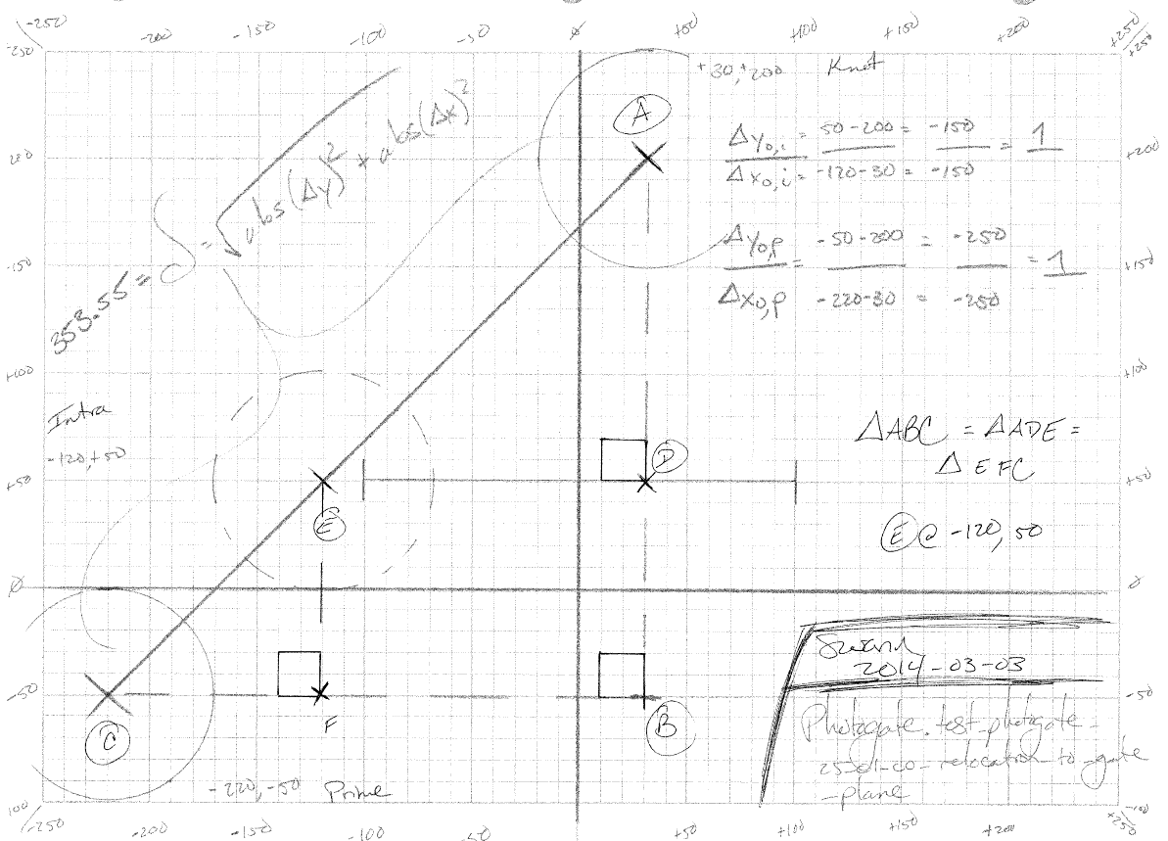

test notes :: object travels from point A to C in single time-step; should trip the gate as path includes location E

// Photogate.relocation_to_gate_plane()

@Test

**public** **void** test_photogate_25_01_00_relocation_to_gate_plane() {

// The Setup

Ball alpha = Ball.*generate_Baseball*(-220, -50, *ZERO*);

ArrayList<Actor_Object> interaction_list = **new** ArrayList<Actor_Object>();

interaction_list.add( alpha );

Photogate the_gate = **new** Photogate( *ZERO*, 50, *ZERO*,

50, Photogate.axis_enumeration.*Y*, 200);

// Pack velocity to full second

alpha.update_velocity(-250\**TIME_STEPS*, -250\**TIME_STEPS*, *ZERO*);

// relocation

the_gate.relocation_to_gate_plane( alpha );

*assertEquals*(the_gate.is_tripped_by( alpha ), **true**);

// intra-execute test peek

the_gate.update_information(interaction_list, *ZERO*);

*assertEquals*(the_gate.get_object_which_tripped(), alpha);

}

function notes :: implementation of relocation_to_gate_plane()

/**

* Repositions the passed actor object to the axis plan on which the gate itself exists.

*

* Nota Bene ::

* This is only to be used with objects having been flagged and added to the swapped item list.

* ~swann 2014-03-03

*

* **@param** { Actor_Object } : The object being re-positioned.

*/

**public** **void** relocation_to_gate_plane( Actor_Object the_object ) {

// Establish velocity vector for intra-step calculations

Vector object_velocity = **new** Vector( the_object.get_velocity() );

Vector time_step_velocity = Vector.*scalar_multiply*(object_velocity, *TIME_STEP*);

// tracking variables

**float** x_differential, y_differential, proportion,

x_position, y_position;

// axis dependent relative math

**switch**( **this**.axis ){

**case** *X*:

x_differential = Math.*abs*( the_object.get_x_position() - **this**.fixed_axis_value );

proportion = x_differential/Math.*abs*(time_step_velocity.get_x_comp());

y_differential = proportion*time_step_velocity.get_y_comp();

y_position = the_object.get_y_position() - y_differential;

the_object.update_location(**this**.fixed_axis_value, y_position, *ZERO*);

**break**;

**case** *Y*:

y_differential = Math.*abs*( the_object.get_y_position() - **this**.fixed_axis_value );

proportion = y_differential/Math.*abs*(time_step_velocity.get_y_comp());

x_differential = proportion*time_step_velocity.get_x_comp();

x_position = the_object.get_x_position() - x_differential;

the_object.update_location(x_position, **this**.fixed_axis_value, *ZERO*);

**break**;

}

} // end Photogate.relocation_to_gate_plane()

module :: Item/Photogate.java

test/design :: test_photogate_25_02_00_relocation_to_gate_plane

description :: design of functionality scripted to return an object’s state to the point when it passed the gate’s plane;

then call of static state check on interaction with the gate itself

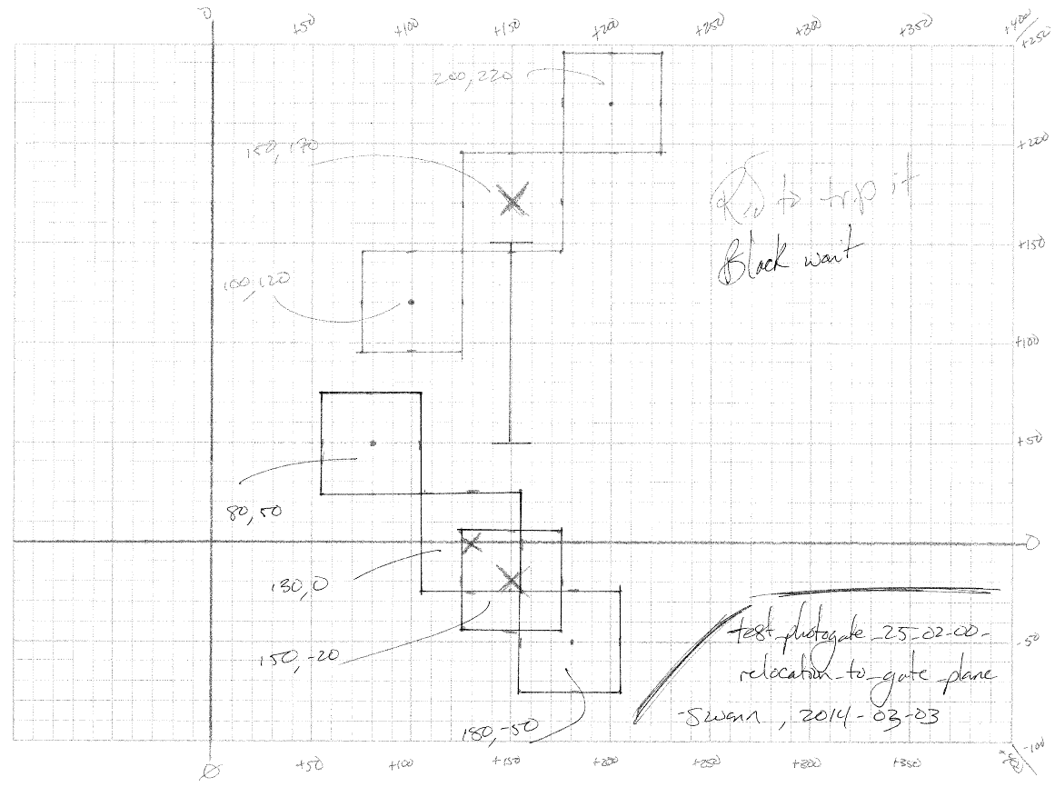

test notes :: explores an object just barely tripping the gate and one passing by without tripping it

// Photogate.relocation_to_gate_plane()

@Test

**public** **void** test_photogate_25_02_00_relocation_to_gate_plane() {

// The Setup

Standard_Mass alpha = Standard_Mass.*generate_one_g_mass*( 180, -50, *ZERO*);

Standard_Mass beta = Standard_Mass.*generate_five_g_mass*(200, 220, *ZERO*);

ArrayList<Actor_Object> interaction_list = **new** ArrayList<Actor_Object>();

interaction_list.add( alpha );

interaction_list.add( beta );

Photogate the_gate = **new** Photogate( 150, 100, *ZERO*,

150, Photogate.axis_enumeration.*X*, 100);

// Pack velocity to full second

alpha.update_velocity(100\**TIME_STEPS*, -100\**TIME_STEPS*, *ZERO*);

beta.update_velocity( 100\**TIME_STEPS*, 100\**TIME_STEPS*, *ZERO*);

// relocation

the_gate.relocation_to_gate_plane( alpha );

*assertEquals*(the_gate.is_tripped_by( alpha ), **false**);

*assertEquals*(alpha.get_x_position(), 150, *ZERO*);

*assertEquals*(alpha.get_y_position(), -20, *A_THOUSANDTH*);

the_gate.relocation_to_gate_plane( beta );

*assertEquals*(the_gate.is_tripped_by( beta ), **true**);

*assertEquals*(beta.get_x_position(), 150, *ZERO*);

*assertEquals*(beta.get_y_position(), 170, *ZERO*);

// intra-execute test peek

the_gate.update_information(interaction_list, *ZERO*);

*assertEquals*(the_gate.get_object_which_tripped(), beta);

}

module :: Item/Photogate.java

test/design :: test_photogate_30_01_00_correct_trigger_event && test_photogate_30_02_00_correct_trigger_event

&& test_photogate_30_03_00_correct_trigger_event

description :: design of the functionality to determine which object tripped the gate first; includes clipping and static

state objects

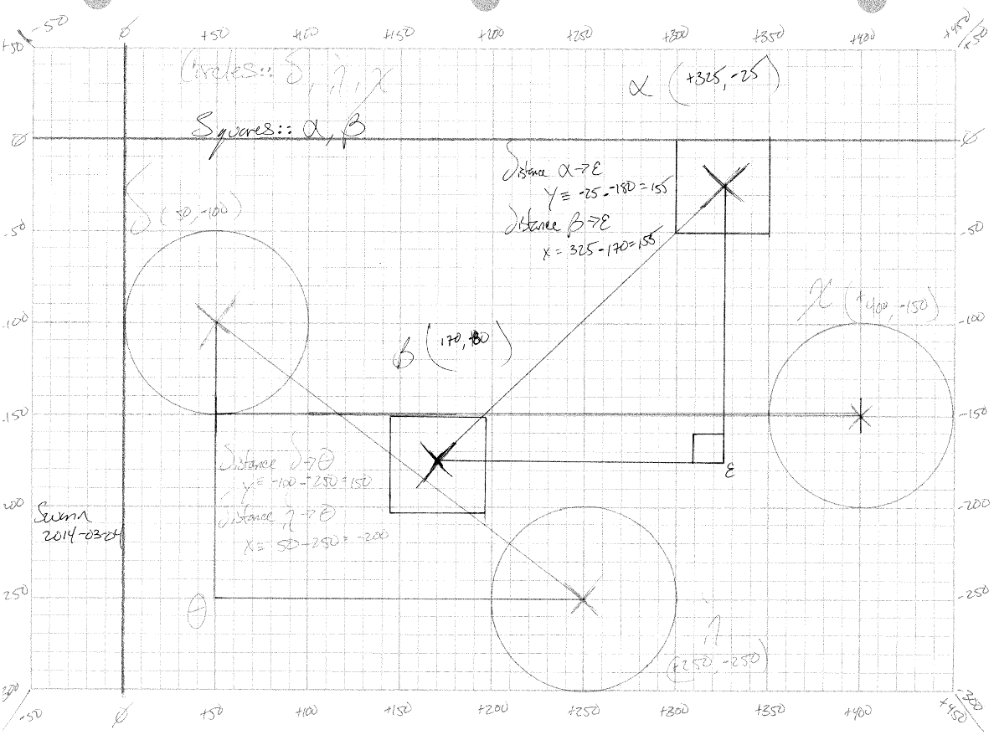

test notes :: explores full battery of use cases for photogate; clipping and static state objects with recognition as to

which object tripped it first

// Photogate test --> multiple objects pass through the gate, which one is first

@Test

**public** **void** test_photogate_30_01_00_correct_trigger_event() {

// The Setup

Standard_Mass alpha = Standard_Mass.*generate_fifty_g_mass*(325, -25, *ZERO*);

Ball delta = Ball.*generate_Baseball*( 50, 99, *ZERO*);

Photogate the_gate = **new** Photogate( 225, -150, *ZERO*,

-150, Photogate.axis_enumeration.*Y*, 350);

ArrayList<Actor_Object> interaction_list = **new** ArrayList<Actor_Object>();

interaction_list.add( delta );

interaction_list.add( alpha );

// Pack velocity to full second

alpha.update_velocity( 155\**TIME_STEPS*, 155\**TIME_STEPS*, *ZERO*);

delta.update_velocity(-200\**TIME_STEPS*, 150\**TIME_STEPS*, *ZERO*);

the_gate.relocation_to_gate_plane( alpha );

*assertEquals*(the_gate.is_tripped_by( alpha ), **true**);

the_gate.relocation_to_gate_plane( delta );

*assertEquals*(the_gate.is_tripped_by( delta ), **true**);

// intra-execute test peek

the_gate.update_information(interaction_list, *ZERO*);

*assertEquals*(the_gate.get_object_which_tripped(), delta);

}

// Photogate test --> multiple objects pass through the gate, which one is first

@Test

**public** **void** test_photogate_30_02_00_correct_trigger_event() {

// The Setup

Standard_Mass alpha = Standard_Mass.*generate_fifty_g_mass*(325, -25, *ZERO*);

Ball delta = Ball.*generate_Baseball*( 50, 99, *ZERO*);

Photogate the_gate = **new** Photogate( 225, -150, *ZERO*,

-150, Photogate.axis_enumeration.*Y*, 350);

ArrayList<Actor_Object> interaction_list = **new** ArrayList<Actor_Object>();

interaction_list.add( alpha );

interaction_list.add( delta );

// Pack velocity to full second

alpha.update_velocity( 155\**TIME_STEPS*, 155\**TIME_STEPS*, *ZERO*);

delta.update_velocity(-200\**TIME_STEPS*, 150\**TIME_STEPS*, *ZERO*);

the_gate.relocation_to_gate_plane( alpha );

*assertEquals*(the_gate.is_tripped_by( alpha ), **true**);

the_gate.relocation_to_gate_plane( delta );

*assertEquals*(the_gate.is_tripped_by( delta ), **true**);

// intra-execute test peek

the_gate.update_information(interaction_list, *ZERO*);

*assertEquals*(the_gate.get_object_which_tripped(), alpha);

}

// Photogate test --> multiple objects pass through the gate, which one is first

@Test

**public** **void** test_photogate_30_03_00_correct_trigger_event() {

// The Setup

Standard_Mass alpha = Standard_Mass.*generate_fifty_g_mass*(325, -25, *ZERO*);

Ball delta = Ball.*generate_Baseball*( 50, 99, *ZERO*);

Ball chi = Ball.*generate_Baseball*(400, -150, *ZERO*);

Photogate the_gate = **new** Photogate( 225, -150, *ZERO*,

-150, Photogate.axis_enumeration.*Y*, 350);

ArrayList<Actor_Object> interaction_list = **new** ArrayList<Actor_Object>();

interaction_list.add( alpha );

interaction_list.add( delta );

interaction_list.add( chi );

// Pack velocity to full second

alpha.update_velocity( 155\**TIME_STEPS*, 155\**TIME_STEPS*, *ZERO*);

delta.update_velocity(-200\**TIME_STEPS*, 150\**TIME_STEPS*, *ZERO*);

// intra-execute test peek

the_gate.update_information(interaction_list, *ZERO*);

*assertEquals*(the_gate.get_object_which_tripped(), chi);

}

module :: Item/Shape.java

test/design :: test_circle_15_01_00_projection_returns && test_square_15_01_00_projection_returns

&& test_rectangle_15_01_00_projection_returns

description :: design of the functionality to determine the x and y axis projections of a given shape

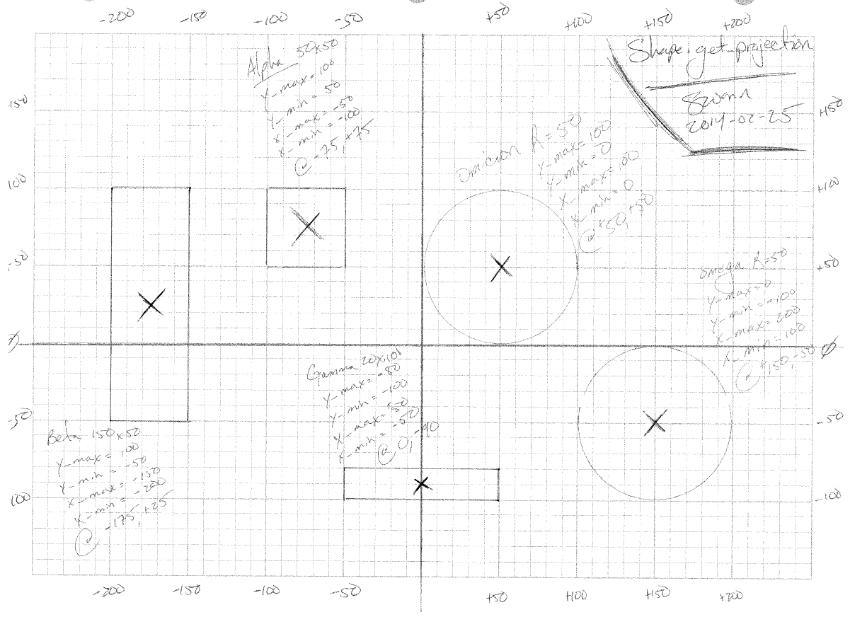

test notes :: explores full battery of shapes and their related projections on the x and y axis

// Circle Projection F(x)'s Suite

// --> Circle.get_x_projection()

// --> Cricle.get_low_bound_x_projection()

// --> Cricle.get_high_bound_x_projection()

//

// --> Circle.get_y_projection()

// --> Cricle.get_low_bound_y_projection()

// --> Cricle.get_low_bound_x_projection()

@Test

**public** **void** test_circle_15_01_00_projection_returns() {

// The Setup

Circle omicron = **new** Circle(50, 50, *ZERO*, 50);

Circle omega = **new** Circle(150, -50, *ZERO*, 50);

// Omicron Battery

*assertEquals*( omicron.get_high_bound_x_projection(), 100, *ZERO* );

*assertEquals*( omicron.get_low_bound_x_projection(), 0, *ZERO* );

*assertEquals*( omicron.get_high_bound_y_projection(), 100, *ZERO* );

*assertEquals*( omicron.get_low_bound_y_projection(), 0, *ZERO* );

*assertEquals*( omicron.get_high_bound_x_projection(), omicron.get_x_projection()[*ONE*], *ZERO* );

*assertEquals*( omicron.get_low_bound_x_projection(), omicron.get_x_projection()[*ZERO*], *ZERO* );

*assertEquals*( omicron.get_high_bound_y_projection(), omicron.get_y_projection()[*ONE*], *ZERO* );

*assertEquals*( omicron.get_low_bound_y_projection(), omicron.get_y_projection()[*ZERO*], *ZERO* );

// Omega Battery

*assertEquals*( omega.get_high_bound_x_projection(), 200, *ZERO* );

*assertEquals*( omega.get_low_bound_x_projection(), 100, *ZERO* );

*assertEquals*( omega.get_high_bound_y_projection(), 0, *ZERO* );

*assertEquals*( omega.get_low_bound_y_projection(), -100, *ZERO* );

*assertEquals*( omega.get_high_bound_x_projection(), omega.get_x_projection()[*ONE*], *ZERO* );

*assertEquals*( omega.get_low_bound_x_projection(), omega.get_x_projection()[*ZERO*], *ZERO* );

*assertEquals*( omega.get_high_bound_y_projection(), omega.get_y_projection()[*ONE*], *ZERO* );

*assertEquals*( omega.get_low_bound_y_projection(), omega.get_y_projection()[*ZERO*], *ZERO* );

}

// Square Projection F(x)'s Suite

// --> Square.get_x_projection()

// --> Square.get_low_bound_x_projection()

// --> Square.get_high_bound_x_projection()

//

// --> Square.get_y_projection()

// --> Square.get_low_bound_y_projection()

// --> Square.get_low_bound_x_projection()

@Test

**public** **void** test_square_15_00_01_projection_returns() {

// The Setup

Square alpha = **new** Square(-75, 75, *ZERO*, 50, 50);

// Omicron Battery

*assertEquals*( alpha.get_high_bound_x_projection(), -50, *ZERO* );

*assertEquals*( alpha.get_low_bound_x_projection(), -100, *ZERO* );

*assertEquals*( alpha.get_high_bound_y_projection(), 100, *ZERO* );

*assertEquals*( alpha.get_low_bound_y_projection(), 50, *ZERO* );

*assertEquals*( alpha.get_high_bound_x_projection(), alpha.get_x_projection()[*ONE*], *ZERO* );

*assertEquals*( alpha.get_low_bound_x_projection(), alpha.get_x_projection()[*ZERO*], *ZERO* );

*assertEquals*( alpha.get_high_bound_y_projection(), alpha.get_y_projection()[*ONE*], *ZERO* );

*assertEquals*( alpha.get_low_bound_y_projection(), alpha.get_y_projection()[*ZERO*], *ZERO* );

}

// Rectangle Projection F(x)'s Suite

// --> Rectangle.get_x_projection()

// --> Rectangle.get_low_bound_x_projection()

// --> Rectangle.get_high_bound_x_projection()

//

// --> Rectangle.get_y_projection()

// --> Rectangle.get_low_bound_y_projection()

// --> Rectangle.get_low_bound_x_projection()

@Test

**public** **void** test_rectangle_15_00_01_projection_returns() {

// The Setup

Rectangle beta = **new** Rectangle(-175, 25, *ZERO*, 150, 50);

Rectangle gamma = **new** Rectangle( 0, -90, *ZERO*, 20, 100);

// Omicron Battery

*assertEquals*( beta.get_high_bound_x_projection(), -150, *ZERO* );

*assertEquals*( beta.get_low_bound_x_projection(), -200, *ZERO* );

*assertEquals*( beta.get_high_bound_y_projection(), 100, *ZERO* );

*assertEquals*( beta.get_low_bound_y_projection(), -50, *ZERO* );

*assertEquals*( beta.get_high_bound_x_projection(), beta.get_x_projection()[*ONE*], *ZERO* );

*assertEquals*( beta.get_low_bound_x_projection(), beta.get_x_projection()[*ZERO*], *ZERO* );

*assertEquals*( beta.get_high_bound_y_projection(), beta.get_y_projection()[*ONE*], *ZERO* );

*assertEquals*( beta.get_low_bound_y_projection(), beta.get_y_projection()[*ZERO*], *ZERO* );

// Omega Battery

*assertEquals*( gamma.get_high_bound_x_projection(), 50, *ZERO* );

*assertEquals*( gamma.get_low_bound_x_projection(), -50, *ZERO* );

*assertEquals*( gamma.get_high_bound_y_projection(), -80, *ZERO* );

*assertEquals*( gamma.get_low_bound_y_projection(), -100, *ZERO* );

*assertEquals*( gamma.get_high_bound_x_projection(), gamma.get_x_projection()[*ONE*], *ZERO* );

*assertEquals*( gamma.get_low_bound_x_projection(), gamma.get_x_projection()[*ZERO*], *ZERO* );

*assertEquals*( gamma.get_high_bound_y_projection(), gamma.get_y_projection()[*ONE*], *ZERO* );

*assertEquals*( gamma.get_low_bound_y_projection(), gamma.get_y_projection()[*ZERO*], *ZERO* );

}

module :: Item/Event_Interaction.java

test/design :: test_event_interaction_10_01/02_00_enqueue && test_event_interaction_10_01/02_00_dequeue

&& test_event_interaction_15_01/02_00_enqueue_dequeue_set

description :: design of the functionality to determine, queue and dequeue groups of actors involved in an event

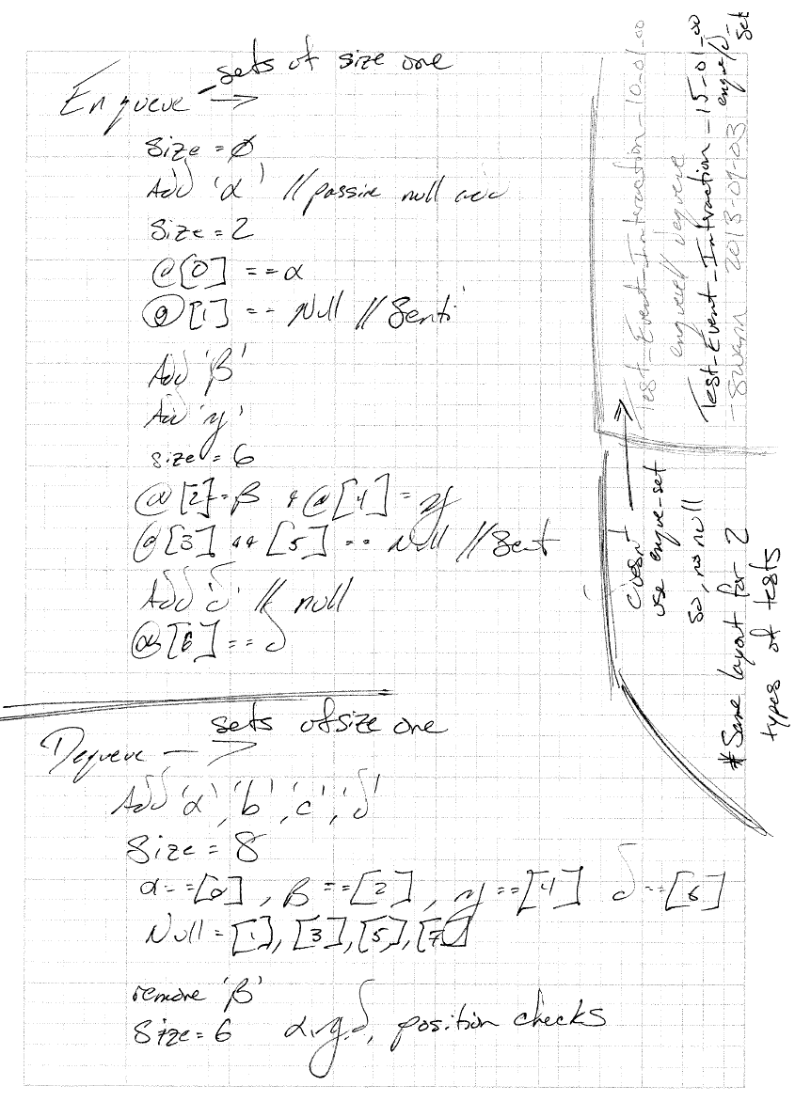

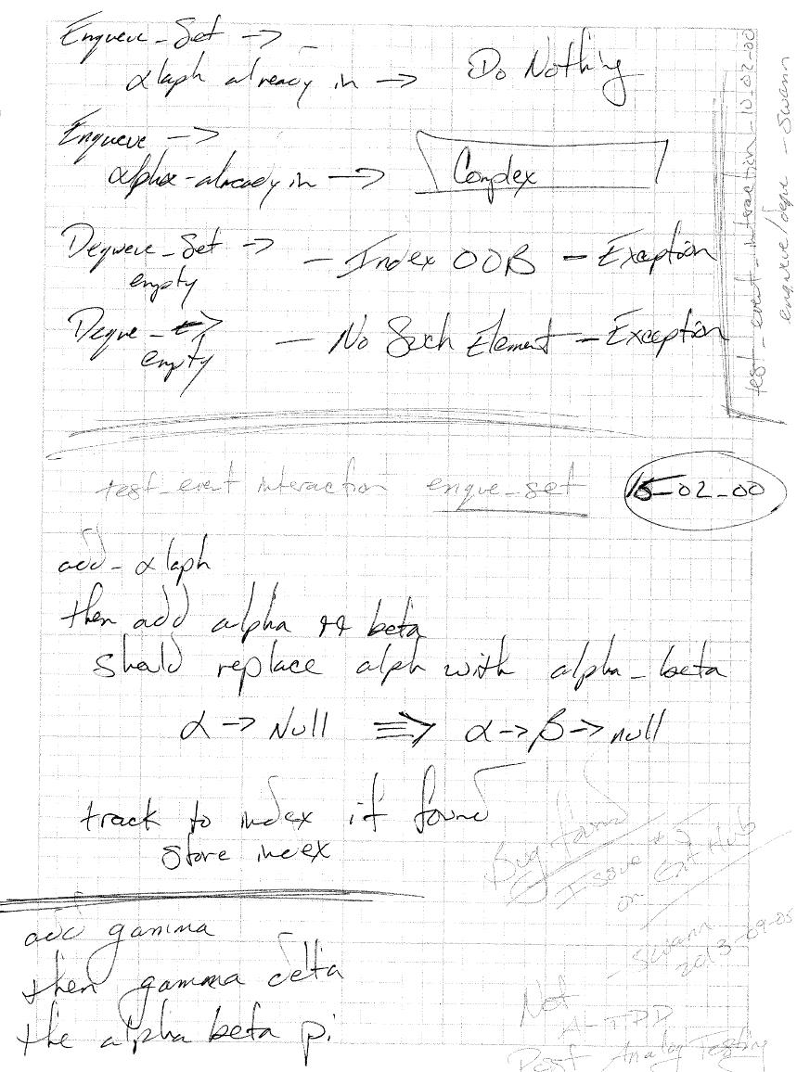

test notes :: explores full battery of enqueue, enqueue_set, dequeue, and dequeue_set functions of customized

event interaction grouping logic

// Event_Interaction.enqueue()

@Test

**public** **void** test_event_interaction_10_01_00_enqueue() {

// corresponding test draft in notebook

// The Setup

Standard_Mass alpha = Standard_Mass.*generate_fifty_g_mass*(*FIVE*, *FIVE*, *ZERO*);

Cannon beta = **new** Cannon(*TEN*, *NEGATIVE_ONE*, *ZERO*);

DropTower gamma = **new** DropTower(*TWO*, *THREE*, *ZERO*);

Ball delta = Ball.*generate_Baseball*(*NEGATIVE_ONE*, *SEVEN*, *ZERO*);

Collision collision = **new** Collision();

LinkedList<Actor_Object> the_list = collision.get_list();

// alpha add

*assertEquals*(*ZERO*, the_list.size(), *ZERO*);

collision.enqueue(alpha);

the_list = collision.get_list();

*assertEquals*(*ONE*, the_list.size(), *ZERO*);

*assertEquals*(alpha, the_list.get(*ZERO*));

// beta add

collision.enqueue(beta);

the_list = collision.get_list();

*assertEquals*(*TWO*, the_list.size(), *ZERO*);

*assertEquals*(alpha, the_list.get(*ZERO*));

*assertEquals*(beta, the_list.get(*ONE*));

// gamma add

collision.enqueue(gamma);

the_list = collision.get_list();

*assertEquals*(*THREE*, the_list.size(), *ZERO*);

*assertEquals*(alpha, the_list.get(*ZERO*));

*assertEquals*(beta, the_list.get(*ONE*));

*assertEquals*(gamma, the_list.get(*TWO*));

// delta add

collision.enqueue(delta);

the_list = collision.get_list();

*assertEquals*(*FOUR*, the_list.size(), *ZERO*);

*assertEquals*(alpha, the_list.get(*ZERO*));

*assertEquals*(beta, the_list.get(*ONE*));

*assertEquals*(gamma, the_list.get(*TWO*));

*assertEquals*(delta, the_list.get(*THREE*));

}

//Event_Interaction.enqueue()

@Test

**public** **void** test_event_interaction_10_02_00_enqueue() {

// Re-adding already added

// The Setup

Standard_Mass alpha = Standard_Mass.*generate_fifty_g_mass*(*FIVE*, *FIVE*, *ZERO*);

Collision collision = **new** Collision();

LinkedList<Actor_Object> the_list = collision.get_list();

// alpha add

*assertEquals*(*ZERO*, the_list.size(), *ZERO*);

collision.enqueue(alpha);

the_list = collision.get_list();

*assertEquals*(*ONE*, the_list.size(), *ZERO*);

collision.enqueue(alpha);

the_list = collision.get_list();

*assertEquals*(*ONE*, the_list.size(), *ZERO*);

}

// Event_Interaction.dequeue()

@Test

**public** **void** test_event_interaction_10_01_00_dequeue() {

// The Setup

Standard_Mass alpha = Standard_Mass.*generate_fifty_g_mass*(*FIVE*, *FIVE*, *ZERO*);

Cannon beta = **new** Cannon(*TEN*, *NEGATIVE_ONE*, *ZERO*);

DropTower gamma = **new** DropTower(*TWO*, *THREE*, *ZERO*);

Ball delta = Ball.*generate_Baseball*(*NEGATIVE_ONE*, *SEVEN*, *ZERO*);

Collision collision = **new** Collision();

LinkedList<Actor_Object> the_list = collision.get_list();

// all add

collision.enqueue(alpha);

collision.enqueue(beta);

collision.enqueue(gamma);

collision.enqueue(delta);

the_list = collision.get_list();

*assertEquals*(*FOUR*, the_list.size(), *ZERO*);

// alpha remove

collision.dequeue();

the_list = collision.get_list();

*assertEquals*(*THREE*, the_list.size(), *ZERO*);

*assertEquals*(beta, the_list.get(*ZERO*));

*assertEquals*(gamma, the_list.get(*ONE*));

*assertEquals*(delta, the_list.get(*TWO*));

// beta remove

collision.dequeue();

the_list = collision.get_list();

*assertEquals*(*TWO*, the_list.size(), *ZERO*);

*assertEquals*(gamma, the_list.get(*ZERO*));

*assertEquals*(delta, the_list.get(*ONE*));

// gamma remove

collision.dequeue();

the_list = collision.get_list();

*assertEquals*(*ONE*, the_list.size(), *ZERO*);

*assertEquals*(delta, the_list.get(*ZERO*));

// gamma remove

collision.dequeue();

the_list = collision.get_list();

*assertEquals*(*ZERO*, the_list.size(), *ZERO*);

}

// Event_Interaction.dequeue()

@Test

**public** **void** test_event_interaction_10_02_00_dequeue() {

// The Setup

Collision collision = **new** Collision();

//LinkedList<Actor_Object> the_list = collision.get_list();

**try** {

collision.dequeue();

}

**catch** (NoSuchElementException e){

// do nothing just pass

}

}

// Event_Interaction.enqueue_set()

@Test

**public** **void** test_event_interaction_15_01_00_enqueue_set() {

// corresponding test draft in notebook

// The Setup

Standard_Mass alpha = Standard_Mass.*generate_fifty_g_mass*(*FIVE*, *FIVE*, *ZERO*);

Cannon beta = **new** Cannon(*TEN*, *NEGATIVE_ONE*, *ZERO*);

DropTower gamma = **new** DropTower(*TWO*, *THREE*, *ZERO*);

Ball delta = Ball.*generate_Baseball*(*NEGATIVE_ONE*, *SEVEN*, *ZERO*);

ArrayList<Actor_Object> alpha_list = **new** ArrayList<Actor_Object>();

alpha_list.add((Actor_Object)alpha);

ArrayList<Actor_Object> beta_list = **new** ArrayList<Actor_Object>();

beta_list.add((Actor_Object)beta);

ArrayList<Actor_Object> gamma_list = **new** ArrayList<Actor_Object>();

gamma_list.add((Actor_Object)gamma);

ArrayList<Actor_Object> delta_list = **new** ArrayList<Actor_Object>();

delta_list.add((Actor_Object)delta);

Collision collision = **new** Collision();

LinkedList<Actor_Object> the_list = collision.get_list();

// alpha add

*assertEquals*(*ZERO*, the_list.size(), *ZERO*);

collision.enqueue_set(alpha_list);

the_list = collision.get_list();

*assertEquals*(*ONE*\**TWO*, the_list.size(), *ZERO*);

*assertEquals*(alpha, the_list.get(*ZERO*));

// beta add

collision.enqueue_set(beta_list);

the_list = collision.get_list();

*assertEquals*(*TWO*\**TWO*, the_list.size(), *ZERO*);

*assertEquals*(alpha, the_list.get(*ZERO*));

*assertEquals*(beta, the_list.get(*ONE*\**TWO*));

// gamma add

collision.enqueue_set(gamma_list);

the_list = collision.get_list();

*assertEquals*(*THREE*\**TWO*, the_list.size(), *ZERO*);

*assertEquals*(alpha, the_list.get(*ZERO*));

*assertEquals*(beta, the_list.get(*ONE*\**TWO*));

*assertEquals*(gamma, the_list.get(*TWO*\**TWO*));

// delta add

collision.enqueue_set(delta_list);

the_list = collision.get_list();

*assertEquals*(*FOUR*\**TWO*, the_list.size(), *ZERO*);

*assertEquals*(alpha, the_list.get(*ZERO*));

*assertEquals*(beta, the_list.get(*ONE*\**TWO*));

*assertEquals*(gamma, the_list.get(*TWO*\**TWO*));

*assertEquals*(delta, the_list.get(*THREE*\**TWO*));

// null sentinel checks

Ball SENTINEL = **null**;

*assertEquals*(SENTINEL, the_list.get(*ONE*));

*assertEquals*(SENTINEL, the_list.get(*THREE*));

*assertEquals*(SENTINEL, the_list.get(*FIVE*));

*assertEquals*(SENTINEL, the_list.get(*SEVEN*));

}

// Event_Interaction.enqueue_set()

@Test

**public** **void** test_event_interaction_15_02_00_enqueue_set() {

// corresponding test draft in notebook

// The Setup

Standard_Mass alpha = Standard_Mass.*generate_fifty_g_mass*(*FIVE*, *FIVE*, *ZERO*);

Cannon beta = **new** Cannon(*TEN*, *NEGATIVE_ONE*, *ZERO*);

DropTower gamma = **new** DropTower(*TWO*, *THREE*, *ZERO*);

Ball delta = Ball.*generate_Baseball*(*NEGATIVE_ONE*, *SEVEN*, *ZERO*);

Ball eta = Ball.*generate_Baseball*(*NEGATIVE_ONE*, *SEVEN*, *ZERO*);

// primary lists

ArrayList<Actor_Object> alpha_list = **new** ArrayList<Actor_Object>();

alpha_list.add((Actor_Object)alpha);

ArrayList<Actor_Object> beta_list = **new** ArrayList<Actor_Object>();

beta_list.add((Actor_Object)beta);

ArrayList<Actor_Object> gamma_list = **new** ArrayList<Actor_Object>();

gamma_list.add((Actor_Object)gamma);

ArrayList<Actor_Object> delta_list = **new** ArrayList<Actor_Object>();

delta_list.add((Actor_Object)delta);

// Misc. Overhead

Collision collision = **new** Collision();

LinkedList<Actor_Object> the_list = collision.get_list();

Ball SENTINEL = **null**;

// add alpha

collision.enqueue_set(alpha_list);

the_list = collision.get_list();

*assertEquals*(*ONE*\**TWO*, the_list.size(), *ZERO*);

*assertEquals*(alpha, the_list.get(*ZERO*));

*assertEquals*(SENTINEL, the_list.get(*ONE*));

// Transmogrification of alpha_list and re-test

alpha_list.add(beta);

alpha_list.add(alpha);

collision.enqueue_set(alpha_list);

the_list = collision.get_list();

//

// **ANALOG**

// Bug found here from **ANALOG** test design

// improper coagulation of set data for a given event

// issue #5 on github.

// ~swann 2013-11-14

*assertEquals*(*THREE*, the_list.size(), *ZERO*);

*assertEquals*(alpha, the_list.get(*ZERO*));

*assertEquals*(beta, the_list.get(*ONE*));

*assertEquals*(SENTINEL, the_list.get(*TWO*));

// add gamma, then gamma-delta

collision.enqueue_set(gamma_list);

*assertEquals*(*FIVE*, the_list.size(), *ZERO*);

*assertEquals*(alpha, the_list.get(*ZERO*));

*assertEquals*(beta, the_list.get(*ONE*));

*assertEquals*(SENTINEL, the_list.get(*TWO*));

*assertEquals*(gamma, the_list.get(*THREE*));

*assertEquals*(SENTINEL, the_list.get(*FOUR*));

// double add

gamma_list.add(gamma);

gamma_list.add(delta);

collision.enqueue_set(gamma_list);

*assertEquals*(*SIX*, the_list.size(), *ZERO*);

*assertEquals*(alpha, the_list.get(*ZERO*));

*assertEquals*(beta, the_list.get(*ONE*));

*assertEquals*(SENTINEL, the_list.get(*TWO*));

*assertEquals*(gamma, the_list.get(*THREE*));

*assertEquals*(delta, the_list.get(*FOUR*));

*assertEquals*(SENTINEL, the_list.get(*FIVE*));

// Triple add to alpha list

alpha_list.add(beta);

alpha_list.add(alpha);

alpha_list.add(eta);

collision.enqueue_set(alpha_list);

the_list = collision.get_list();

*assertEquals*(*SEVEN*, the_list.size(), *ZERO*);

*assertEquals*(gamma, the_list.get(*ZERO*));

*assertEquals*(delta, the_list.get(*ONE*));

*assertEquals*(SENTINEL, the_list.get(*TWO*));

*assertEquals*(alpha, the_list.get(*THREE*));

*assertEquals*(beta, the_list.get(*FOUR*));

*assertEquals*(eta, the_list.get(*FIVE*));

*assertEquals*(SENTINEL, the_list.get(*SIX*));

}

// Event_Interaction.dequeue_set()

@Test

**public** **void** test_event_interaction_15_01_00_dequeue_set() {

// The Setup

Standard_Mass alpha = Standard_Mass.*generate_fifty_g_mass*(*FIVE*, *FIVE*, *ZERO*);

Cannon beta = **new** Cannon(*TEN*, *NEGATIVE_ONE*, *ZERO*);

DropTower gamma = **new** DropTower(*TWO*, *THREE*, *ZERO*);

Ball delta = Ball.*generate_Baseball*(*NEGATIVE_ONE*, *SEVEN*, *ZERO*);

Collision collision = **new** Collision();

ArrayList<Actor_Object> alpha_list = **new** ArrayList<Actor_Object>();

alpha_list.add((Actor_Object)alpha);

ArrayList<Actor_Object> beta_list = **new** ArrayList<Actor_Object>();

beta_list.add((Actor_Object)beta);

ArrayList<Actor_Object> gamma_list = **new** ArrayList<Actor_Object>();

gamma_list.add((Actor_Object)gamma);

ArrayList<Actor_Object> delta_list = **new** ArrayList<Actor_Object>();

delta_list.add((Actor_Object)delta);

LinkedList<Actor_Object> the_list = collision.get_list();

// all add

collision.enqueue_set(alpha_list);

collision.enqueue_set(beta_list);

collision.enqueue_set(gamma_list);

collision.enqueue_set(delta_list);

the_list = collision.get_list();

*assertEquals*(*FOUR*\**TWO*, the_list.size(), *ZERO*);

// null sentinel checks

Ball SENTINEL = **null**;

*assertEquals*(SENTINEL, the_list.get(*ONE*));

*assertEquals*(SENTINEL, the_list.get(*THREE*));

*assertEquals*(SENTINEL, the_list.get(*FIVE*));

*assertEquals*(SENTINEL, the_list.get(*SEVEN*));

// alpha remove

collision.dequeue_set();

the_list = collision.get_list();

*assertEquals*(*THREE*\**TWO*, the_list.size(), *ZERO*);

*assertEquals*(beta, the_list.get(*ZERO*));

*assertEquals*(gamma, the_list.get(*ONE*\**TWO*));

*assertEquals*(delta, the_list.get(*TWO*\**TWO*));

// beta remove

collision.dequeue_set();

the_list = collision.get_list();

*assertEquals*(*TWO*\**TWO*, the_list.size(), *ZERO*);

*assertEquals*(gamma, the_list.get(*ZERO*));

*assertEquals*(delta, the_list.get(*ONE*\**TWO*));

// gamma remove

collision.dequeue_set();

the_list = collision.get_list();

*assertEquals*(*ONE*\**TWO*, the_list.size(), *ZERO*);

*assertEquals*(delta, the_list.get(*ZERO*\**TWO*));

// gamma remove

collision.dequeue_set();

the_list = collision.get_list();

*assertEquals*(*ZERO*, the_list.size(), *ZERO*);

}

// Event_Interaction.dequeue_set()

@Test

**public** **void** test_event_interaction_15_02_00_dequeue_set() {

// The Setup

Collision collision = **new** Collision();

//LinkedList<Actor_Object> the_list = collision.get_list();

**try** {

collision.dequeue_set();

}

**catch** (IndexOutOfBoundsException e){

// do nothing just pass

}

}

module :: Item/Barrier_Event.java

test/design :: test_barrier_general_10_01_00_constructor_equivalence

description :: design of the normalized behaviors of all barrier events

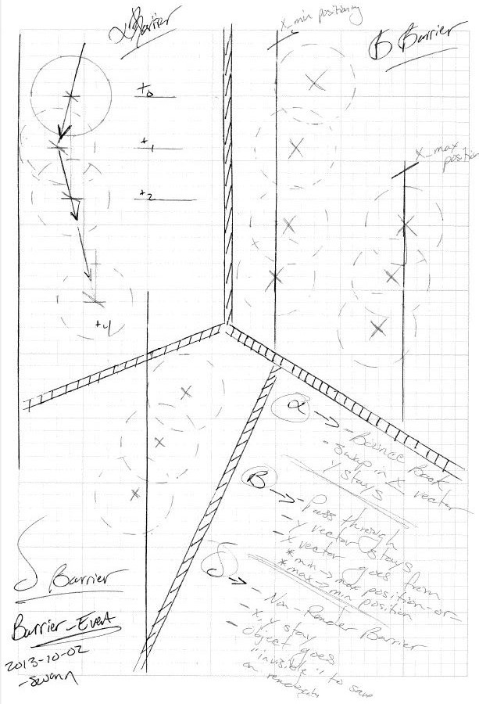

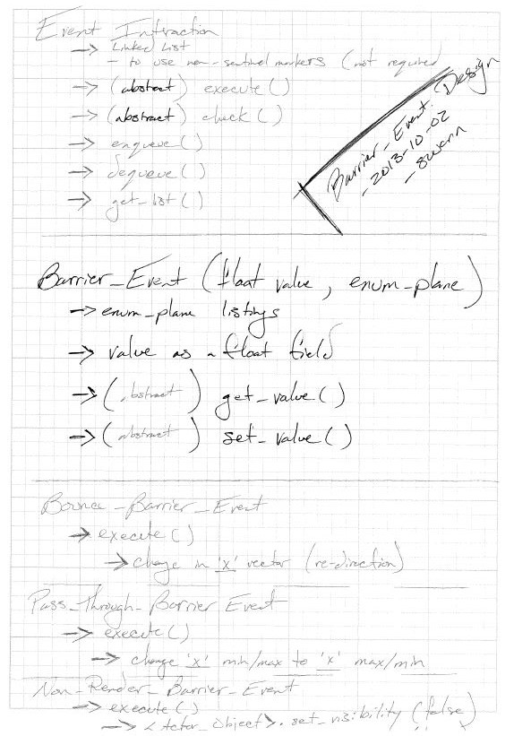

test notes :: explores full battery of normalized behaviors across the three barrier event classes

// Barrier_Event Constructor equivalence

// --> set_value()

// --> get_value()

// --> get_axis()

// --> Pass_Through

@Test

**public** **void** test_barrier_general_10_01_00_constructor_equivalence() {

// The Setup

Bounce_Barrier_Event alpha = **new** Bounce_Barrier_Event(*ZERO*, Barrier_Event.axis_enumeration.*X*,

Barrier_Event.axis_control.*STAY_HIGHER*);

Pass_Through_Barrier_Event beta = **new** Pass_Through_Barrier_Event(*ONE*, *TEN*, Barrier_Event.axis_enumeration.*X*,

Barrier_Event.axis_control.*STAY_HIGHER*);

Non_Render_Barrier_Event delta = **new** Non_Render_Barrier_Event(*TWO*, Barrier_Event.axis_enumeration.*X*,

Barrier_Event.axis_control.*STAY_HIGHER*);

Bounce_Barrier_Event gamma = **new** Bounce_Barrier_Event((**float**) .2, Barrier_Event.axis_enumeration.*Y*,

Barrier_Event.axis_control.*STAY_LOWER*);

Pass_Through_Barrier_Event iota = **new** Pass_Through_Barrier_Event((**float**) .009, *TEN*,

Barrier_Event.axis_enumeration.*Y*, Barrier_Event.axis_control.*STAY_LOWER*);

Non_Render_Barrier_Event eta = **new** Non_Render_Barrier_Event((**float**) 14.77,

Barrier_Event.axis_enumeration.*Y*, Barrier_Event.axis_control.*STAY_LOWER*);

// Battery One

*assertEquals*(*ZERO*, alpha.get_value(), *A_THOUSANDTH*);

*assertEquals*(*ONE*, beta.get_value(), *A_THOUSANDTH*);

*assertEquals*(*TWO*, delta.get_value(), *A_THOUSANDTH*);

*assertEquals*((**float**) .2, gamma.get_value(), *A_THOUSANDTH*);

*assertEquals*((**float**) .009, iota.get_value(), *A_THOUSANDTH*);

*assertEquals*((**float**) 14.77, eta.get_value(), *A_THOUSANDTH*);

*assertEquals*(Barrier_Event.axis_enumeration.*X*, alpha.get_axis());

*assertEquals*(Barrier_Event.axis_enumeration.*X*, beta.get_axis());

*assertEquals*(Barrier_Event.axis_enumeration.*X*, delta.get_axis());

*assertEquals*(Barrier_Event.axis_enumeration.*Y*, gamma.get_axis());

*assertEquals*(Barrier_Event.axis_enumeration.*Y*, iota.get_axis());

*assertEquals*(Barrier_Event.axis_enumeration.*Y*, eta.get_axis());

*assertEquals*(Barrier_Event.axis_control.*STAY_HIGHER*, alpha.get_axis_control());

*assertEquals*(Barrier_Event.axis_control.*STAY_HIGHER*, beta.get_axis_control());

*assertEquals*(Barrier_Event.axis_control.*STAY_HIGHER*, delta.get_axis_control());

*assertEquals*(Barrier_Event.axis_control.*STAY_LOWER*, gamma.get_axis_control());

*assertEquals*(Barrier_Event.axis_control.*STAY_LOWER*, iota.get_axis_control());

*assertEquals*(Barrier_Event.axis_control.*STAY_LOWER*, eta.get_axis_control());

// Battery Two

alpha.set_value((**float**) .7);

beta.set_value( (**float**) .7);

delta.set_value((**float**) .7);

gamma.set_value((**float**) .7);

iota.set_value( (**float**) .7);

eta.set_value( (**float**) .7);

*assertEquals*((**float**) .7, gamma.get_value(), *A_THOUSANDTH*);

*assertEquals*((**float**) 0.7, iota.get_value(), *A_THOUSANDTH*);

*assertEquals*((**float**) .7, eta.get_value(), *A_THOUSANDTH*);

*assertEquals*((**float**) .7, alpha.get_value(), *A_THOUSANDTH*);

*assertEquals*((**float**) 0.7, beta.get_value(), *A_THOUSANDTH*);

*assertEquals*((**float**) 0.7, delta.get_value(), *A_THOUSANDTH*);

// Battery_Three

*assertEquals*(*TEN*, iota.get_opposing_value(), *A_THOUSANDTH*);

*assertEquals*(*TEN*, beta.get_opposing_value(), *A_THOUSANDTH*);

iota.set_opposing_value( (**float**) -.001 );

beta.set_opposing_value( (**float**) 12345.6789 );

*assertEquals*((**float**) -.001, iota.get_opposing_value(), *A_THOUSANDTH*);

*assertEquals*((**float**) 12345.6789, beta.get_opposing_value(), *A_THOUSANDTH*);

}

module :: Item/Bounce_Barrier_Event.java && Item.Pass_Through_Barrier.java

test/design :: test_bounce_barrier_20_01_00_check && test_bouce_barrier_20_02_00_execute &&

test_pass_through_barrier_20_01_00_check && test_pass_through_barrier_20_02_00_execute

description :: design of the specific check and execute behaviors for bounce and pass through barriers

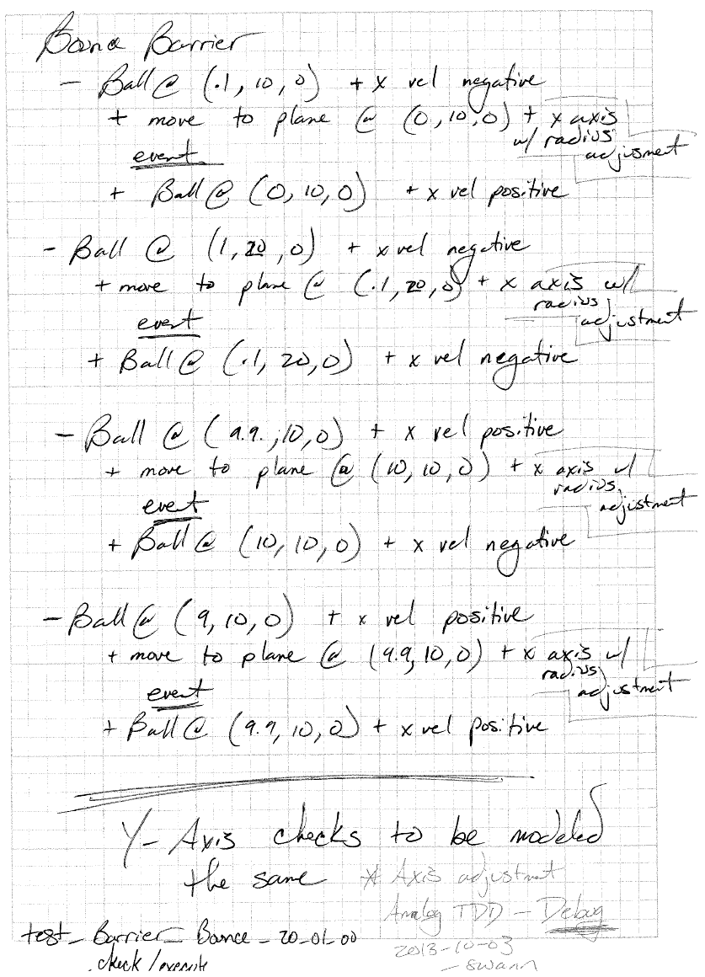

test notes :: explores functionality associated with both bounce barrier and pass through barrier; above test scenario

recycled for pass through barriers with slight logic modifications

// Bounce_Barrier_Event.check/execute()

@Test

**public** **void** test_barrier_bounce_20_01_00_check() {

// The setup

Ball alpha;

Ball beta;

**float**[] velocity_spread;

Bounce_Barrier_Event omicron;

LinkedList<Actor_Object> flag_list;

ArrayList<Actor_Object> the_list = **new** ArrayList<Actor_Object>();

//

// X Axis Sweep

//

// Battery One --> No changes yet

alpha = Ball.*generate_Baseball*((**float**) .1, *TEN*, *ZERO*);

beta = Ball.*generate_Baseball*(*ONE*, *TEN*, *ZERO*);

omicron = **new** Bounce_Barrier_Event(*ZERO*-alpha.get_shape().get_radius(),

Barrier_Event.axis_enumeration.*Y*,

Barrier_Event.axis_control.*STAY_HIGHER*);

alpha.update_velocity(*ZERO*-*FIVE*\**TEN*, *ZERO*, *ZERO*);

beta.update_velocity (*ZERO*-*FIVE*\**TEN*, *ZERO*, *ZERO*);

the_list.add(alpha);

the_list.add(beta);

omicron.check(the_list);

omicron.execute();

flag_list = omicron.get_list();

*assertEquals*(*ZERO*, flag_list.size());

// alpha has changed vel, beta does not

alpha.update_location(*ZERO*, *TEN*, *ZERO*);

beta.update_location((**float**) .1, *TEN*, *ZERO*);

omicron.check(the_list);

omicron.execute();

flag_list = omicron.get_list();

*assertEquals*(*ONE*, flag_list.size());

*assertEquals*(alpha, flag_list.get(*ZERO*));

velocity_spread = alpha.get_velocity();

*assertEquals*(*ZERO*, velocity_spread[*TWO*], *ZERO*);

*assertEquals*(*ZERO*, velocity_spread[*ONE*], *ZERO*);

*assertEquals*(*FIVE*\**TEN*\*alpha.get_coefficient_of_restitution(), velocity_spread[*ZERO*], *ZERO*);

// beta has changed vel, alpha does not

omicron.clean_list();

beta.update_location(*ZERO*, *TEN*, *ZERO*);

alpha.update_location(*ONE*, *TEN*, *ZERO*);

omicron.check(the_list);

omicron.execute();

flag_list = omicron.get_list();

*assertEquals*(*ONE*, flag_list.size());

*assertEquals*(beta, flag_list.get(*ZERO*));

velocity_spread = beta.get_velocity();

*assertEquals*(*ZERO*, velocity_spread[*TWO*], *ZERO*);

*assertEquals*(*ZERO*, velocity_spread[*ONE*], *ZERO*);

*assertEquals*(*FIVE*\**TEN*\*beta.get_coefficient_of_restitution(), velocity_spread[*ZERO*], *ZERO*);

velocity_spread = alpha.get_velocity();

*assertEquals*(*ZERO*, velocity_spread[*TWO*], *ZERO*);

*assertEquals*(*ZERO*, velocity_spread[*ONE*], *ZERO*);

*assertEquals*(*FIVE*\**TEN*\*alpha.get_coefficient_of_restitution(), velocity_spread[*ZERO*], *ZERO*);

// Battery Two --> No changes yet

alpha = Ball.*generate_Baseball*((**float**) 9.9, *TEN*, *ZERO*);

beta = Ball.*generate_Baseball*(*NINE*, *TEN*, *ZERO*);

omicron = **new** Bounce_Barrier_Event(*TEN*+alpha.get_shape().get_radius(),

Barrier_Event.axis_enumeration.*Y*,

Barrier_Event.axis_control.*STAY_LOWER*);

the_list = **new** ArrayList<Actor_Object>();

alpha.update_velocity(*FIVE*\**TEN*, *ZERO*, *ZERO*);

beta.update_velocity (*FIVE*\**TEN*, *ZERO*, *ZERO*);

the_list.add(alpha);

the_list.add(beta);

omicron.check(the_list);

omicron.execute();

flag_list = omicron.get_list();

*assertEquals*(*ZERO*, flag_list.size());

// alpha has changed vel, beta does not

alpha.update_location(*TEN*, *TEN*, *ZERO*);

beta.update_location((**float**) 9.9, *TEN*, *ZERO*);

omicron.check(the_list);

omicron.execute();

flag_list = omicron.get_list();

*assertEquals*(*ONE*, flag_list.size());

*assertEquals*(alpha, flag_list.get(*ZERO*));

velocity_spread = alpha.get_velocity();

*assertEquals*(*ZERO*, velocity_spread[*TWO*], *ZERO*);

*assertEquals*(*ZERO*, velocity_spread[*ONE*], *ZERO*);

*assertEquals*(*ZERO*-*FIVE*\**TEN*\*alpha.get_coefficient_of_restitution(), velocity_spread[*ZERO*], *ZERO*);

// beta has changed vel, alpha does not

omicron.clean_list();

beta.update_location(*TEN*, *TEN*, *ZERO*);

alpha.update_location(*NINE*, *TEN*, *ZERO*);

omicron.check(the_list);

omicron.execute();

flag_list = omicron.get_list();

*assertEquals*(*ONE*, flag_list.size());

*assertEquals*(beta, flag_list.get(*ZERO*));

velocity_spread = beta.get_velocity();

*assertEquals*(*ZERO*, velocity_spread[*TWO*], *ZERO*);

*assertEquals*(*ZERO*, velocity_spread[*ONE*], *ZERO*);

*assertEquals*(*ZERO*-*FIVE*\**TEN*\*beta.get_coefficient_of_restitution(), velocity_spread[*ZERO*], *ZERO*);

velocity_spread = alpha.get_velocity();

*assertEquals*(*ZERO*, velocity_spread[*TWO*], *ZERO*);

*assertEquals*(*ZERO*, velocity_spread[*ONE*], *ZERO*);

*assertEquals*(*ZERO*-*FIVE*\**TEN*\*alpha.get_coefficient_of_restitution(), velocity_spread[*ZERO*], *ZERO*);

//

// Y Axis Sweep

//

// Battery Three --> No changes yet

alpha = Ball.*generate_Baseball*(*TEN*, (**float**) .1, *ZERO*);

beta = Ball.*generate_Baseball*(*TEN*, *ONE*, *ZERO*);

omicron = **new** Bounce_Barrier_Event(*ZERO*-alpha.get_shape().get_radius(),

Barrier_Event.axis_enumeration.*X*,

Barrier_Event.axis_control.*STAY_HIGHER*);

alpha.update_velocity(*ZERO*, *ZERO*-*FIVE*\**TEN*, *ZERO*);

beta.update_velocity (*ZERO*, *ZERO*-*FIVE*\**TEN*, *ZERO*);

the_list.add(alpha);

the_list.add(beta);

omicron.check(the_list);

omicron.execute();

flag_list = omicron.get_list();

*assertEquals*(*ZERO*, flag_list.size());

// alpha has changed vel, beta does not

alpha.update_location(*TEN*, *ZERO*, *ZERO*);

beta.update_location(*TEN*, (**float**) .1, *ZERO*);

omicron.check(the_list);

omicron.execute();

flag_list = omicron.get_list();

*assertEquals*(*ONE*, flag_list.size());

*assertEquals*(alpha, flag_list.get(*ZERO*));

velocity_spread = alpha.get_velocity();

*assertEquals*(*ZERO*, velocity_spread[*TWO*], *ZERO*);

*assertEquals*(*ZERO*, velocity_spread[*ZERO*], *ZERO*);

*assertEquals*(*FIVE*\**TEN*\*alpha.get_coefficient_of_restitution(), velocity_spread[*ONE*], *ZERO*);

// beta has changed vel, alpha does not

omicron.clean_list();

beta.update_location(*TEN*, *ZERO*, *ZERO*);

alpha.update_location(*TEN*, *ONE*, *ZERO*);

omicron.check(the_list);

omicron.execute();

flag_list = omicron.get_list();

*assertEquals*(*ONE*, flag_list.size());

*assertEquals*(beta, flag_list.get(*ZERO*));

velocity_spread = beta.get_velocity();

*assertEquals*(*ZERO*, velocity_spread[*TWO*], *ZERO*);

*assertEquals*(*ZERO*, velocity_spread[*ZERO*], *ZERO*);

*assertEquals*(*FIVE*\**TEN*\*beta.get_coefficient_of_restitution(), velocity_spread[*ONE*], *ZERO*);

velocity_spread = alpha.get_velocity();

*assertEquals*(*ZERO*, velocity_spread[*TWO*], *ZERO*);

*assertEquals*(*ZERO*, velocity_spread[*ZERO*], *ZERO*);

*assertEquals*(*FIVE*\**TEN*\*alpha.get_coefficient_of_restitution(), velocity_spread[*ONE*], *ZERO*);

// Battery Four --> No changes yet

alpha = Ball.*generate_Baseball*(*TEN*, (**float**) 9.9, *ZERO*);

beta = Ball.*generate_Baseball*(*TEN*, *NINE*, *ZERO*);

omicron = **new** Bounce_Barrier_Event(*TEN*+alpha.get_shape().get_radius(),

Barrier_Event.axis_enumeration.*X*,

Barrier_Event.axis_control.*STAY_LOWER*);

the_list = **new** ArrayList<Actor_Object>();

alpha.update_velocity(*ZERO*, *FIVE*\**TEN*, *ZERO*);

beta.update_velocity (*ZERO*, *FIVE*\**TEN*, *ZERO*);

the_list.add(alpha);

the_list.add(beta);

omicron.check(the_list);

omicron.execute();

flag_list = omicron.get_list();

*assertEquals*(*ZERO*, flag_list.size());

// alpha has changed vel, beta does not

alpha.update_location(*TEN*, *TEN*, *ZERO*);

beta.update_location(*TEN*, (**float**) 9.9, *ZERO*);

omicron.check(the_list);

omicron.execute();

flag_list = omicron.get_list();

*assertEquals*(*ONE*, flag_list.size());

*assertEquals*(alpha, flag_list.get(*ZERO*));

velocity_spread = alpha.get_velocity();

*assertEquals*(*ZERO*, velocity_spread[*TWO*], *ZERO*);

*assertEquals*(*ZERO*, velocity_spread[*ZERO*], *ZERO*);

*assertEquals*(*ZERO*-*FIVE*\**TEN*\*alpha.get_coefficient_of_restitution(), velocity_spread[*ONE*], *ZERO*);

// beta has changed vel, alpha does not

omicron.clean_list();

beta.update_location(*TEN*, *TEN*, *ZERO*);

alpha.update_location(*TEN*, *NINE*, *ZERO*);

omicron.check(the_list);

omicron.execute();

flag_list = omicron.get_list();

*assertEquals*(*ONE*, flag_list.size());

*assertEquals*(beta, flag_list.get(*ZERO*));

velocity_spread = beta.get_velocity();

*assertEquals*(*ZERO*, velocity_spread[*TWO*], *ZERO*);

*assertEquals*(*ZERO*, velocity_spread[*ZERO*], *ZERO*);

*assertEquals*(*ZERO*-*FIVE*\**TEN*\*beta.get_coefficient_of_restitution(), velocity_spread[*ONE*], *ZERO*);

velocity_spread = alpha.get_velocity();

*assertEquals*(*ZERO*, velocity_spread[*TWO*], *ZERO*);

*assertEquals*(*ZERO*, velocity_spread[*ZERO*], *ZERO*);

*assertEquals*(*ZERO*-*FIVE*\**TEN*\*alpha.get_coefficient_of_restitution(), velocity_spread[*ONE*], *ZERO*);

}

// Bounce_Barrier_Event.check/execute()

@Test

**public** **void** test_barrier_bounce_20_02_00_check_execute() {

// The setup

Standard_Mass gamma;

Standard_Mass delta;

Cannon the_cannon;

**float**[] velocity_spread;

Bounce_Barrier_Event omicron;

LinkedList<Actor_Object> flag_list;

ArrayList<Actor_Object> the_list = **new** ArrayList<Actor_Object>();

//

// X Axis Sweep

//

// Battery One --> No changes yet

gamma = Standard_Mass.*generate_fifty_g_mass*((**float**) .1, *TEN*, *ZERO*);

delta = Standard_Mass.*generate_fifty_g_mass*(*ONE*, *TEN*, *ZERO*);

the_cannon = **new** Cannon(*ZERO*, *ZERO*, *ZERO*);

omicron = **new** Bounce_Barrier_Event((**float**) (*ZERO*-*FIVE*\**TEN*/*TWO*),

Barrier_Event.axis_enumeration.*Y*,

Barrier_Event.axis_control.*STAY_HIGHER*);

gamma.update_velocity(*ZERO*-*FIVE*\**TEN*, *ZERO*, *ZERO*);

delta.update_velocity(*ZERO*-*FIVE*\**TEN*, *ZERO*, *ZERO*);

the_list.add(gamma);

the_list.add(delta);

the_list.add(the_cannon);

omicron.check(the_list);

omicron.execute();

flag_list = omicron.get_list();

*assertEquals*(*ZERO*, flag_list.size());

// alpha has changed vel, beta does not

gamma.update_location((**float**) -.1, *TEN*, *ZERO*);

delta.update_location((**float**) .1, *TEN*, *ZERO*);

// # **ANALOG** -->

// Found update_location bug... does not update radius or points

// ~swann 2013-10-07

// -------------------------------

// Logged into github; issue #19

// Solved via <Shape.set_location() Override>

// Time to fix :: 45-60 seconds

// test re-run and test pass

// ~swann 2013-10-07

//gamma.get_shape().set_radius(gamma.get_shape().get_radius());

//delta.get_shape().set_radius(delta.get_shape().get_radius());

omicron.check(the_list);

omicron.execute();

flag_list = omicron.get_list();

*assertEquals*(*ONE*, flag_list.size());

*assertEquals*(gamma, flag_list.get(*ZERO*));

velocity_spread = gamma.get_velocity();

*assertEquals*(*ZERO*, velocity_spread[*TWO*], *ZERO*);

*assertEquals*(*ZERO*, velocity_spread[*ONE*], *ZERO*);

*assertEquals*(*FIVE*\**TEN*\*gamma.get_coefficient_of_restitution(), velocity_spread[*ZERO*], *ZERO*);

// beta has changed vel, alpha does not

omicron.clean_list();

delta.update_location((**float**) -.1, *TEN*, *ZERO*);

gamma.update_location(*ONE*, *TEN*, *ZERO*);

// DO NOT DELETE --> needed for above Analog tag

// ~swann 2013-10-07

//gamma.get_shape().set_radius(gamma.get_shape().get_radius());

//delta.get_shape().set_radius(delta.get_shape().get_radius());

omicron.check(the_list);

omicron.execute();

flag_list = omicron.get_list();

*assertEquals*(*ONE*, flag_list.size());

*assertEquals*(delta, flag_list.get(*ZERO*));

velocity_spread = delta.get_velocity();

*assertEquals*(*ZERO*, velocity_spread[*TWO*], *ZERO*);

*assertEquals*(*ZERO*, velocity_spread[*ONE*], *ZERO*);

*assertEquals*(*FIVE*\**TEN*\*delta.get_coefficient_of_restitution(), velocity_spread[*ZERO*], *ZERO*);

velocity_spread = gamma.get_velocity();

*assertEquals*(*ZERO*, velocity_spread[*TWO*], *ZERO*);

*assertEquals*(*ZERO*, velocity_spread[*ONE*], *ZERO*);

*assertEquals*(*FIVE*\**TEN*\*gamma.get_coefficient_of_restitution(), velocity_spread[*ZERO*], *ZERO*);

}

// Pass_Through_Barrier_Event.check/execute()

@Test

**public** **void** test_barrier_pass_through_20_01_00_check_execute() {

// not designed or installed

// ~swann 2013-10-03

// The setup

Ball alpha;

Ball beta;

**float**[] location_spread;

Pass_Through_Barrier_Event omicron;

LinkedList<Actor_Object> flag_list;

ArrayList<Actor_Object> the_list = **new** ArrayList<Actor_Object>();

//

// X Axis Sweep

//

// Battery One --> No changes yet

alpha = Ball.*generate_Baseball*((**float**) .1, *TEN*, *ZERO*);

beta = Ball.*generate_Baseball*(*ONE*, *TEN*, *ZERO*);

omicron = **new** Pass_Through_Barrier_Event(*ZERO*,

*TEN*,

Barrier_Event.axis_enumeration.*Y*,

Barrier_Event.axis_control.*STAY_HIGHER*);

the_list.add(alpha);

the_list.add(beta);

omicron.check(the_list);

omicron.execute();

flag_list = omicron.get_list();

*assertEquals*(*ZERO*, flag_list.size());

// alpha has changed vel, beta does not

alpha.update_location(*ZERO*, *TEN*, *ZERO*);

beta.update_location((**float**) .1, *TEN*, *ZERO*);

omicron.check(the_list);

omicron.execute();

flag_list = omicron.get_list();

*assertEquals*(*ONE*, flag_list.size());

*assertEquals*(alpha, flag_list.get(*ZERO*));

location_spread = alpha.get_location();

*assertEquals*(*TEN*, location_spread[*ZERO*], *ZERO*);

// beta has changed vel, alpha does not

omicron.clean_list();

beta.update_location(*ZERO*, *TEN*, *ZERO*);

alpha.update_location(*ONE*, *TEN*, *ZERO*);

omicron.check(the_list);

omicron.execute();

flag_list = omicron.get_list();

*assertEquals*(*ONE*, flag_list.size());

*assertEquals*(beta, flag_list.get(*ZERO*));

location_spread = beta.get_location();

*assertEquals*(*TEN*, location_spread[*ZERO*], *ZERO*);

//

// Y Axis Sweep

//

// Battery One --> No changes yet

alpha = Ball.*generate_Baseball*(*ONE*, (**float**) 9.9, *ZERO*);

beta = Ball.*generate_Baseball*(*ONE*, *NINE*, *ZERO*);

omicron = **new** Pass_Through_Barrier_Event(*TEN*,

*ZERO*,

Barrier_Event.axis_enumeration.*X*,

Barrier_Event.axis_control.*STAY_LOWER*);

the_list = **new** ArrayList<Actor_Object>();

the_list.add(alpha);

the_list.add(beta);

omicron.check(the_list);

omicron.execute();

flag_list = omicron.get_list();

*assertEquals*(*ZERO*, flag_list.size());

// alpha has changed vel, beta does not

alpha.update_location(*ONE*, *TEN*, *ZERO*);

beta.update_location( *ONE*, (**float**) 9.9, *ZERO*);

omicron.check(the_list);

omicron.execute();

flag_list = omicron.get_list();

*assertEquals*(*ONE*, flag_list.size());

*assertEquals*(alpha, flag_list.get(*ZERO*));

location_spread = alpha.get_location();

*assertEquals*(*ZERO*, location_spread[*ONE*], *ZERO*);

// beta has changed vel, alpha does not

omicron.clean_list();

beta.update_location(*ZERO*, *TEN*, *ZERO*);

alpha.update_location(*ONE*, *TEN*, *ZERO*);

omicron.check(the_list);

omicron.execute();

flag_list = omicron.get_list();

*assertEquals*(*TWO*, flag_list.size());

*assertEquals*(alpha, flag_list.get(*ZERO*));

*assertEquals*(beta, flag_list.get(*ONE*));

location_spread = beta.get_location();

*assertEquals*(*ZERO*, location_spread[*ONE*], *ZERO*);

location_spread = alpha.get_location();

*assertEquals*(*ZERO*, location_spread[*ONE*], *ZERO*);

}

module :: Item/Non_Render_Barrier_Event.java

test/design :: test_non_render_barrier_20_01_00_check_execute && test_non_render_barrier_20_02_00_check_execute

description :: design of the specific check and execute behaviors for bounce and pass through barriers

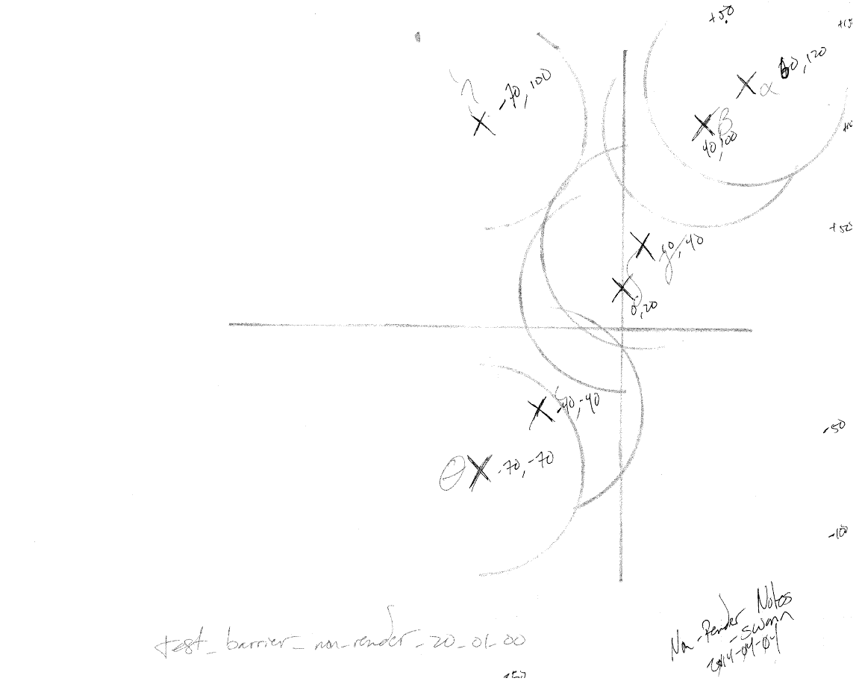

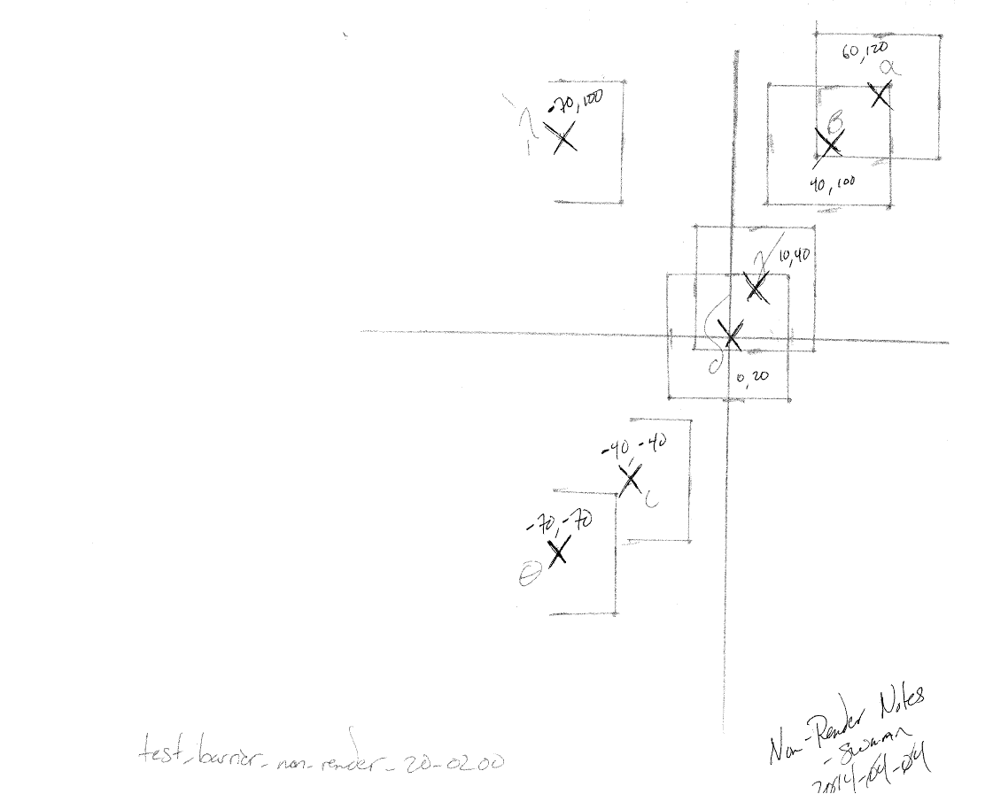

test notes :: explores functionality associated with non render barriers

// Non_Render_Barrier_Event.check_execute()

@Test

**public** **void** test_barrier_non_render_20_01_00_check_execute() {

// The setup

Ball alpha, beta, gamma, delta, iota, theta, eta;

Cannon the_cannon;

Non_Render_Barrier_Event omicron;

LinkedList<Actor_Object> flag_list;

ArrayList<Actor_Object> the_list = **new** ArrayList<Actor_Object>();

//

// X Axis Sweep

//

// Battery One --> No changes yet

alpha = Ball.*generate_Baseball*(60, 120, *ZERO*);

beta = Ball.*generate_Baseball*(40, 100, *ZERO*);

gamma = Ball.*generate_Baseball*(10, 40, *ZERO*);

delta = Ball.*generate_Baseball*(0, 20, *ZERO*);

iota = Ball.*generate_Baseball*(-40, -40, *ZERO*);

theta = Ball.*generate_Baseball*(-70, -70, *ZERO*);

eta = Ball.*generate_Baseball*(-70, 100, *ZERO*);

the_cannon = **new** Cannon(*ZERO*, *ZERO*, *ZERO*);

omicron = **new** Non_Render_Barrier_Event( *ZERO*,

Barrier_Event.axis_enumeration.*Y*,

Barrier_Event.axis_control.*STAY_HIGHER*);

the_list.add(alpha);

the_list.add(beta);

the_list.add(gamma);

the_list.add(delta);

the_list.add(iota);

the_list.add(theta);

the_list.add(eta);

the_list.add(the_cannon);

// Should have two objects not visible

omicron.check(the_list);

omicron.execute();

flag_list = omicron.get_list();

*assertEquals*(*THREE*, flag_list.size());

*assertEquals*(alpha.get_visibility(), **true**);

*assertEquals*(beta.get_visibility(), **true**);

*assertEquals*(gamma.get_visibility(), **true**);

*assertEquals*(delta.get_visibility(), **true**);

*assertEquals*(iota.get_visibility(), **false**);

*assertEquals*(theta.get_visibility(), **false**);

*assertEquals*(eta.get_visibility(), **false**);

*assertEquals*(the_cannon.get_visibility(), **true**);

// Movement and re-check

omicron.clean_list();

alpha.update_location(10, 1000, *ZERO*);

beta.update_location(-400, 35, *ZERO*);

gamma.update_location(-50, *ZERO*, *ZERO*);

delta.update_location(-24, *ZERO*, *ZERO*);

iota.update_location(-51, *ZERO*, *ZERO*);

the_cannon.update_location(-1000, *ZERO*, *ZERO*);

omicron.check(the_list);

omicron.execute();

flag_list = omicron.get_list();

*assertEquals*(*FIVE*, flag_list.size());

*assertEquals*(alpha.get_visibility(), **true**);

*assertEquals*(beta.get_visibility(), **false**);

*assertEquals*(gamma.get_visibility(), **false**);

*assertEquals*(delta.get_visibility(), **true**);

*assertEquals*(iota.get_visibility(), **false**);

*assertEquals*(theta.get_visibility(), **false**);

*assertEquals*(eta.get_visibility(), **false**);

}

// Non_Render_Barrier_Event.check_execute()

@Test

**public** **void** test_barrier_non_render_20_02_00_check_execute() {

// The setup

Standard_Mass alpha, beta, gamma, delta, iota, theta, eta;

Cannon the_cannon;

Non_Render_Barrier_Event omicron;

LinkedList<Actor_Object> flag_list;

ArrayList<Actor_Object> the_list = **new** ArrayList<Actor_Object>();

//

// X Axis Sweep

//

// Battery One --> No changes yet

alpha = Standard_Mass.*generate_fifty_g_mass*(60, 120, *ZERO*);

beta = Standard_Mass.*generate_fifty_g_mass*(40, 100, *ZERO*);

gamma = Standard_Mass.*generate_fifty_g_mass*(10, 40, *ZERO*);

delta = Standard_Mass.*generate_fifty_g_mass*(0, 20, *ZERO*);

iota = Standard_Mass.*generate_fifty_g_mass*(-40, -40, *ZERO*);

theta = Standard_Mass.*generate_fifty_g_mass*(-70, -70, *ZERO*);

eta = Standard_Mass.*generate_fifty_g_mass*(-70, 100, *ZERO*);

the_cannon = **new** Cannon(*ZERO*, *ZERO*, *ZERO*);

omicron = **new** Non_Render_Barrier_Event( *ZERO*,

Barrier_Event.axis_enumeration.*Y*,

Barrier_Event.axis_control.*STAY_HIGHER*);

the_list.add(alpha);

the_list.add(beta);

the_list.add(gamma);

the_list.add(delta);

the_list.add(iota);

the_list.add(theta);

the_list.add(eta);

the_list.add(the_cannon);

// Should have two objects not visible

omicron.check(the_list);

omicron.execute();

flag_list = omicron.get_list();

*assertEquals*(*THREE*, flag_list.size());

*assertEquals*(alpha.get_visibility(), **true**);

*assertEquals*(beta.get_visibility(), **true**);

*assertEquals*(gamma.get_visibility(), **true**);

*assertEquals*(delta.get_visibility(), **true**);

*assertEquals*(iota.get_visibility(), **false**);

*assertEquals*(theta.get_visibility(), **false**);

*assertEquals*(eta.get_visibility(), **false**);

*assertEquals*(the_cannon.get_visibility(), **true**);

// Movement and re-check

omicron.clean_list();

alpha.update_location(10, 1000, *ZERO*);

beta.update_location(-400, 35, *ZERO*);

gamma.update_location(-50, *ZERO*, *ZERO*);

delta.update_location(-10, *ZERO*, *ZERO*);

iota.update_location(-51, *ZERO*, *ZERO*);

the_cannon.update_location(-1000, *ZERO*, *ZERO*);

omicron.check(the_list);

omicron.execute();

flag_list = omicron.get_list();

*assertEquals*(*FIVE*, flag_list.size());

*assertEquals*(alpha.get_visibility(), **true**);

*assertEquals*(beta.get_visibility(), **false**);

*assertEquals*(gamma.get_visibility(), **false**);

*assertEquals*(delta.get_visibility(), **true**);

*assertEquals*(iota.get_visibility(), **false**);

*assertEquals*(theta.get_visibility(), **false**);

*assertEquals*(eta.get_visibility(), **false**);

}

module :: Item/Collision.java

test/design :: test_collision_25_01_00_point_inside_shape

description :: design of the specific check indicating whether a given node is within another shape

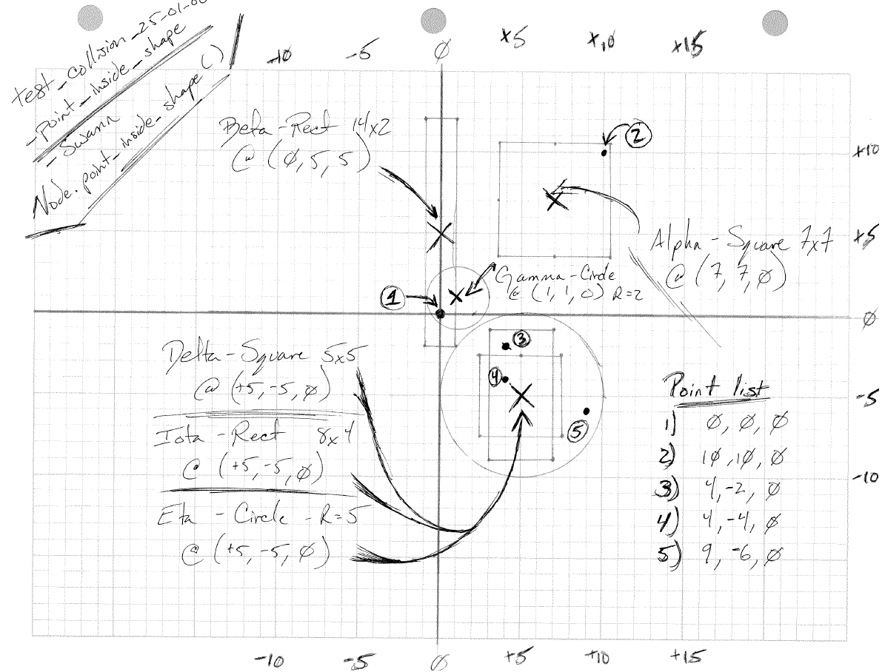

test notes :: explores support functionality determining whether a given shape’s node exists within another shape

// Collision.point_inside_shape()

// --> Heterogeneous Test

@Test

**public** **void** test_collision_25_01_00_point_inside_shape() {

// The setup

Node one = **new** Node(0, 0, 0),

two = **new** Node(10, 10, 0),

tre = **new** Node(4, -2, 0),

four = **new** Node(4, -4, 0),

five = **new** Node(9, -6, 0);

// Simple Shapes

Square alpha = **new** Square( 7, 7, 7, 7, 7);

Square delta = **new** Square( 5, -5, 0, 5, 5);

Rectangle beta = **new** Rectangle( 0, 5, 0, 14, 2);

Rectangle iota = **new** Rectangle( 5, -5, 0, 8, 4);

Circle gamma = **new** Circle( 1, 1, 0, 2);

Circle eta = **new** Circle( 5, -5, 0, 5);

// Complex Shape

Shape omega = **new** Shape( 5, -5, 0);

omega.add_shape(delta);

omega.add_shape(iota);

omega.add_shape(eta);

// Alpha Shape

*assertEquals*(Collision.*point_inside_shape*(one, alpha), **false**);

*assertEquals*(Collision.*point_inside_shape*(two, alpha), **true**);

*assertEquals*(Collision.*point_inside_shape*(tre, alpha), **false**);

*assertEquals*(Collision.*point_inside_shape*(four, alpha), **false**);

*assertEquals*(Collision.*point_inside_shape*(five, alpha), **false**);

// Beta Shape

*assertEquals*(Collision.*point_inside_shape*(one, beta), **true**);

*assertEquals*(Collision.*point_inside_shape*(two, beta), **false**);

*assertEquals*(Collision.*point_inside_shape*(tre, beta), **false**);

*assertEquals*(Collision.*point_inside_shape*(four, beta), **false**);

*assertEquals*(Collision.*point_inside_shape*(five, beta), **false**);

// Gamma Shape

*assertEquals*(Collision.*point_inside_shape*(one, gamma), **true**);

*assertEquals*(Collision.*point_inside_shape*(two, gamma), **false**);

*assertEquals*(Collision.*point_inside_shape*(tre, gamma), **false**);

*assertEquals*(Collision.*point_inside_shape*(four, gamma), **false**);

*assertEquals*(Collision.*point_inside_shape*(five, gamma), **false**);

// Delta Shape

*assertEquals*(Collision.*point_inside_shape*(one, delta), **false**);

*assertEquals*(Collision.*point_inside_shape*(two, delta), **false**);

*assertEquals*(Collision.*point_inside_shape*(tre, delta), **false**);

*assertEquals*(Collision.*point_inside_shape*(four, delta), **true**);

*assertEquals*(Collision.*point_inside_shape*(five, delta), **false**);

// Iota Shape

*assertEquals*(Collision.*point_inside_shape*(one, iota), **false**);

*assertEquals*(Collision.*point_inside_shape*(two, iota), **false**);

*assertEquals*(Collision.*point_inside_shape*(tre, iota), **true**);

*assertEquals*(Collision.*point_inside_shape*(four, iota), **true**);

*assertEquals*(Collision.*point_inside_shape*(five, iota), **false**);

// Eta Shape

*assertEquals*(Collision.*point_inside_shape*(one, eta), **false**);

*assertEquals*(Collision.*point_inside_shape*(two, eta), **false**);

*assertEquals*(Collision.*point_inside_shape*(tre, eta), **true**);

*assertEquals*(Collision.*point_inside_shape*(four, eta), **true**);

*assertEquals*(Collision.*point_inside_shape*(five, eta), **true**);

// Omega Shape

*assertEquals*(Collision.*point_inside_shape*(one, omega), **false**);

*assertEquals*(Collision.*point_inside_shape*(two, omega), **false**);

*assertEquals*(Collision.*point_inside_shape*(tre, omega), **true**);

*assertEquals*(Collision.*point_inside_shape*(four, omega), **true**);

*assertEquals*(Collision.*point_inside_shape*(five, omega), **true**);

}

function notes :: implementation of point_inside_shape()

/**

* Controls the logic path for determining whether or not a

*

* **@param** vertex_node : The point/node for comparison

* **@param** target_shape : The show for comparison

*

* **@return** { boolean } : Boolean variable representing whether the point is

* inside the shape.

*/

**public** **static** **boolean** point_inside_shape( Node vertex_node, Shape target_shape ) {

**if** ( target_shape.is_composite() ) {

**return** Collision.*point_inside_complex_shape*( vertex_node, target_shape );

}

**else** {

**return** Collision.*point_inside_simple_shape*( vertex_node, target_shape );

}

} // end Collision.point_inside_shape()

/**

* Determines whether or not a point is within the bounds of a simple shape.

*

* **@param** vertex_node : The point/node for comparison

* **@param** target_shape : The show for comparison

*

* **@return** { boolean } : Boolean variable representing whether the point is

* inside the shape.

*/

**public** **static** **boolean** point_inside_simple_shape( Node vertex_node, Shape target_shape ) {

**boolean** output = **false**;

// What to do if Circle shape.

**if** (target_shape **instanceof** Circle){

// Point must be within radius only.

**if** (target_shape.get_radius() > Node.*distance_between_nodes*(vertex_node,

target_shape.get_primary_node())) {

output = **true**;

} // end internal IF

} // end instanceof IF

// What to do if NOT Circle shape.

**else** {

Node head_node = target_shape.get_head_point();

// tracking variable : if NOT ~ 360 at the end, node is not inside

**float** tracker = *ZERO*;

**while**( head_node.has_next() ) {

**if** ( head_node.is_edge_closed() ) {

tracker += Node.*get_angle*(vertex_node,

head_node,

head_node.get_next());

} // end internal IF

head_node = head_node.get_next();

} // end WHILE

Node top_node = target_shape.get_head_point();

// Wrap around to front node.

**if** ( head_node.is_edge_closed() ) {

tracker += Node.*get_angle*( vertex_node,

head_node,

top_node);

} // end IF

// If angle summation ~360 --> node is within the shape

//

// This therom was originally grabbed from Wolfram Alpha's website

// I have since not been able to locate the function. If I can find

// another reference, I will supply it.

// ~ swann 2013-11-19

//

**if** ( tracker < *TOP* && tracker > *BOTTOM* ) {

output = **true**;

}

} // end ELSE

**return** output;

} // end Collision.point_inside_simple_shape()

/**

* Determines whether or not a point is within the bounds of a complex shape.

*

* **@param** vertex_node : The point/node for comparison

* **@param** target_shape : The show for comparison

*

* **@return** output : Boolean variable representing whether the point is

* inside the shape.

*/

**public** **static** **boolean** point_inside_complex_shape( Node vertex_node, Shape target_shape ) {

**boolean** output = **false**;

**for** (**int** i = *ZERO* ; i < target_shape.get_composite_list().size() ; i++ ) {

**if** (Collision.*point_inside_shape*(vertex_node,

target_shape.get_composite_list().get(i))) {

output = **true**;

}

} // end FOR

**return** output;

} // end Collision.point_inside_complex_shape()

module :: Item/Collision.java

test/design :: test_collision_30_01_00_collision_check

function :: Collision.check() && Collision.execute()

description :: design of the specific check determining whether or not different shape objects collide

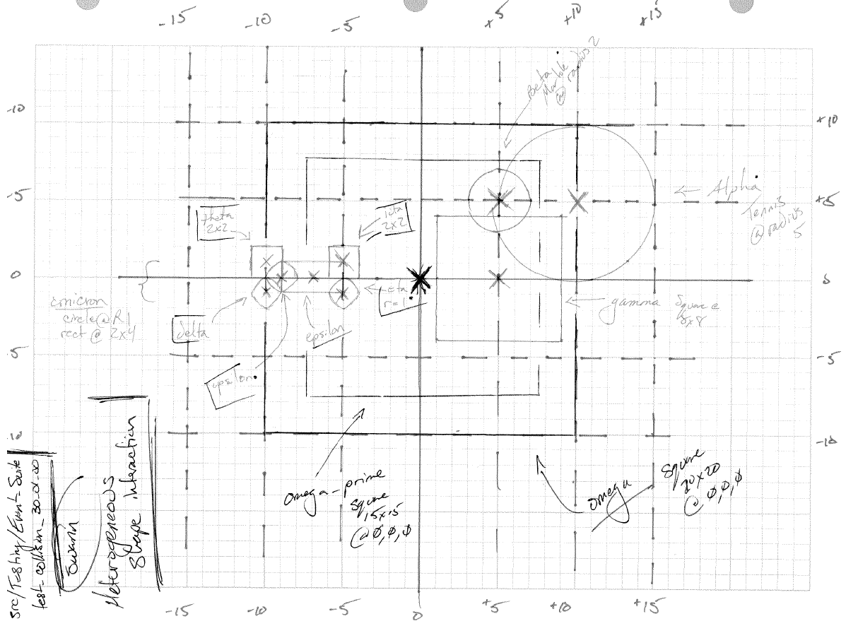

test notes :: explores functionality determining whether different shapes collide

// Collision.collision_check()

// --> Heterogeneous Test

@Test

**public** **void** test_collision_30_01_00_collision_check() {

// The Setup

// Simple Shapes

Circle alpha = **new** Circle(*TEN*, *FIVE*, *FIVE*, *FIVE*);

Circle beta = **new** Circle(*FIVE*, *FIVE*, *FIVE*, *TWO*);

Circle delta = **new** Circle(-10, -1, -1, *ONE*);

Circle eta = **new** Circle(-5, -1, -1, *ONE*);

Circle upsilon = **new** Circle(-9, *ZERO*, *ZERO*, *ONE*);

Square gamma = **new** Square(*FIVE*, *ZERO*, *ZERO*, *EIGHT*, *EIGHT*);

Square theta = **new** Square(-10, *ONE*, *ONE*, *TWO*, *TWO*);

Square iota = **new** Square(-5, *ONE*, *ONE*, *TWO*, *TWO*);

Square omega = **new** Square(*ZERO*, *ZERO*, *ZERO*, 20, 20);

Square omega_p = **new** Square(*ZERO*, *ZERO*, *ZERO*, 15, 15);

Rectangle epsilon = **new** Rectangle(-7, *ZERO*, *ZERO*, *TWO*, *FOUR*);

// Complex Shapes

Shape omicron = **new** Shape(-9, *ZERO*, *ZERO*);

omicron.add_shape( upsilon );

omicron.add_shape( epsilon );

omicron.calculate_radius();

*assertEquals*(omicron.get_radius(), Math.*pow*(17, *A_HALF*), *A_HUNDREDTH*);

// Alpha Shape

*assertEquals*(Collision.*collision_check*( alpha, alpha ), **false**);

*assertEquals*(Collision.*collision_check*( alpha, beta ), **true**);

*assertEquals*(Collision.*collision_check*( alpha, gamma ), **true**);

*assertEquals*(Collision.*collision_check*( alpha, delta ), **false**);

*assertEquals*(Collision.*collision_check*( alpha, eta ), **false**);

*assertEquals*(Collision.*collision_check*( alpha, upsilon ), **false**);

*assertEquals*(Collision.*collision_check*( alpha, epsilon ), **false**);

*assertEquals*(Collision.*collision_check*( alpha, iota ), **false**);

*assertEquals*(Collision.*collision_check*( alpha, theta ), **false**);

*assertEquals*(Collision.*collision_check*( alpha, omega ), **true**);

*assertEquals*(Collision.*collision_check*( alpha, omega_p ), **true**);

// Beta Shape

*assertEquals*(Collision.*collision_check*( beta, alpha ), **true**);

*assertEquals*(Collision.*collision_check*( beta, beta ), **false**);

*assertEquals*(Collision.*collision_check*( beta, gamma ), **true**);

*assertEquals*(Collision.*collision_check*( beta, delta ), **false**);

*assertEquals*(Collision.*collision_check*( beta, eta ), **false**);

*assertEquals*(Collision.*collision_check*( beta, upsilon ), **false**);

*assertEquals*(Collision.*collision_check*( beta, epsilon ), **false**);

*assertEquals*(Collision.*collision_check*( beta, iota ), **false**);

*assertEquals*(Collision.*collision_check*( beta, theta ), **false**);

*assertEquals*(Collision.*collision_check*( beta, omega ), **true**);

*assertEquals*(Collision.*collision_check*( beta, omega_p ), **true**);

// Gamma Shape

*assertEquals*(Collision.*collision_check*( gamma, alpha ), **true**);

*assertEquals*(Collision.*collision_check*( gamma, beta ), **true**);

*assertEquals*(Collision.*collision_check*( gamma, gamma ), **false**);

*assertEquals*(Collision.*collision_check*( gamma, delta ), **false**);

*assertEquals*(Collision.*collision_check*( gamma, eta ), **false**);

*assertEquals*(Collision.*collision_check*( gamma, upsilon ), **false**);

*assertEquals*(Collision.*collision_check*( gamma, epsilon ), **false**);

*assertEquals*(Collision.*collision_check*( gamma, iota ), **false**);

*assertEquals*(Collision.*collision_check*( gamma, theta ), **false**);

*assertEquals*(Collision.*collision_check*( gamma, omega ), **true**);

*assertEquals*(Collision.*collision_check*( gamma, omega_p ), **true**);

// Delta Shape

*assertEquals*(Collision.*collision_check*( delta, alpha ), **false**);

*assertEquals*(Collision.*collision_check*( delta, beta ), **false**);

*assertEquals*(Collision.*collision_check*( delta, gamma ), **false**);

*assertEquals*(Collision.*collision_check*( delta, delta ), **false**);

*assertEquals*(Collision.*collision_check*( delta, eta ), **false**);

*assertEquals*(Collision.*collision_check*( delta, upsilon ), **true**);

*assertEquals*(Collision.*collision_check*( delta, epsilon ), **false**);

*assertEquals*(Collision.*collision_check*( delta, iota ), **false**);

*assertEquals*(Collision.*collision_check*( delta, theta ), **true**);

*assertEquals*(Collision.*collision_check*( delta, omega ), **true**);

*assertEquals*(Collision.*collision_check*( delta, omega_p ), **false**);

// Eta Shape

*assertEquals*(Collision.*collision_check*( eta, alpha ), **false**);

*assertEquals*(Collision.*collision_check*( eta, beta ), **false**);

*assertEquals*(Collision.*collision_check*( eta, gamma ), **false**);

*assertEquals*(Collision.*collision_check*( eta, delta ), **false**);

*assertEquals*(Collision.*collision_check*( eta, eta ), **false**);

*assertEquals*(Collision.*collision_check*( eta, upsilon ), **false**);

*assertEquals*(Collision.*collision_check*( eta, epsilon ), **true**);

*assertEquals*(Collision.*collision_check*( eta, iota ), **true**);

*assertEquals*(Collision.*collision_check*( eta, theta ), **false**);

*assertEquals*(Collision.*collision_check*( eta, omega ), **true**);

*assertEquals*(Collision.*collision_check*( eta, omega_p ), **true**);

// Iota Shape

*assertEquals*(Collision.*collision_check*( iota, alpha ), **false**);

*assertEquals*(Collision.*collision_check*( iota, beta ), **false**);

*assertEquals*(Collision.*collision_check*( iota, gamma ), **false**);

*assertEquals*(Collision.*collision_check*( iota, delta ), **false**);

*assertEquals*(Collision.*collision_check*( iota, eta ), **true**);

*assertEquals*(Collision.*collision_check*( iota, upsilon ), **false**);

*assertEquals*(Collision.*collision_check*( iota, epsilon ), **true**);

*assertEquals*(Collision.*collision_check*( iota, iota ), **false**);

*assertEquals*(Collision.*collision_check*( iota, theta ), **false**);

*assertEquals*(Collision.*collision_check*( iota, omega ), **true**);

*assertEquals*(Collision.*collision_check*( iota, omega_p ), **true**);

// Theta Shape

*assertEquals*(Collision.*collision_check*( theta, alpha ), **false**);

*assertEquals*(Collision.*collision_check*( theta, beta ), **false**);

*assertEquals*(Collision.*collision_check*( theta, gamma ), **false**);

*assertEquals*(Collision.*collision_check*( theta, delta ), **true**);

*assertEquals*(Collision.*collision_check*( theta, eta ), **false**);

*assertEquals*(Collision.*collision_check*( theta, upsilon ), **true**);

*assertEquals*(Collision.*collision_check*( theta, epsilon ), **true**);

*assertEquals*(Collision.*collision_check*( theta, iota ), **false**);

*assertEquals*(Collision.*collision_check*( theta, theta ), **false**);

*assertEquals*(Collision.*collision_check*( theta, omega ), **true**);

*assertEquals*(Collision.*collision_check*( theta, omega_p ), **false**);

// Upsilon Shape

*assertEquals*(Collision.*collision_check*( upsilon, alpha ), **false**);

*assertEquals*(Collision.*collision_check*( upsilon, beta ), **false**);

*assertEquals*(Collision.*collision_check*( upsilon, gamma ), **false**);

*assertEquals*(Collision.*collision_check*( upsilon, delta ), **true**);

*assertEquals*(Collision.*collision_check*( upsilon, eta ), **false**);

*assertEquals*(Collision.*collision_check*( upsilon, upsilon ), **false**);

*assertEquals*(Collision.*collision_check*( upsilon, epsilon ), **true**);

*assertEquals*(Collision.*collision_check*( upsilon, iota ), **false**);

*assertEquals*(Collision.*collision_check*( upsilon, theta ), **true**);

*assertEquals*(Collision.*collision_check*( upsilon, omega ), **true**);

*assertEquals*(Collision.*collision_check*( upsilon, omega_p ), **false**);

// Epsilon Shape

*assertEquals*(Collision.*collision_check*( epsilon, alpha ), **false**);

*assertEquals*(Collision.*collision_check*( epsilon, beta ), **false**);

*assertEquals*(Collision.*collision_check*( epsilon, gamma ), **false**);

*assertEquals*(Collision.*collision_check*( epsilon, delta ), **false**);

*assertEquals*(Collision.*collision_check*( epsilon, eta ), **true**);

*assertEquals*(Collision.*collision_check*( epsilon, upsilon ), **true**);

*assertEquals*(Collision.*collision_check*( epsilon, epsilon ), **false**);

*assertEquals*(Collision.*collision_check*( epsilon, iota ), **true**);

*assertEquals*(Collision.*collision_check*( epsilon, theta ), **true**);

*assertEquals*(Collision.*collision_check*( epsilon, omega ), **true**);

*assertEquals*(Collision.*collision_check*( epsilon, omega_p ), **true**);

// Omicron Shape --> Forward

*assertEquals*(Collision.*collision_check*( omicron, alpha ), **false**);

*assertEquals*(Collision.*collision_check*( omicron, beta ), **false**);

*assertEquals*(Collision.*collision_check*( omicron, gamma ), **false**);

*assertEquals*(Collision.*collision_check*( omicron, delta ), **true**);

*assertEquals*(Collision.*collision_check*( omicron, eta ), **true**);

*assertEquals*(Collision.*collision_check*( omicron, iota ), **true**);

*assertEquals*(Collision.*collision_check*( omicron, theta ), **true**);

*assertEquals*(Collision.*collision_check*( omicron, omega ), **true**);

*assertEquals*(Collision.*collision_check*( omicron, omega_p ), **true**);

// Omicron Shape --> Backward

*assertEquals*(Collision.*collision_check*( alpha, omicron ), **false**);

*assertEquals*(Collision.*collision_check*( beta , omicron ), **false**);

*assertEquals*(Collision.*collision_check*( gamma, omicron ), **false**);

*assertEquals*(Collision.*collision_check*( delta, omicron ), **true**);

*assertEquals*(Collision.*collision_check*( eta, omicron ), **true**);

*assertEquals*(Collision.*collision_check*( iota, omicron ), **true**);

*assertEquals*(Collision.*collision_check*( theta, omicron ), **true**);

*assertEquals*(Collision.*collision_check*( omega, omicron ), **true**);

*assertEquals*(Collision.*collision_check*( omega_p, omicron ), **true**);

}

Fuction notes :: implementation of primary and support logic for execute() and check()

/**

* This function controls the routing logic as to which version of the execute functions

* ought be called. A set of size two can use a simple update mechanism. A set of larger

* sizes requires a more complex method.

*/

**public** **void** execute( ) **throws** CloneNotSupportedException, RuntimeException {

// A working set is needed.

ArrayList<Actor_Object> working_set;

// While there are more collision sets to execute.

**while** ( **this**.flagged_object_list.size() > *ZERO* ){

working_set = dequeue_set();

// Shouldn't have a set of size zero

**if** ( working_set.size() == *ZERO* ) {

**throw** **new** RuntimeException("working set size is ZERO, too low for processing a COLLISION");

}

// Shouldn't have a set of size one

**else** **if** ( working_set.size() == *ONE* ) {

**throw** **new** RuntimeException("working set size is ONE, too low for processing a COLLISION");

}

// For size two, use the simpler calculation method

**else** **if** ( working_set.size() == *TWO* ) {

**this**.execute_collision_size_two( working_set );

}

// For size three or larger, use the more complex method

**else** {

**this**.execute_collision_size_n( working_set );

} // end IF-ELSE Chain

} // end while connected to this.flagged_object_list

} // end Collision.execute()

/**

* This function handles the execution of a collision event on a pair of objects.

*

* **@param** set : ArrayList of two Actor_Objects

*/

**public** **void** execute_collision_size_two( ArrayList<Actor_Object> set ) **throws** CloneNotSupportedException, RuntimeException {

Iterator<Actor_Object> working_set_iterator = set.iterator();

// Get the two Actor_Objects for this collision.

Actor_Object actor_one;

Actor_Object actor_two;

// Initialize both to the first to allow 2-at-a-time iteration.

actor_one = actor_two = working_set_iterator.next();

**while** ( working_set_iterator.hasNext() ){

// Pull the new actor from the working set.

actor_one = actor_two;

actor_two = working_set_iterator.next();

Vector[] vector_list = **this**.execute_collision_support(actor_one, actor_two, actor_one.get_mass() + actor_two.get_mass());

Vector new_a = Vector.*add*(**new** Vector(actor_one.get_velocity()), vector_list[*ZERO*]);

Vector new_b = Vector.*add*(**new** Vector(actor_two.get_velocity()), vector_list[*ONE*]);

// Update each actor with the adjusted velocities.

actor_one.update_velocity(new_a.get_x_comp(), new_a.get_y_comp(), new_a.get_z_comp());

actor_two.update_velocity(new_b.get_x_comp(), new_b.get_y_comp(), new_b.get_z_comp());

// Calculate the popout distance between the two objects.

**float** diff = actor_one.get_shape().get_radius() +

actor_two.get_shape().get_radius() -

Node.*distance_between_nodes*( actor_one.get_shape().get_primary_node(),

actor_two.get_shape().get_primary_node() );

Vector a_pos = **new** Vector(actor_one.get_location());

Vector b_pos = **new** Vector(actor_two.get_location());

// Calculate the ratio of the diff distance which should be applied to each object.

**float** diff_one = diff * (actor_one.get_shape().get_radius() / (

actor_one.get_shape().get_radius() +

actor_two.get_shape().get_radius()));

**float** diff_two = diff * (actor_two.get_shape().get_radius() / (

actor_one.get_shape().get_radius() +

actor_two.get_shape().get_radius()));

// Calculate the normal of impact for this collision (Normal vector for collision plane).

Vector norm_of_impact = Vector.*normalize*(Vector.*subtract*(b_pos, a_pos));

a_pos = Vector.*add*(a_pos, Vector.*scalar_multiply*(norm_of_impact, -diff_one));

b_pos = Vector.*add*(b_pos, Vector.*scalar_multiply*(norm_of_impact, diff_two));

actor_one.update_location(a_pos.get_x_comp(), a_pos.get_y_comp(), a_pos.get_z_comp());

actor_two.update_location(b_pos.get_x_comp(), b_pos.get_y_comp(), b_pos.get_z_comp());

} // end while

} // end Collision.execute_collision_size_two()

/**

* This function handles the execution of a collision event on a number of objects

* greater than two.

*

* **@param** set : ArrayList of three or more Actor_Objects

*/

**public** **void** execute_collision_size_n( ArrayList<Actor_Object> set )

**throws** CloneNotSupportedException, RuntimeException {

// Working object memory reservations

Actor_Object first_object, second_object;

Vector[] vector_list;

// Make a clone copy

ArrayList<Actor_Object> copied_set = Event_Interaction.*clone_list*( set );

**float** total_mass = *ZERO*;

**for** ( **int** i = *ZERO* ; i < set.size() ; i++ ){

total_mass += set.get(i).get_mass();

}

// External loop

**for** ( **int** i = *ZERO* ; i <= set.size() - *TWO* ; i++ ) {

first_object = set.get(i);

// Internal loop

**for** ( **int** j = i + *ONE* ; j <= set.size() - *ONE* ; j++ ) {

second_object = set.get(j);

**float**[] a = first_object.get_velocity();

**float**[] b = second_object.get_velocity();

vector_list = **this**.execute_collision_support(first_object, second_object, total_mass);

Actor_Object first_objectx = copied_set.get(i);

Actor_Object second_objectx = copied_set.get(j);

a = first_objectx.get_velocity();

b = second_objectx.get_velocity();

Vector new_a = Vector.*add*(**new** Vector(first_objectx.get_velocity()), vector_list[*ZERO*]);

Vector new_b = Vector.*add*(**new** Vector(second_objectx.get_velocity()), vector_list[*ONE*]);

// Update each actor with the adjusted velocities.

first_objectx.update_velocity(new_a.get_x_comp(), new_a.get_y_comp(), new_a.get_z_comp());

second_objectx.update_velocity(new_b.get_x_comp(), new_b.get_y_comp(), new_b.get_z_comp());

} // end internal loop

} // end external loop

// Unpacking the clone

**for** ( **int** i = *ZERO* ; i < set.size() ; i++ ){

Actor_Object the_obj = set.get(i);

Actor_Object updated_obj = copied_set.get(i);

//Vector v = Vector.scalar_multiply(new Vector(updated_obj.get_velocity()), the_obj.get_mass() / total_mass );

Vector v = **new** Vector(updated_obj.get_velocity());

the_obj.update_velocity(v.get_x_comp(), v.get_y_comp(), v.get_z_comp());

} // end for loop

} // end Collision.execute_collision_size_n()

/**

* This function handles the execution of a collision event on a number of objects

* greater than two.

*

* **@param** alpha : First of two Actor_Objects

* **@param** beta : Second of two Actor_Objects

*

* **@return** {Vector[] } : Array of two Vector Adjustments

*/

**public** Vector[] execute_collision_support( Actor_Object alpha, Actor_Object beta, **float** total_mass )

**throws** CloneNotSupportedException, RuntimeException {

Actor_Object actor_one = (Actor_Object)alpha.clone();

Actor_Object actor_two = (Actor_Object) beta.clone();

// Get the actors' locations as vectors.

Vector a_pos = **new** Vector(actor_one.get_location());

Vector b_pos = **new** Vector(actor_two.get_location());

// Calculate the normal of impact for this collision (Normal vector for collision plane).

Vector norm_of_impact = Vector.*normalize*(Vector.*subtract*(b_pos, a_pos));

// Get the actors' velocities as vectors.

Vector a_vel = **new** Vector(actor_one.get_velocity());

Vector b_vel = **new** Vector(actor_two.get_velocity());

// Calculate the relative velocity between the two actors.

Vector relative_velocity = Vector.*subtract*(b_vel, a_vel);

// Get the magnitude of the relative velocity along the collision normal.

**float** relative_velocity_along_normal = Vector.*dot_product*(relative_velocity, norm_of_impact);

// Find the lower coefficient of restitution (elasticity)

**float** coeff_of_restitution = Math.*min*(actor_one.get_coefficient_of_restitution(), actor_two.get_coefficient_of_restitution());

// Calculate the impulse magnitude.

**float** impulse_scalar = -(1+coeff_of_restitution) * relative_velocity_along_normal;

impulse_scalar = impulse_scalar / (1/actor_one.get_mass() + 1/actor_two.get_mass());

// Scale the normal of collision by the impulse magnitude.

Vector impulse_along_normal = Vector.*scalar_multiply*(norm_of_impact, impulse_scalar);

// Using mass ratios (to conserve mass / energy in the system), calculate the velocity adjustments for each actor.

Vector a_adjust = Vector.*scalar_multiply*(impulse_along_normal, -1/actor_one.get_mass());

Vector b_adjust = Vector.*scalar_multiply*(impulse_along_normal, +1/actor_two.get_mass());

Vector[] vector_list = **new** Vector[*TWO*];

vector_list[*ZERO*] = a_adjust;

vector_list[*ONE*] = b_adjust;

**return** vector_list;

} // end Collision.execute_collision_support()

/**

* Checks each object within the sim-space and determines if a boundary

*

* **@param** list_of_objects : All interactive objects within the sim-space.

*

* **@return** { boolean } : Representing whether or not something has an collision event.

*/

**public** **boolean** check( ArrayList<Actor_Object> list_of_objects ) {

ArrayList<Actor_Object> flex_list;

**boolean** checked = **false**;

**for** (**int** i = *ZERO* ; i < list_of_objects.size() ; i++) {

**for** (**int** j = i + *ONE* ; j < list_of_objects.size() ; j++) {

Actor_Object first_object = list_of_objects.get(i);

Actor_Object second_object = list_of_objects.get(j);

// short circuit operation if non-interactive event

**if** ( first_object.get_interactive() == **true** &&

second_object.get_interactive() == **true**) {

**if** ( Collision.*collision_check*( first_object.get_shape(),

second_object.get_shape() )) {

flex_list = **new** ArrayList<Actor_Object>();

flex_list.add( first_object );

flex_list.add(second_object );

**this**.enqueue_set( flex_list );

checked = **true**;

} // end IF

} // end interactive check

} // end internal for-loop --> J var

} // end external for-loop --> I var

**return** checked;

} // end Collision.check()

/**

* Ascertains whether a point exists within a given shape.

*

* **@param** vertex_node : The point/node for comparison

* **@param** target_shape : The show for comparison

*

* **@return** output : Boolean variable representing whether the point is

* inside the shape.

*/

**public** **static** **boolean** collision_check( Shape shape_one, Shape shape_two ) {

**boolean** result = **false**;

// Identity Check should end quickly

**if** (shape_one == shape_two) {

result = **false**;

} // end short circuit

// Circle vs Circle Check

**else** **if** (shape_one **instanceof** Circle && shape_two **instanceof** Circle) {

result = Collision.*boundary_sphere_incident*( shape_one, shape_two );

} // end IF

**else** {

// Checks boundary spheres. Only enters point by point check if a sphere

// incident has taken place.

**if** ( Collision.*boundary_sphere_incident*(shape_one, shape_two) ){

**if** (shape_one **instanceof** Circle) {

shape_one.set_head_node(shape_two);

}

**if** (shape_two **instanceof** Circle) {

shape_two.set_head_node(shape_one);

}

// START FORWARD CHECK

**if** ( ! shape_one.is_composite() ){

Node head_node = shape_one.get_head_point();

**if** ( Collision.*point_inside_shape*(head_node, shape_two) ) {

result = **true**;

}

**while** ( result == **false** && head_node.has_next() ) {

**if** ( Collision.*point_inside_shape*(head_node, shape_two) ) {

result = **true**;

}

head_node = head_node.get_next();

}// end while

} // end if

**else** {

ArrayList<Shape> the_list = shape_one.get_composite_list();

**for** (**int** i = *ZERO*; i < the_list.size(); i++) {

Node head_node = the_list.get(i).get_head_point();

**if** ( Collision.*point_inside_shape*(head_node, shape_two) ) {

result = **true**;

}

**while** ( result == **false** && head_node.has_next() ) {

**if** ( Collision.*point_inside_shape*(head_node, shape_two) ) {

result = **true**;

}

head_node = head_node.get_next();

}// end while

} // end for-loop

} // end else

// END FORWARD CHECK

// START REVERSE CHECK

**if** ( ! shape_two.is_composite() ){

Node head_node = shape_two.get_head_point();

**if** ( Collision.*point_inside_shape*(head_node, shape_one) ) {

result = **true**;

}

**while** ( result == **false** && head_node.has_next() ) {

**if** ( Collision.*point_inside_shape*(head_node, shape_one) ) {

result = **true**;

}

head_node = head_node.get_next();

}// end while

} // end if

**else** {

ArrayList<Shape> the_list = shape_two.get_composite_list();

**for** (**int** i = *ZERO*; i < the_list.size(); i++) {

Node head_node = the_list.get(i).get_head_point();

**if** ( Collision.*point_inside_shape*(head_node, shape_one) ) {

result = **true**;

}

**while** ( result == **false** && head_node.has_next() ) {

**if** ( Collision.*point_inside_shape*(head_node, shape_one) ) {

result = **true**;

}

head_node = head_node.get_next();

}// end while

} // end for-loop

} // end else

// END REVERSE CHECK

} // end Boundary Sphere incident check

} // end ELSE

**return** result;

} // end Collision.collision_check()

module :: Item/Collision.java

test/design :: test_collision_31_01_00_collision_check

description :: design of the specific check determining whether or not different shape objects collide

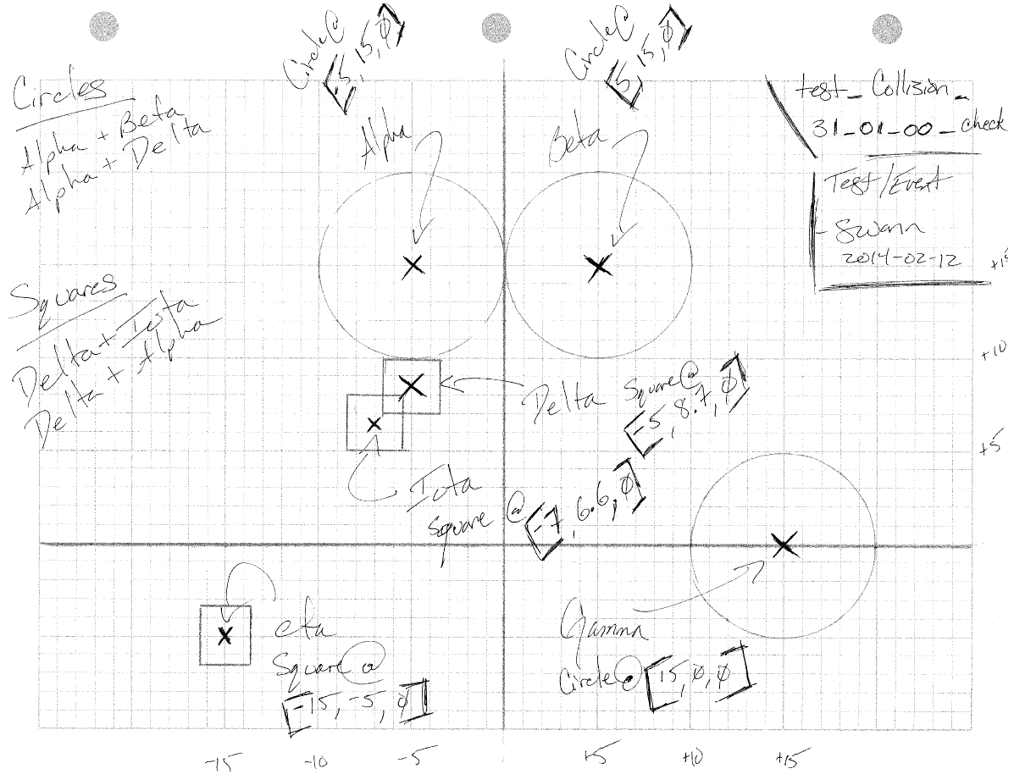

test notes :: explores functionality determining whether different shapes collide

// Collision.collision_check()

// --> Heterogeneous Test

@Test

**public** **void** test_collision_31_01_00_collision_check() {

// The Setup

Circle Alpha = **new** Circle( -5, 15, 0),

Beta = **new** Circle( 5, 15, 0),

Gamma = **new** Circle( 15, 0, 0);

Square Delta = **new** Square( -5, (**float**)8.7, 0, 3, 3),

Iota = **new** Square( -7, (**float**)6.6, 0, 3, 3),

Eta = **new** Square(-15, -5, 0, 3, 3);

// Alpha Checks

*assertEquals*(Collision.*collision_check*( Alpha, Alpha ), **false**);

*assertEquals*(Collision.*collision_check*( Alpha, Beta ), **false**);

*assertEquals*(Collision.*collision_check*( Alpha, Gamma ), **false**);

*assertEquals*(Collision.*collision_check*( Alpha, Delta ), **false**);

*assertEquals*(Collision.*collision_check*( Alpha, Iota ), **false**);

*assertEquals*(Collision.*collision_check*( Alpha, Eta ), **false**);

// Beta Checks

*assertEquals*(Collision.*collision_check*( Beta, Alpha ), **false**);

*assertEquals*(Collision.*collision_check*( Beta, Beta ), **false**);

*assertEquals*(Collision.*collision_check*( Beta, Gamma ), **false**);

*assertEquals*(Collision.*collision_check*( Beta, Delta ), **false**);

*assertEquals*(Collision.*collision_check*( Beta, Iota ), **false**);

*assertEquals*(Collision.*collision_check*( Beta, Eta ), **false**);

// Gamma Checks

*assertEquals*(Collision.*collision_check*( Gamma, Alpha ), **false**);

*assertEquals*(Collision.*collision_check*( Gamma, Beta ), **false**);

*assertEquals*(Collision.*collision_check*( Gamma, Gamma ), **false**);

*assertEquals*(Collision.*collision_check*( Gamma, Delta ), **false**);

*assertEquals*(Collision.*collision_check*( Gamma, Iota ), **false**);

*assertEquals*(Collision.*collision_check*( Gamma, Eta ), **false**);

// Delta Checks

*assertEquals*(Collision.*collision_check*( Delta, Alpha ), **false**);

*assertEquals*(Collision.*collision_check*( Delta, Beta ), **false**);

*assertEquals*(Collision.*collision_check*( Delta, Gamma ), **false**);

*assertEquals*(Collision.*collision_check*( Delta, Delta ), **false**);

*assertEquals*(Collision.*collision_check*( Delta, Iota ), **true**);

*assertEquals*(Collision.*collision_check*( Delta, Eta ), **false**);

// Iota Checks

*assertEquals*(Collision.*collision_check*( Iota, Alpha ), **false**);

*assertEquals*(Collision.*collision_check*( Iota, Beta ), **false**);

*assertEquals*(Collision.*collision_check*( Iota, Gamma ), **false**);

*assertEquals*(Collision.*collision_check*( Iota, Delta ), **true**);

*assertEquals*(Collision.*collision_check*( Iota, Iota ), **false**);

*assertEquals*(Collision.*collision_check*( Iota, Eta ), **false**);

// Eta Checks

*assertEquals*(Collision.*collision_check*( Eta, Alpha ), **false**);

*assertEquals*(Collision.*collision_check*( Eta, Beta ), **false**);

*assertEquals*(Collision.*collision_check*( Eta, Gamma ), **false**);

*assertEquals*(Collision.*collision_check*( Eta, Delta ), **false**);

*assertEquals*(Collision.*collision_check*( Eta, Iota ), **false**);

*assertEquals*(Collision.*collision_check*( Eta, Eta ), **false**);

}

module :: Item/Collision.java

test/design :: test_collision_40_(03-08)_00_collision_check

description :: design of the specific check determining whether or not different shape objects collide; single sets

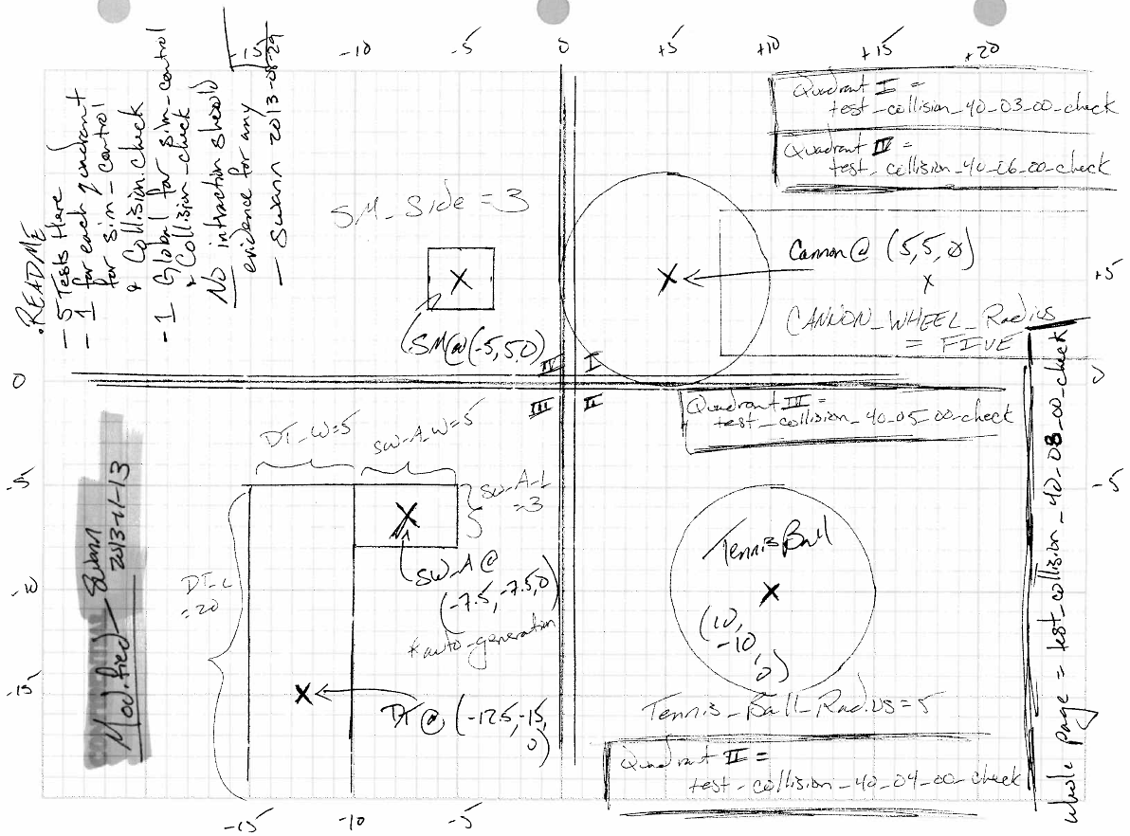

test notes :: explores functional validity of check algorithm against single sets of objects

// Collision.check()

@Test

**public** **void** test_collision_40_03_00_check() {

ArrayList<Actor_Object> test_list = **new** ArrayList<Actor_Object>();

// Quadrant One Test of related analog test design --> see notebook

// ~swann, 2013-08-29

test_list.add( **new** Cannon(*FIVE*, *FIVE*, *ZERO*) );

*assertEquals*(test_list.size(), *ONE*, *ZERO*);

collider.check(test_list);

LinkedList<Actor_Object> THE_list = collider.get_list();

*assertEquals*(*ZERO*, THE_list.size(), *ZERO*);

}

// Collision.check()

@Test

**public** **void** test_collision_40_04_00_check() {

ArrayList<Actor_Object> test_list = **new** ArrayList<Actor_Object>();

// Quadrant Two Test of related analog test design --> see notebook

// ~swann, 2013-08-29

test_list.add( Ball.*generate_Tennis_Ball*(*TEN*, *ZERO*-*TEN*, *ZERO*) );

*assertEquals*(test_list.size(), *ONE*, *ZERO*);

collider.check(test_list);

LinkedList<Actor_Object> THE_list = collider.get_list();

*assertEquals*(*ZERO*, THE_list.size(), *ZERO*);

}

// Collision.check()

@Test

**public** **void** test_collision_40_05_00_check() {

ArrayList<Actor_Object> test_list = **new** ArrayList<Actor_Object>();

// Quadrant Three Test of related analog test design --> see notebook

// ~swann, 2013-08-29

DropTower drop_tower = **new** DropTower((**float**) (*ZERO*-12.5), *ZERO*-15, *ZERO*);

test_list.add( drop_tower );

test_list.add( drop_tower.swing_arm_generation() );

*assertEquals*(test_list.size(), *TWO*, *ZERO*);

collider.check(test_list);

LinkedList<Actor_Object> THE_list = collider.get_list();

*assertEquals*(*ZERO*, THE_list.size(), *ZERO*);

}

// Collision.check()

@Test

**public** **void** test_collision_40_06_00_check() {

ArrayList<Actor_Object> test_list = **new** ArrayList<Actor_Object>();

// Quadrant Four Test of related analog test design --> see notebook

// ~swann, 2013-08-29

test_list.add( Standard_Mass.*generate_one_g_mass*(*ZERO*-*FIVE*, *FIVE*, *ZERO*) );

*assertEquals*(test_list.size(), *ONE*, *ZERO*);

collider.check(test_list);

LinkedList<Actor_Object> THE_list = collider.get_list();

*assertEquals*(*ZERO*, THE_list.size(), *ZERO*);

}

// Collision.check()

@Test

**public** **void** test_collision_40_07_00_check() {

//ArrayList<Actor_Object> test_list = new ArrayList<Actor_Object>();

// Undefined test number/test structure

// ~swann, 2013-08-29

}

// Collision.check()

@Test

**public** **void** test_collision_40_08_00_check() {

ArrayList<Actor_Object> test_list = **new** ArrayList<Actor_Object>();

// ALL Quadrant Test of related analog test design --> see notebook

// ~swann, 2013-08-29

DropTower drop_tower = **new** DropTower((**float**) (*ZERO*-12.5), *ZERO*-15, *ZERO*);

test_list.add( drop_tower );

test_list.add( drop_tower.swing_arm_generation() );

test_list.add( **new** Cannon(*FIVE*, *FIVE*, *ZERO*) );

test_list.add( Standard_Mass.*generate_one_g_mass*(*ZERO*-*FIVE*, *FIVE*, *ZERO*) );

test_list.add( Ball.*generate_Tennis_Ball*(*TEN*, *ZERO*-*TEN*, *ZERO*) );

*assertEquals*(test_list.size(), *FIVE*, *ZERO*);

collider.check(test_list);

LinkedList<Actor_Object> THE_list = collider.get_list();

// console feed of linked list internals.

// save for now. **ANALOG**

// ~swann, 2013-11-13

//

// list has 3 elements, the mass, the ball and a NULL sentinel

// cannons, swing_arms and drop_towers are ALL NON-interactive at this time

**for** ( **int** i = *ZERO* ; i < THE_list.size() ; i++ ) {

**if** ( THE_list.get(i) == **null** ) {

System.*out*.println( "null" );

} **else** {

System.*out*.println( THE_list.get(i).toString() );

}

}

*assertEquals*(*THREE*, THE_list.size(), *ZERO*);

} // test_collision_40_08_00_check

module :: Item/Collision.java

test/design :: test_collision_40_09_00_collision_check

description :: design of the first heterogenous shape collision check; testing functional validity of enqueue/dequeue

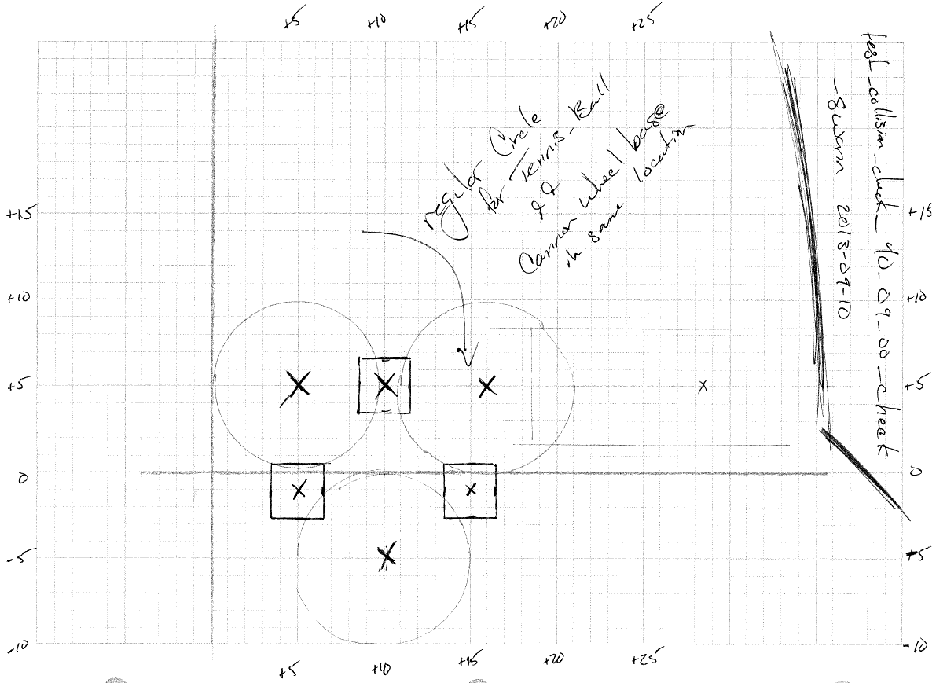

test notes :: heterogenous check on shape collisions; also a functional validity test on enqueue and dequeue

// Collision.check()

@Test

**public** **void** test_collision_40_09_00_check() {

ArrayList<Actor_Object> test_list = **new** ArrayList<Actor_Object>();

// Related to analog test design --> see notebook

// ~swann, 2013-09-10

test_list.add( Standard_Mass.*generate_one_g_mass*(*TEN*, *FIVE*, *ZERO*) );

test_list.add( Standard_Mass.*generate_one_g_mass*(*FIVE*, *NEGATIVE_ONE*, *ZERO*) );

test_list.add( Standard_Mass.*generate_one_g_mass*(*TEN*+*FIVE*, *NEGATIVE_ONE*, *ZERO*) );

test_list.add( Ball.*generate_Tennis_Ball*(16, *FIVE*, *ZERO*) );

test_list.add( Ball.*generate_Tennis_Ball*(*FIVE*, *FIVE*, *ZERO*) );

test_list.add( Ball.*generate_Tennis_Ball*(*TEN*, *ZERO*-*FIVE*, *ZERO*) );

test_list.add( **new** Cannon(16, *FIVE*, *ZERO*) );

*assertEquals*(test_list.size(), *SEVEN*, *ZERO*);

collider.check(test_list);

LinkedList<Actor_Object> THE_list = collider.get_list();

// 7 Objects, 1 Non-Interactive, 1 Sentinel = 7 total in list

*assertEquals*(*SEVEN*, THE_list.size(), *ZERO*);

}

module :: Item/Collision.java

test/design :: test_collision_40_10_00_collision_check

description :: design of the first heterogenous interactivity collision check; testing functional validity of enqueue/dequeue

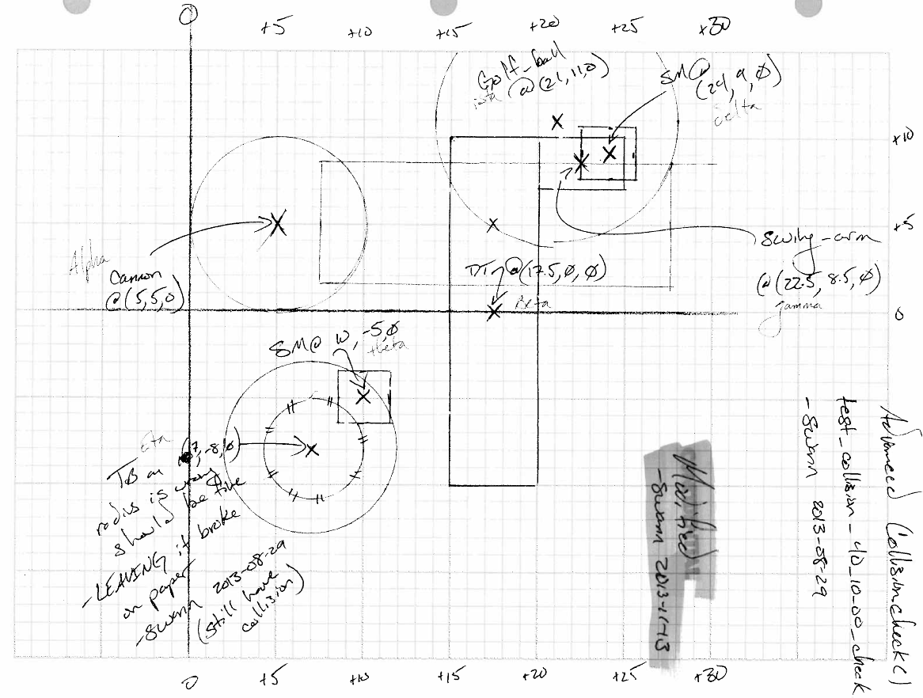

test notes :: heterogenous check on shape collisions; also a functional validity test on interactivity logic within enqueue and

dequeue

// Collision.check()

@Test

**public** **void** test_collision_40_10_00_check() {

ArrayList<Actor_Object> test_list = **new** ArrayList<Actor_Object>();

// Related to analog test design --> see notebook

// ~swann, 2013-08-29

DropTower beta = **new** DropTower((**float**) (17.5), *ZERO*, *ZERO*);

SwingArm gamma = beta.swing_arm_generation();

Standard_Mass delta = Standard_Mass.*generate_one_g_mass*(24, *NINE*, *ZERO*);

Standard_Mass theta = Standard_Mass.*generate_one_g_mass*(*TEN*, *ZERO*-*FIVE*, *ZERO*);

Cannon alpha = **new** Cannon(*FIVE*, *FIVE*, *ZERO*);

Ball eta = Ball.*generate_Tennis_Ball*(*SEVEN*, *ZERO*-*EIGHT*, *ZERO*);

Ball iota = Ball.*generate_Golf_Ball*(21, 11, *ZERO*);

// Battery One

test_list.add( eta );

test_list.add( theta );

*assertEquals*(test_list.size(), *TWO*, *ZERO*);

collider.check(test_list);

LinkedList<Actor_Object> THE_list = collider.get_list();

// eta + beta + null = 3

*assertEquals*(*THREE*, THE_list.size(), *ZERO*);

// Battery Two

test_list = **new** ArrayList<Actor_Object>();

test_list.add( delta ); // Standard_Mass

test_list.add( iota ); // Ball

test_list.add( eta ); // Ball

test_list.add( theta ); // Standard_Mass

*assertEquals*(test_list.size(), *FOUR*, *ZERO*);

collider.check(test_list);

THE_list = collider.get_list();

// ORIGINAL NOTATIONS

//

// eta + beta + null = 3

// delta + itoa + null = 3 ==> 6

//

// ---------------------------------------------

// console feed of linked list internals.

// save for now. **ANALOG**

// ~swann 2013-11-13

//

// list has 5 elements, after re-sizing, the collision sets

// converge into ONE larger set. the size drops one because of the lost

// of a flagged sentinel value

//

// eta + beta + delta + itoa + null = 5

//

**for** ( **int** i = *ZERO* ; i < THE_list.size() ; i++ ) {

**if** ( THE_list.get(i) == **null** ) {

System.*out*.println( "null" );

} **else** {

System.*out*.println( THE_list.get(i).toString() );

}

}

*assertEquals*(*FIVE*, THE_list.size(), *ZERO*);

// Battery Three - part A

//

// ASSUMES SWING ARM NEVER INTERACTIVE

// ASSUMES CANNON NEVER INTERACTIVE

test_list = **new** ArrayList<Actor_Object>();

test_list.add( alpha ); // Cannon

test_list.add( beta ); // DropTower

test_list.add( gamma ); // SwingArm

test_list.add( delta ); // Standard_Mass

test_list.add( iota ); // Ball

test_list.add( eta ); // Ball

test_list.add( theta ); // Standard_Mass

*assertEquals*(test_list.size(), *SEVEN*, *ZERO*);

collider.check(test_list);

THE_list = collider.get_list();

collider.clean_list();

// ORIGINAL NOTATIONS

//

// eta + beta + null = 3

// delta + itoa + gamma + null = 4 ==> 7

//

// ---------------------------------------------

// console feed of linked list internals.

// save for now. **ANALOG**

// ~swann 2013-11-03

//

// list has 5 elements, after re-sizing, the collision sets

// converge into ONE larger set. the size drops one because of the lost

// of a flagged sentinel value

//

System.*out*.println("----Battery Three A---------");

**for** ( **int** i = *ZERO* ; i < THE_list.size() ; i++ ) {

**if** ( THE_list.get(i) == **null** ) {

System.*out*.println( "null" );

} **else** {

System.*out*.println( THE_list.get(i).toString() );

}

}

*assertEquals*(*FIVE*, THE_list.size(), *ZERO*);

// Battery Three - part B

//

// ASSUMES SWING ARM CAN MAYBE BE INTERACTIVE

// ASSUMES CANNON NEVER INTERACTIVE

test_list = **new** ArrayList<Actor_Object>();

gamma.set_interactive(**true**);

*assertEquals*(gamma.get_interactive(), **true**);

test_list.add( alpha ); // Cannon

test_list.add( beta ); // DropTower

test_list.add( gamma ); // SwingArm

test_list.add( delta ); // Standard_Mass

test_list.add( iota ); // Ball

test_list.add( eta ); // Ball

test_list.add( theta ); // Standard_Mass

*assertEquals*(test_list.size(), *SEVEN*, *ZERO*);

collider.check(test_list);

THE_list = collider.get_list();

collider.clean_list();

// eta + beta + null = 3

// delta + itoa + null = 3 ==> 6

System.*out*.println("----Battery Three B---------");

**for** ( **int** i = *ZERO* ; i < THE_list.size() ; i++ ) {

**if** ( THE_list.get(i) == **null** ) {

System.*out*.println( "null" );

} **else** {

System.*out*.println( THE_list.get(i).toString() );

}

}

*assertEquals*(*SIX*, THE_list.size(), *ZERO*);

// Battery Four

//

//

// **ANALOG**

// Bug found here from analog test design.

// SwingArm.Swing() appearing to mis-behave.

// Isolated and vixed via <Event_Interaction>.clean_list() installation

// ~swann 2013-09-10

//

test_list = **new** ArrayList<Actor_Object>();

gamma.swing();

*assertEquals*(gamma.get_interactive(), **false**);

test_list.add( alpha ); // Cannon

test_list.add( beta ); // DropTower

test_list.add( gamma ); // SwingArm

test_list.add( delta ); // Standard_Mass

test_list.add( iota ); // Ball

test_list.add( eta ); // Ball

test_list.add( theta ); // Standard_Mass

*assertEquals*(test_list.size(), *SEVEN*, *ZERO*);

collider.check(test_list);

THE_list = collider.get_list();

collider.clean_list();

// eta + beta + null = 3

// delta + itoa + null = 3 ==> 6

// --------------------------------------

// eta + beta + delta + itoa + null = 5

// Changes made to reflect the above on 2013-11-13

System.*out*.println("----Battery Four---------");

**for** ( **int** i = *ZERO* ; i < THE_list.size() ; i++ ) {

**if** ( THE_list.get(i) == **null** ) {

System.*out*.println( "null" );

} **else** {

System.*out*.println( THE_list.get(i).toString() );

}

}

*assertEquals*(*FIVE*, THE_list.size(), *ZERO*);

} // test_collision_40_10_00_check

module :: Item/Collision.java

test/design :: test_collision_50_(05-08)_00_ execute

description :: design of the first heterogenous shape collision execution with calculated velocity vectors

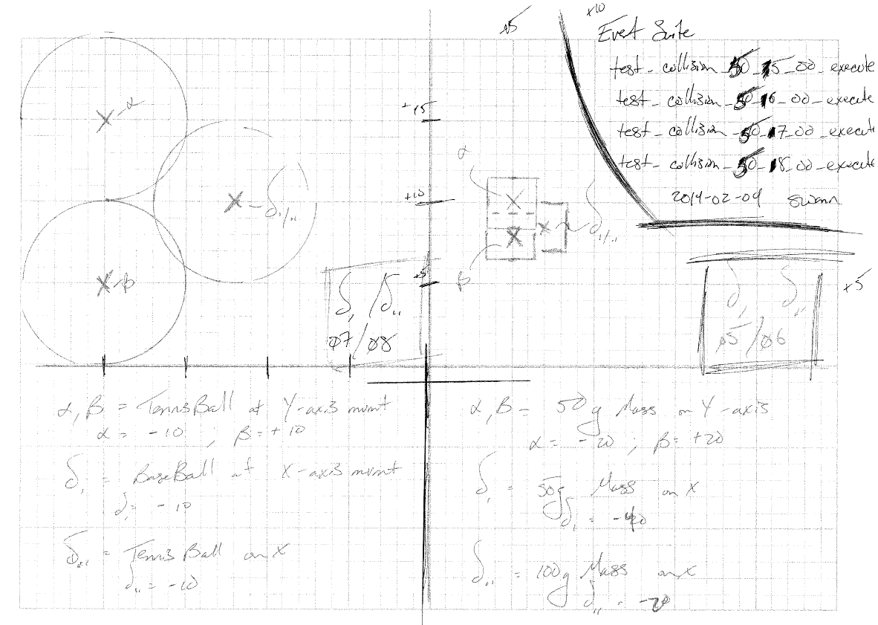

test notes :: heterogenous check on shape collisions related to the mathematics of calculating velocity vectors; new vector

values pushed to screen output in this version of the test for manual floating point analysis

// Collision.execute()

@Test

**public** **void** test_collision_50_05_00_execute() **throws** CloneNotSupportedException{

// The Setup

ArrayList<Actor_Object> test_list = **new** ArrayList<Actor_Object>();

Standard_Mass alpha = Standard_Mass.*generate_fifty_g_mass*(*FIVE*, *TEN*, *ZERO*);

alpha.update_velocity(*ZERO*, -20, *ZERO*);

Standard_Mass beta = Standard_Mass.*generate_fifty_g_mass*(*FIVE*, *EIGHT*, *ZERO*);

beta.update_velocity(*ZERO*, 20, *ZERO*);

Standard_Mass delta = Standard_Mass.*generate_fifty_g_mass*(*SEVEN*, *NINE*, *ZERO*);

delta.update_velocity(-40, *ZERO*, *ZERO*);

test_list.add(alpha);

test_list.add( beta);

test_list.add(delta);

*assertEquals*(test_list.size(), *THREE*, *ZERO*);

collider.clean_list();

// Battery

collider.check(test_list);

LinkedList<Actor_Object> THE_list = collider.get_list();

*assertEquals*(*FOUR*, THE_list.size(), *ZERO*);

*assertEquals*(alpha, THE_list.get(*ZERO*));

*assertEquals*(beta, THE_list.get(*ONE*));

*assertEquals*(delta, THE_list.get(*TWO*));

*assertEquals*(**null**, THE_list.get(*THREE*));

// execute

collider.execute();

} // test_collision_50_05_00_execute

// Collision.execute()

@Test

**public** **void** test_collision_50_06_00_execute() **throws** CloneNotSupportedException {

// The Setup

ArrayList<Actor_Object> test_list = **new** ArrayList<Actor_Object>();

Standard_Mass alpha = Standard_Mass.*generate_fifty_g_mass*(*FIVE*, *TEN*, *ZERO*);

alpha.update_velocity(*ZERO*, -20, *ZERO*);

Standard_Mass beta = Standard_Mass.*generate_fifty_g_mass*(*FIVE*, *EIGHT*, *ZERO*);

beta.update_velocity(*ZERO*, 20, *ZERO*);

Standard_Mass delta = Standard_Mass.*generate_one_hundred_g_mass*(*SEVEN*, *NINE*, *ZERO*);

delta.update_velocity(-20, *ZERO*, *ZERO*);

test_list.add(alpha);

test_list.add( beta);

test_list.add(delta);

*assertEquals*(test_list.size(), *THREE*, *ZERO*);

collider.clean_list();

// Battery

collider.check(test_list);

LinkedList<Actor_Object> THE_list = collider.get_list();

*assertEquals*(*FOUR*, THE_list.size(), *ZERO*);

*assertEquals*(alpha, THE_list.get(*ZERO*));

*assertEquals*(beta, THE_list.get(*ONE*));

*assertEquals*(delta, THE_list.get(*TWO*));

*assertEquals*(**null**, THE_list.get(*THREE*));

// execute

collider.execute();

} //test_collision_50_06_00_execute

// Collision.execute()

@Test

**public** **void** test_collision_50_07_00_execute() **throws** CloneNotSupportedException{

// The Setup

ArrayList<Actor_Object> test_list = **new** ArrayList<Actor_Object>();

Ball alpha = Ball.*generate_Tennis_Ball*(-200, 50, *ZERO*);

alpha.update_velocity(*ZERO*, -10, *ZERO*);

Ball beta = Ball.*generate_Tennis_Ball*(-200, 149, *ZERO*);

beta.update_velocity(*ZERO*, 10, *ZERO*);

Ball delta = Ball.*generate_Baseball*(-140, (**float**) 99.5, *ZERO*);

delta.update_velocity(-140, (**float**) 99.5, *ZERO*);

test_list.add(alpha);

test_list.add( beta);

test_list.add(delta);

*assertEquals*(test_list.size(), *THREE*, *ZERO*);

collider.clean_list();

// Battery

collider.check(test_list);

LinkedList<Actor_Object> THE_list = collider.get_list();

*assertEquals*(*FOUR*, THE_list.size(), *ZERO*);

*assertEquals*(alpha, THE_list.get(*ZERO*));

*assertEquals*(beta, THE_list.get(*ONE*));

*assertEquals*(delta, THE_list.get(*TWO*));

*assertEquals*(**null**, THE_list.get(*THREE*));

// execute

collider.execute();

} // test_collision_50_07_00_execute

// Collision.execute()

@Test

**public** **void** test_collision_50_08_00_execute() **throws** CloneNotSupportedException {

// The Setup

ArrayList<Actor_Object> test_list = **new** ArrayList<Actor_Object>();

Ball alpha = Ball.*generate_Tennis_Ball*(-200, 149, *ZERO*);

alpha.update_velocity(*ZERO*, -10, *ZERO*);

Ball beta = Ball.*generate_Tennis_Ball*(-200, 50, *ZERO*);

beta.update_velocity(*ZERO*, 10, *ZERO*);

Ball delta = Ball.*generate_Tennis_Ball*(-140, (**float**) 99.5, *ZERO*);

delta.update_velocity(-10, *ZERO*, *ZERO*);

test_list.add(alpha);

test_list.add( beta);

test_list.add(delta);

*assertEquals*(test_list.size(), *THREE*, *ZERO*);

// Battery

collider.check(test_list);

LinkedList<Actor_Object> THE_list = collider.get_list();

*assertEquals*(*FOUR*, THE_list.size(), *ZERO*);

*assertEquals*(alpha, THE_list.get(*ZERO*));

*assertEquals*(beta, THE_list.get(*ONE*));

*assertEquals*(delta, THE_list.get(*TWO*));

*assertEquals*(**null**, THE_list.get(*THREE*));

// execute

collider.execute();

} // test_collision_50_08_00_execute

module :: Item/Collision.java

test/design :: test_collision_30_02_00_collision_check && test_shape_47_03_00_calcuate_complex_radius

description :: design of the logic stress test for logic exercise; notation of won’t fix designations outside of project scope

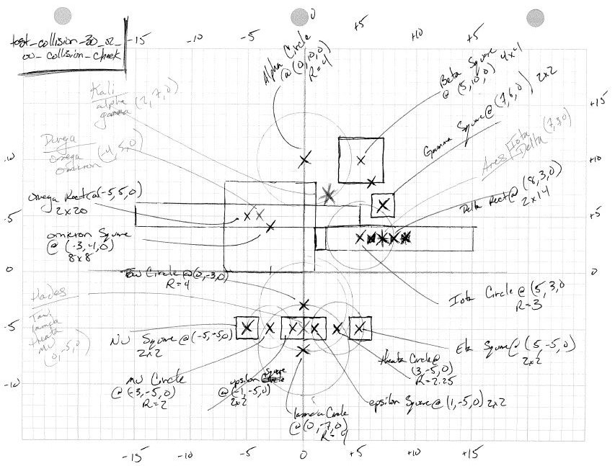

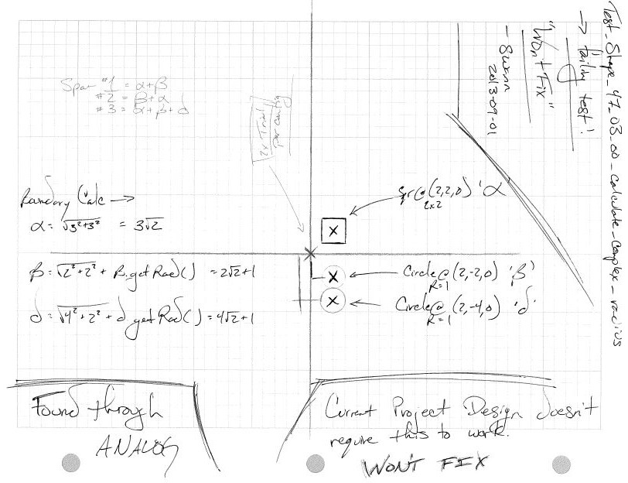

test notes :: logic stress test of several constructs outside of project scope to preform self-reconnassiance; won’t fix

designation associated with boundary sphere calcuations outside scope

// Collision.collision_check()

// --> Heterogeneous Test

@Test

**public** **void** test_collision_30_02_00_collision_check() {

// The Setup

// Simple Shapes

Circle alpha = **new** Circle(*ZERO*, *TEN*, *ZERO*, *FOUR*);

Circle iota = **new** Circle(*FIVE*, *THREE*, *ZERO*, *THREE*);

Circle theta = **new** Circle(*THREE*, -5, *ZERO*, (**float**) 2.25);

Circle lamda = **new** Circle(*ZERO*, -7, *ZERO*, *FOUR*);

Circle mu = **new** Circle(-3, -5, *ZERO*, *TWO*);

Circle tau = **new** Circle(*ZERO*, -3, *ZERO*, *FOUR*);

//Square beta = new Square(FIVE, TEN, ZERO, FOUR, FOUR);

Square gamma = **new** Square(*SEVEN*, *SIX*, *ZERO*, *TWO*, *TWO*);

//Square eta = new Square(FIVE, -5, ZERO, TWO, TWO);

//Square epsilon = new Square(ONE, -5, ZERO, TWO, TWO);

//Square upsilon = new Square(-1, -5, ZERO, TWO, TWO);

//Square nu = new Square(-5, -5, ZERO, TWO, TWO);

Square omicron = **new** Square(-3, -4, *ZERO*, *EIGHT*, *EIGHT*);

Rectangle delta = **new** Rectangle(*EIGHT*, *THREE*, *ZERO*, *TWO*, 14);

Rectangle omega = **new** Rectangle(-5, -5, *ZERO*, *TWO*, 20);

// Complex Shapes

Shape hades = **new** Shape(*ZERO*, -5, *ZERO*);

hades.add_shape( mu );

hades.add_shape( theta );

hades.add_shape( tau );

hades.add_shape( lamda );

hades.calculate_radius();

Shape ares = **new** Shape(*SEVEN*, *THREE*, *ZERO*);

ares.add_shape( iota );

ares.add_shape( delta );

ares.calculate_radius();

Shape durga = **new** Shape(-4, *FIVE*, *ZERO*);

durga.add_shape( omega );

durga.add_shape( omicron );

durga.calculate_radius();

Shape kali = **new** Shape(*ZERO*, *TEN*, *ZERO*);

kali.add_shape( alpha );

kali.add_shape( gamma );

kali.calculate_radius();

// **ANALOG**: TEST DESIGN

// -----------------------

// Calc radius may need a re-working... maybe

// keep this note if so... Analog test design evidencing bugs before

// digital testing even in place.

// ~swann 2013-08-29

// -----------------------

// projected error --> boundary sphere will not calc full boundary sphere

// -----------------------

// error confirmed ~ swann, 2013-08-29

// WON'T FIX --> unless I have to in the future

// commented tests are those that won't pass -- not needed for reqs

// Kali vs. Complex Shapes

*assertEquals*(Collision.*collision_check*( kali, kali ), **false**);

//assertEquals(Collision.collision_check( kali, durga ), true);

*assertEquals*(Collision.*collision_check*( kali, hades ), **false**);

*assertEquals*(Collision.*collision_check*( kali, ares ), **true**);

// Durga vs. Complex Shapes

*assertEquals*(Collision.*collision_check*( durga, durga ), **false**);

*assertEquals*(Collision.*collision_check*( durga, hades ), **true**);

//assertEquals(Collision.collision_check( durga, kali ), true);

//assertEquals(Collision.collision_check( durga, ares ), true);

// Hades vs. Complex Shapes

*assertEquals*(Collision.*collision_check*( hades, hades ), **false**);

*assertEquals*(Collision.*collision_check*( hades, kali ), **false**);

*assertEquals*(Collision.*collision_check*( hades, ares ), **false**);

*assertEquals*(Collision.*collision_check*( hades, durga ), **true**);

// Ares vs. Complex Shapes

*assertEquals*(Collision.*collision_check*( ares, ares ), **false**);

*assertEquals*(Collision.*collision_check*( ares, hades ), **false**);

*assertEquals*(Collision.*collision_check*( ares, kali ), **true**);

//assertEquals(Collision.collision_check( ares, durga ), true);

}

// Shape.calculate_complex_radius()

//

@Test

**public** **void** test_shape_47_03_00_calculate_complex_radius() {

// Battery One

// --> Setup

Shape outer_one = **new** Shape(*ZERO*, *ZERO*, *ZERO*);

Shape outer_two = **new** Shape(*ZERO*, *ZERO*, *ZERO*);

Square inner_one = **new** Square(*TWO*, *TWO*, *TWO*, *TWO*, *TWO*);

Circle inner_two = **new** Circle(*TWO*, *NEGATIVE_TWO*, *ZERO*, *ONE*);

Circle inner_tre = **new** Circle(*TWO*, *ZERO*-*FOUR*, *ZERO*, *ONE*);

// Shape One

*assertEquals*(outer_one.get_radius(), *ZERO*, *ZERO*);

*assertEquals*(outer_one.is_composite(), **false**);

outer_one.add_shape( inner_two );

outer_one.calculate_radius();

*assertEquals*(outer_one.get_radius(), *TWO*\*Math.*pow*(*TWO*, *A_HALF*)+1, *A_THOUSANDTH*);

outer_one.add_shape( inner_one );

outer_one.calculate_radius();

*assertEquals*(outer_one.get_radius(), *THREE*\*Math.*pow*(*TWO*, *A_HALF*), *A_THOUSANDTH*);

outer_one.add_shape( inner_tre );

outer_one.calculate_radius();

//assertEquals(outer_one.get_radius(), THREE*Math.pow(TWO, A_HALF), A_THOUSANDTH);

// TEST END HERE --> KNOWN BUG ON RADIUS CALCULATION WHEN CIRCLES ADDED AFTER AND

// OUTSIDE

// WON'T FIX FOR NOW. NO INTERNAL ITEMS REQUIRE THIS FIX

// ~ swann, 2013-09-01

//

// FOUND THROUGH **ANALOG**:

}